A canonical decomposition theory  
 for metrics on a finite set

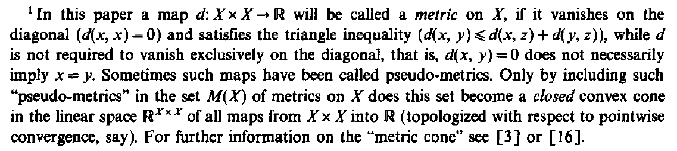

Let $X$ be a set. Non serve finito per ora.

**Def**. (pseudo-metric)

A function $d :X×X→R$ is a **pseudo-metric** on $X$ if

$d\left(x,x\right)=0, ∀ x∈X$

$d\left(x,y\right)≤d\left(x,z\right)+d\left(y,z\right), ∀ x,y,z∈X$

that is, it vanishes on the diagonal $Δ_{X}=\left\{ \left(x,y\right)∈X×X | x=y \right\}$ and it satisfies the triangle inequality.

**Def**. (metric)

A function $d :X×X→R$ is a **metric** on $X$ if

$d\left(x,y\right)=0 ⟺ x=y, ∀ x,y∈X$

$d\left(x,y\right)≤d\left(x,z\right)+d\left(y,z\right), ∀ x,y,z∈X$

In particular, a metric is a pseudo-metric.

[BD92a] non parla di non-negatività e simmetria  
 (si possono ricavare da disuguaglianza triangolare + diagonale nulla).

**Prop**. If $d :X×X→R$ is a pseudo-metric, then

$d\left(x,y\right)=d\left(y,x\right), ∀ x,y∈X$

$d\left(x,y\right)≥0, ∀ x,y∈X$

that is, it is a symmetric and non-negative function.

**Dim**. From triangle inequality on $x,y,x$ and on $y,x,y$

$$d\left(x,y\right)≤d\left(x,x\right)+d\left(y,x\right)$$

$$d\left(y,x\right)≤d\left(y,y\right)+d\left(x,y\right)$$

that implies $d\left(x,y\right)=d\left(y,x\right)$.

From triangle inequality on $x,x,y$

$$0=d\left(x,x\right)≤d\left(x,y\right)+d\left(x,y\right)=2d(x,y)$$

that implies $d\left(x,y\right)≥0$.

Let $V$ be a vector space over $R$.

**Def**. (convex set)

A subset $C⊆V$ is **convex** if $∀ v,w∈C$

$$(1-λ)v+λw∈C, ∀ λ∈[0,1]$$

**Def**. ((linear) cone)

A subset $C⊆V$ is a **(linear) cone** if

$$v∈C ⟹ λv∈C, ∀ λ≥0$$

**Not**. $R^{X×X} :=\left\{ f :X×X→R \right| f \text{function }\}$

$$M\left(X\right) :=\left\{ d :X×X→R \right| d \text{pseudo-metric }\}⊆R^{X×X}$$

**Fact $R^{X×X}$** is a (real) vector space.

**Prop**. $M\left(X\right)$ is a convex cone.

**Dim**. Let $d∈M(X)$ pseudo-metric on $X$ and $λ≥0$. Then

$d\left(x,x\right)=0 ⟹ λd\left(x,x\right)=0, ∀ x∈X$

$d\left(x,y\right)≤d\left(x,z\right)+d\left(y,z\right)⟹$ $$λd\left(x,y\right)≤λ\left(d\left(x,z\right)+d\left(y,z\right)\right)=λd\left(x,z\right)+λd\left(y,z\right), ∀ x,y,z∈X$$

So $λd$ is a pseudo-metric, $λd∈M(X)$, and $M(X)$ is a cone.

To show that $M(X)$ is convex,  
 we need to show that $∀ d_{1},d_{2}∈M(X)$

$$(1-λ)d_{1}+λd_{2}∈M(X) , ∀ λ∈[0,1]$$

But since $M\left(X\right)$ is a cone,

$$(1-λ)d_{1}∈M(X) and λd_{2}∈M(X)$$

so it suffice to show that $M(X)$ is closed under addition.

Let $d_{1},d_{2}∈M(X)$. Then

$\left(d_{1}+d_{2}\right)\left(x,x\right)=\underset{=0}{\underbrace{d_{1}\left(x,x\right)}}+\underset{=0}{\underbrace{d_{2}\left(x,x\right)}}=0, ∀ x∈X$

$\left(d_{1}+d_{2}\right)\left(x,y\right)=d_{1}\left(x,y\right)+d_{2}\left(x,y\right)≤$ $$≤d_{1}\left(x,z\right)+d_{1}\left(y,z\right)+d_{2}\left(x,z\right)+d_{2}\left(y,z\right)= \\ =d_{1}\left(x,z\right)+d_{2}\left(x,z\right)+d_{1}\left(y,z\right)+d_{2}\left(y,z\right)= \\ =\left(d_{1}+d_{2}\right)\left(x,z\right)+\left(d_{1}+d_{2}\right)\left(y,z\right), ∀ x,y,z∈X$$

So $d_{1}+d_{2}$ is a pseudo-metric on $X$.

The set of all metrics is also a non-pointed convex cone (same definition of cone but with $λ>0$): in fact, the zero function is not a metric.

Let us consider $R^{X×X}$ with the topology of pointwise convergence $τ_{p}$.

**Prop**. If $X$ is countable[1]*, then is closed in $(R^{X×X},τ_{p})$.

**Dim**. Let us show that $M(X)$ is sequentially closed.

Let us consider a convergent sequence of pseudo-metrics

$$d_{n}→\overline{d}, d_{n}∈M\left(X\right), ∀ n∈N$$

and let us show that the limit is also a pseudo-metric,

$$\overline{d}∈M(X)$$

For the characterization of the pointwise convergence,

$$d_{n}→\overline{d} ⟺ d_{n}\left(x\right)→\overline{d}\left(x\right), ∀ x∈X×X$$

Now for every $x∈X×X$, ${\left\{d_{n}\left(x\right)\right\}}_{n∈N}$ 
 is a real-valued sequence, so $∀ x,y,z∈X$

$d_{n}\left(x,x\right)=0, ∀ n∈N ⟹\lim_{n→+∞}{d_{n}\left(x,x\right)}=\overline{d}\left(x,x\right)=0$

* $d_{n}\left(x,y\right)≤d_{n}\left(x,z\right)+d_{n}\left(y,z\right), ∀ n∈N$, so in the limit $\overline{d}\left(x,y\right) ≤ \overline{d}\left(x,z\right) + \overline{d}\left(y,z\right)$

This shows that $\overline{d}$ is a pseudo-metric  
 and $M(X)$ is sequentially closed.

Since $X$ is countable (and so is $X×X$), the space $R^{X×X}=\prod_{x ∈ X×X}{R}$  
 is a countable product of first-countable spaces (namely $R$), so it is first-countable itself.

Now $M(X)$ is sequentially closed in a first-countable space,  
 so it is closed.

If $X$ is uncountable, then we cannot conclude that $R^{X×X}$ is first-countable.

**Oss**. In the same hypothesis, the set of metrics is not even sequentially closed in $(R^{X×X},τ_{p})$.

**Dim**. Let us consider a convergent sequence of metrics such that

$$d_{n}→\overline{d} and d_{n}\left(x\right)=\frac{1}{n}, n∈N$$

for some $x∈(X×X) \backslash Δ_{X}$. Then

$$\overline{d}\left(x\right)=\lim_{n→+∞}{d_{n}\left(x\right)}=0$$

but $x∉Δ_{X}$, so $\overline{d}$ is not a metric.

<https://en.wikipedia.org/wiki/Metric_space>  
<https://en.wikipedia.org/wiki/Pseudometric_space>

<https://en.wikipedia.org/wiki/Vector_space>  
<https://en.wikipedia.org/wiki/Convex_set>  
<https://en.wikipedia.org/wiki/Convex_cone>

<https://en.wikipedia.org/wiki/Pointwise_convergence>  
<https://en.wikipedia.org/wiki/Sequential_space>

Sometimes it is useful to think of functions $d :X×X→R , \left(d∈R^{X×X}\right),$  
 as real-valued square matrices $D∈M(|X|,R)$.  
In particular, a pseudo-metric corresponds to a symmetric matrix,  
 with 0 on the diagonal, non-negative entries elsewhere  
 and such that the elements satisfy the triangle inequality.

Chapter 1: Introduction

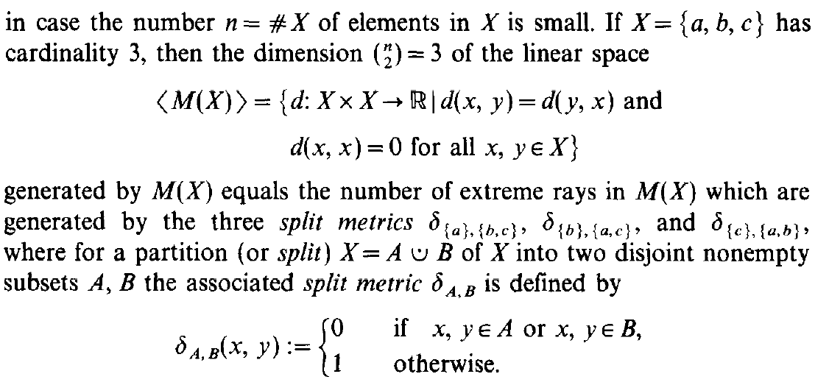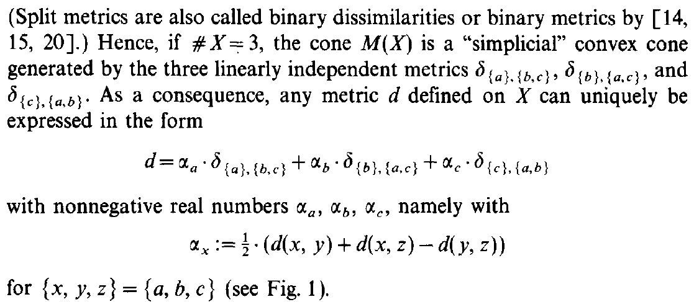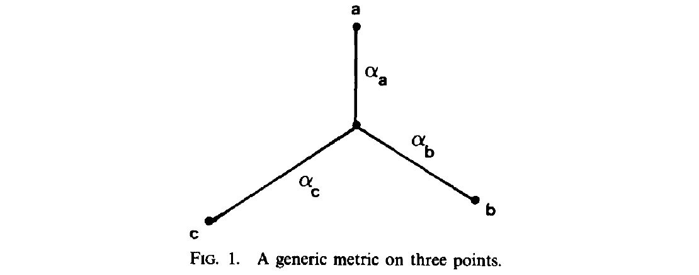

Let us consider a real vector space $V$.

**Def**. (conic/conical combination)

A point $v∈V$ is a **conical combination** of $v_{1},…,v_{k}∈V$ if

$∃ λ_{1},…,λ_{k}≥0$ such that $v=λ_{1}v_{1}+…+λ_{k}v_{k}$

**Def**. (extreme/extremal ray)

An **extreme ray** of a cone $C⊆V$ is a subset $S⊆C$ of the form

$$S=\left\{ λr | λ≥0 \right\}$$

for some $r∈C \backslash \{0\}$, such that the elements of $S$ cannot be expressed as conical combinations of elements of $C \backslash S$;

or equivalently, for every $v_{1},…,v_{k}∈C$ and $λ_{1},…,λ_{k}≥0$

$$λ_{1}v_{1}+…+λ_{k}v_{k}∈S ⟹ ∃ i∈\left\{1,…,k\right\} :v_{i}∈S$$

or equivalently, for every $v,w∈C$

$$v+w∈S ⟹ v∈S \text{or} w∈S$$

We can identify an extreme ray with the associated vector $r$.

**Def**. (simplicial cone)

A cone $C⊆V$ is a **simplicial cone** if every complete[2]* set of representatives of the extreme rays is linearly independent;

or equivalently, if

$$\#\{\text{extreme rays}\}=\dim_{R}{〈C〉}$$

where $〈C〉$ is the vector subspace spanned by $C$.

From now on we will assume $X$ finite of cardinality $n$.  
We may sometimes identify $X$ with $\{1,…,n\}$, since they are in bijection.

**Def**. (split metric / binary metric / binary dissimilarity)

Given a partition (or split) of $X$ into two disjoint non-empty sets $A$ and $B$, we call **split metric** of $\{A,B\}$ the function $δ_{A,B} :X×X→R$ defined by

$$δ_{A,B}\left(x,y\right) :=\left\{ \begin{matrix}0 , \text{if} x,y∈A \text{or} x,y∈B \\ 1 , \text{otherwise}\end{matrix}\right.$$

**Not**. If $a∈X$, we denote the trivial split metric

$$δ_{a} :=δ_{\left\{a\right\},(X \backslash \{a\})}$$

**Prop**. The split metrics are pseudo-metrics.

**Dim**. Let us fix a split $\{A,B\}$ of $X$ and let us show that $δ_{A,B}∈M(X)$. The vanishing on the diagonal is obvious.

Let us show the triangle inequality.



$x,y,z∈A$ $$\underset{0}{\underbrace{δ_{A,B}\left(x,y\right)}}≤ \underset{0}{\underbrace{δ_{A,B}\left(x,z\right)}}+\underset{0}{\underbrace{δ_{A,B}\left(y,z\right)}}$$

$x,y∈A, z∈B$ $$\underset{0}{\underbrace{δ_{A,B}\left(x,y\right)}}≤ \underset{1}{\underbrace{δ_{A,B}\left(x,z\right)}}+\underset{1}{\underbrace{δ_{A,B}\left(y,z\right)}}$$

$x,z∈A, y∈B$ $$\underset{1}{\underbrace{δ_{A,B}\left(x,y\right)}}≤ \underset{0}{\underbrace{δ_{A,B}\left(x,z\right)}}+\underset{1}{\underbrace{δ_{A,B}\left(y,z\right)}}$$

$x∈A, y,z∈B$ $$\underset{1}{\underbrace{δ_{A,B}\left(x,y\right)}}≤ \underset{1}{\underbrace{δ_{A,B}\left(x,z\right)}}+\underset{0}{\underbrace{δ_{A,B}\left(y,z\right)}}$$

Analogous cases switching $A$ and $B$.

**Oss**. Given $d∈M(X)$, for every $x,y,z∈X$ we have the following triangle inequalities

$$\left\{ \begin{matrix}d\left(x,y\right)≤d\left(x,z\right)+d\left(y,z\right) \\ d\left(x,z\right)≤d\left(x,y\right)+d\left(y,z\right) \\ d\left(y,z\right)≤d\left(x,y\right)+d\left(x,z\right)\end{matrix}\right.$$

If $d\left(x,y\right)=0$, from the last two we get $d\left(x,z\right)=d\left(y,z\right)$.

**Not**. For every split $\{A,B\}$ of $X$, we define

$$Γ_{A,B} :=\left\{ γ∈M\left(X\right) | γ\left(x,y\right)=0 \text{if} x,y∈A \text{or} x,y∈B\right\}$$

These are the pseudo-metrics that vanish  
 where the split metric $δ_{A,B}$ vanishes (the other entries can be anything).

**Lemma** These pseudo-metrics are multiples of the relative split metric

$$γ∈Γ_{A,B} ⟹ ∃λ≥0 :γ=λδ_{A,B}$$

$$Γ_{A,B}=\text{cone}(δ_{A,B})$$

**Dim**. Let us fix $a_{0}∈A$.  
Since $∀ b,b^{'}∈B, d\left(b,b^{'}\right)=0$, we have

$$d\left(a_{0},b\right)=d\left(a_{0},b^{'}\right), ∀ b,b^{'}∈B$$

Symmetrically, for $b_{0}∈B$ we have

$$d\left(b_{0},a\right)=d\left(b_{0},a'\right), ∀ a,a'∈A$$

Thus $d\left(a,b\right)=d\left(a',b^{'}\right), ∀ a,a^{'}∈A, ∀ b,b^{'}∈B$.

This means that either $d$ vanishes everywhere or, where $d$ does not vanish, it can assume only one value – say $λ$; and so

$$γ=λδ_{A,B}$$

**Prop**. The split metrics are extreme rays of .[3]*

**Dim**. Let us consider a split $\{A,B\}$ and the associated  
 split metric $δ_{A,B}$. From the previous **Lemma** we have

$$Γ_{A,B}=\left\{ λδ_{A,B} | λ≥0 \right\}$$

so we need to show

$$γ_{1}+γ_{2}∈Γ_{A,B} ⟹ γ_{1}∈Γ_{A,B} \text{or} γ_{2}∈Γ_{A,B}$$

Suppose $γ_{1}+γ_{2}=λδ_{A,B}$. Then for every $a,a'∈A$

$$γ_{1}\left(a,a'\right)+γ_{2}\left(a,a'\right)=λδ_{A,B}\left(a,a'\right)=0$$

but since $γ_{1},γ_{2}$ are non-negative, we have

$$γ_{1}\left(a,a'\right)=γ_{2}\left(a,a'\right)=0$$

Idem for every $b,b^{'}∈B$.

Thus $γ_{1}$ and $γ_{2}$ vanish where $δ_{A,B}$ vanishes, that is

$$γ_{1}∈Γ_{A,B} \text{and} γ_{2}∈Γ_{A,B}$$

**Oss**. The number of split metrics is $2^{n-1}-1$.

In fact, the set of split metrics is in bijection with the set of splits of $X$. In creating a split, for every element of $X$ we have two choices: put it in $A$ or put it in $B$.  
We have $2^{n}$ possible arrangements. We need to subtract the cases corresponding to $(∅,X)$ and $(X,∅)$, and divide by two, since the split $\{A,B\}$ is the same as $\{B,A\}$.   
In the end we get

$$\frac{2^{n}-2}{2}=2^{n-1}-1$$

**Lemma** The functions $ε_{ij} :X×X→R, i≠j∈X$ defined by

$$ε_{ij}\left(x\right)=\left\{\begin{matrix} 1 , \text{if} x=\left(i,j\right) \text{or} x=(j,i) \\ 0 , \text{otherwise}\end{matrix}\right.$$

can be expressed as linear combinations of the split metrics

$${\left\{δ_{i}\right\}}_{i∈X}$$

**Prop**. $〈M(X)〉$ is a vector subspace of $R^{X×X}$ with the following properties:

$〈M(X)〉=\left\{ f :X×X→R | \begin{aligned} f\left(x,y\right)=f\left(y,x\right), ∀ x,y∈X \\ ∧ f\left(x,x\right)=0, ∀ x∈X\end{aligned}\right\}$

$\dim_{R}{〈M(X)〉}=\left({n \atop 2}\right)$

**Dim**. Let us indicate the set of symmetric functions vanishing on the diagonal with $S_{0}(X)$.   
It is clear that $M\left(X\right)⊆S_{0}(X)$ and $S_{0}(X)$ is closed under linear combinations. So $〈M(X)〉⊆S_{0}(X)$.

Notice that ${\left\{ε_{ij}\right\}}_{i<j}$ is a basis for $S_{0}\left(X\right)$. In fact, the functions in $S_{0}\left(X\right)$ can be represented as symmetric matrices with zeroes on the diagonal; while the function $ε_{ij}$ can be represented as a symmetric matrix with $1$ in positions $\left(i,j\right)$ and $(j,i)$, and zeroes elsewhere.

This also shows that

$$\dim_{R}{S_{0}(X)}=\#{\left\{ε_{ij}\right\}}_{i<j}=\left({n \atop 2}\right)$$

From the previous **Lemma** we can express the functions ${\left\{ε_{ij}\right\}}_{i<j}$ as linear combinations of split metrics, thus every function in $S_{0}\left(X\right)$; that is $S_{0}(X)⊆〈M(X)〉$.

**Oss**. For $n=2$, say $X=\{a,b\}$, all the pseudo-metrics  
 are multiple of the only split metric $δ_{\left\{a\right\},\left\{b\right\}}$;   
so $M(X)$ is just a one-dimensional ray.

For $n=3$, say $X=\{a,b,c\}$, the split metrics

$$δ_{a}=δ_{\left\{a\right\},\left\{b,c\right\}}, δ_{b}=δ_{\left\{b\right\},\left\{a,c\right\}}, δ_{c}=δ_{\left\{c\right\},\left\{a,b\right\}}$$

generate the cone $M(X)$.  
In fact, let us consider a pseudo-metric $d∈M(X)$;  
then we want to show that $∃ λ,μ,ν≥0$ such that

$$d=λδ_{a}+μδ_{b}+νδ_{c}$$

In particular, by evaluating

$$d_{ab}≔d\left(a,b\right)= \\ =λδ_{\left\{a\right\},\left\{b,c\right\}}\left(a,b\right)+μδ_{\left\{b\right\},\left\{a,c\right\}}\left(a,b\right)+νδ_{\left\{c\right\},\left\{a,b\right\}}\left(a,b\right)= \\ =λ⋅1+μ⋅1+ν⋅0= \\ =λ+μ$$

and analogously for the other couples,   
we get the following system of equations

$$\left\{ \begin{matrix}d_{ab}=λ+μ \\ d_{ac}=λ+ν \\ d_{bc}=μ+ν\end{matrix}\right.$$

Solving for $λ,μ,ν$ we get

$$λ=\frac{d_{ab}+d_{ac}-d_{bc}}{2}, μ=\frac{d_{ab}-d_{ac}+d_{bc}}{2}, ν=\frac{-d_{ab}+d_{ac}+d_{bc}}{2}$$

Moreover, from triangle inequality on $d$, we have $λ,μ,ν≥0$.  
This shows that these split metrics are the only extreme rays (every other pseudo-metric is a conical combination of them).

The same calculation also shows that  
 the split metrics are linearly independent in $〈M(X)〉$. In fact, if

$$λδ_{a}+μδ_{b}+νδ_{c}=0$$

where $0$ is the identically zero pseudo-metric, then

$$λ=0, μ=0, ν=0$$

In particular, for $n=3$ the decomposition in split metrics is unique.

**Oss**. $M(X)$ is a simplicial cone if and only if $n=2, 3$. In fact,

$$\#\left\{\text{extreme rays}\right\}≥\#\left\{\text{split metrics}\right\}=2^{n-1}-1$$

and for $n≥4$ this number is greater than

$$\dim_{R}{〈M(X)〉}=\left({n \atop 2}\right)=\frac{n(n-1)}{2}$$

But for $n=2, 3$ the number of extreme rays coincide with the number of split metrics and

$$n=2, 2^{2-1}-1=1=\left({2 \atop 2}\right)$$

$$n=3, 2^{3-1}-1=3=\left({3 \atop 2}\right)$$

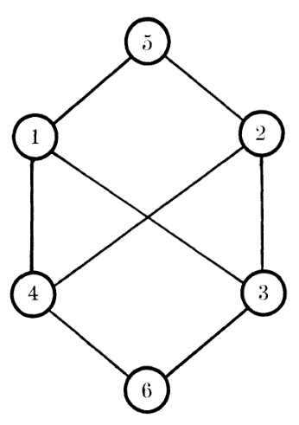Esistono metriche estremali che non sono split? L’esempio a p. 17 di [Avis80] sembra mostrare nel caso $n=6$ una metrica (indotta da un grafo) che è estremale ma non split (il grafo è bipartito ma non completo).

Infatti le split metric si possono rappresentare come grafi bipartiti completi.

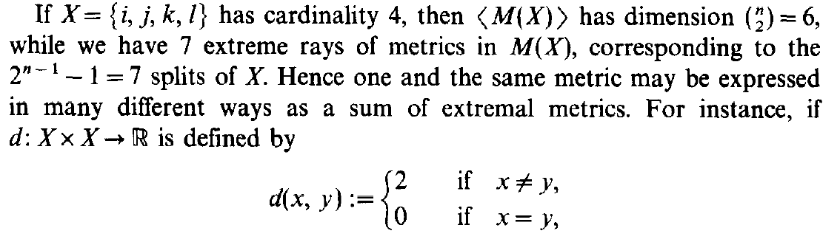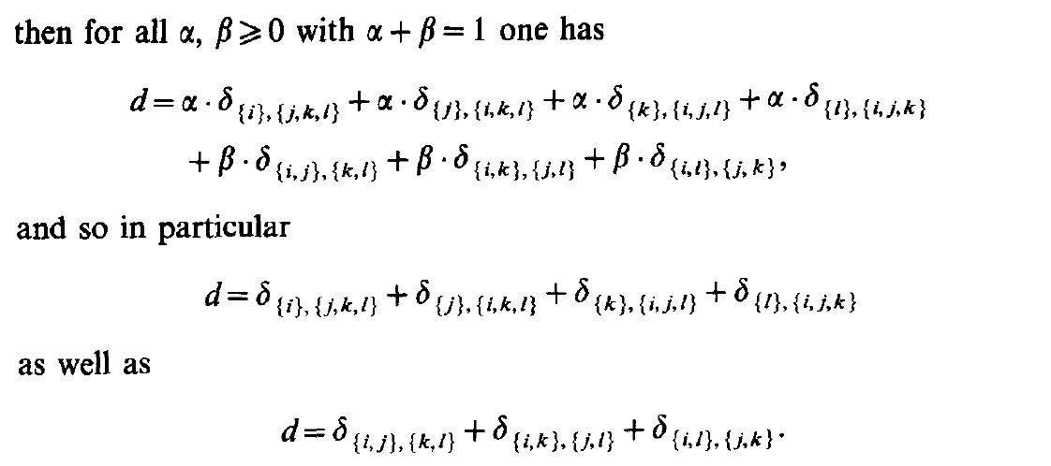

The counterexample above shows that for $n≥4$ the decomposition in split metrics is not necessarily unique.

<https://en.wikipedia.org/wiki/Conical_combination>  
<https://www.damtp.cam.ac.uk/user/hf323/M18-OPT/lecture2.pdf>  
<https://people.math.carleton.ca/~kcheung/math/notes/MATH5801/10/10_2_extreme_rays.html>

<https://www.mat.uniroma2.it/~tvmsscho/Rome-Moscow_School/2012/files/RM12-Cones-Matrices.pdf>  
<https://math.stackexchange.com/questions/4362253/simplicial-polyhedral-cones>

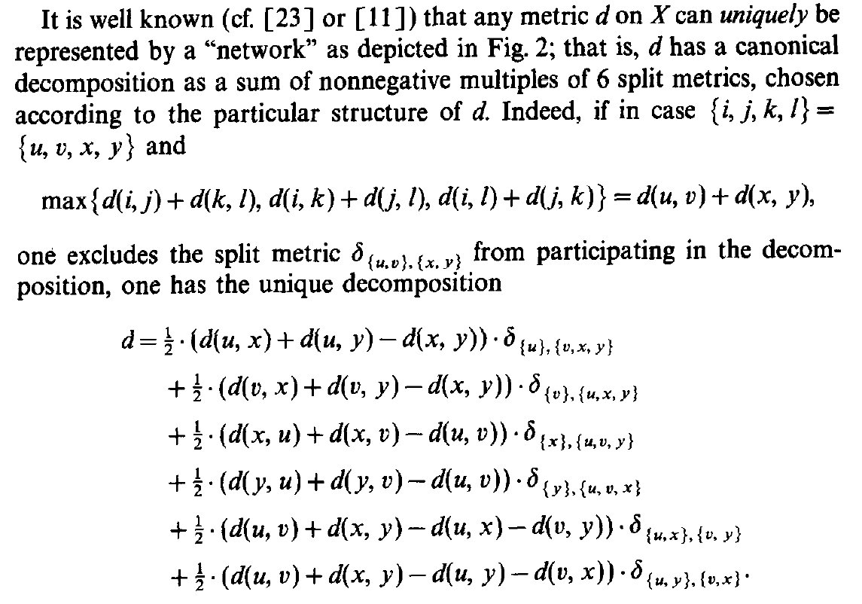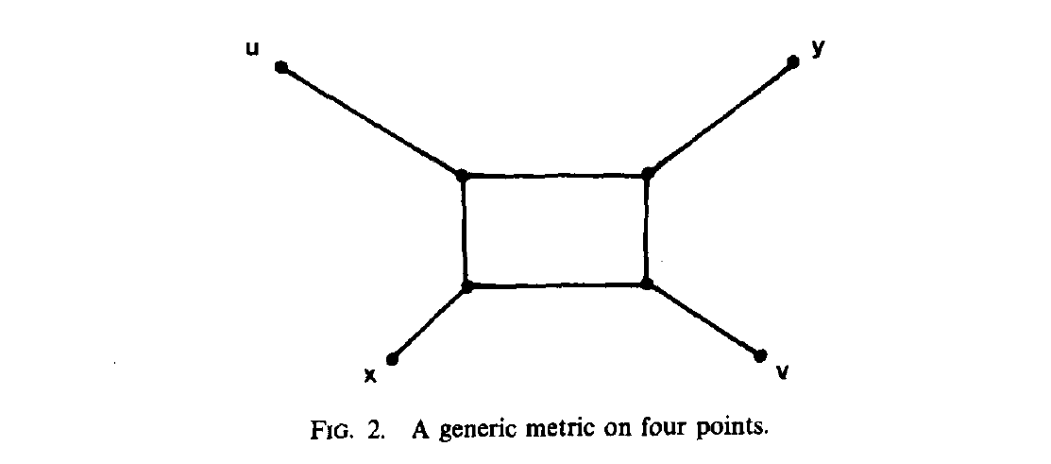

Dimostrare la decomposizione.

Per spiegare la roba che viene dopo è meglio aver letto il resto del paper.

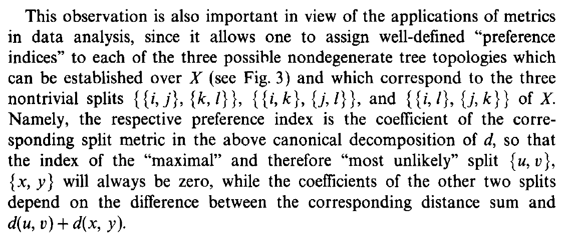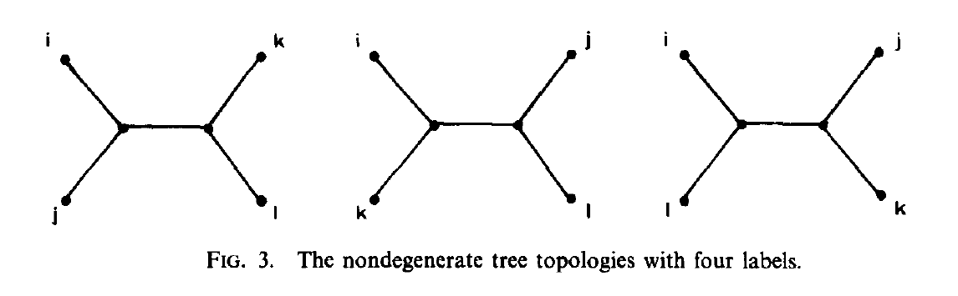

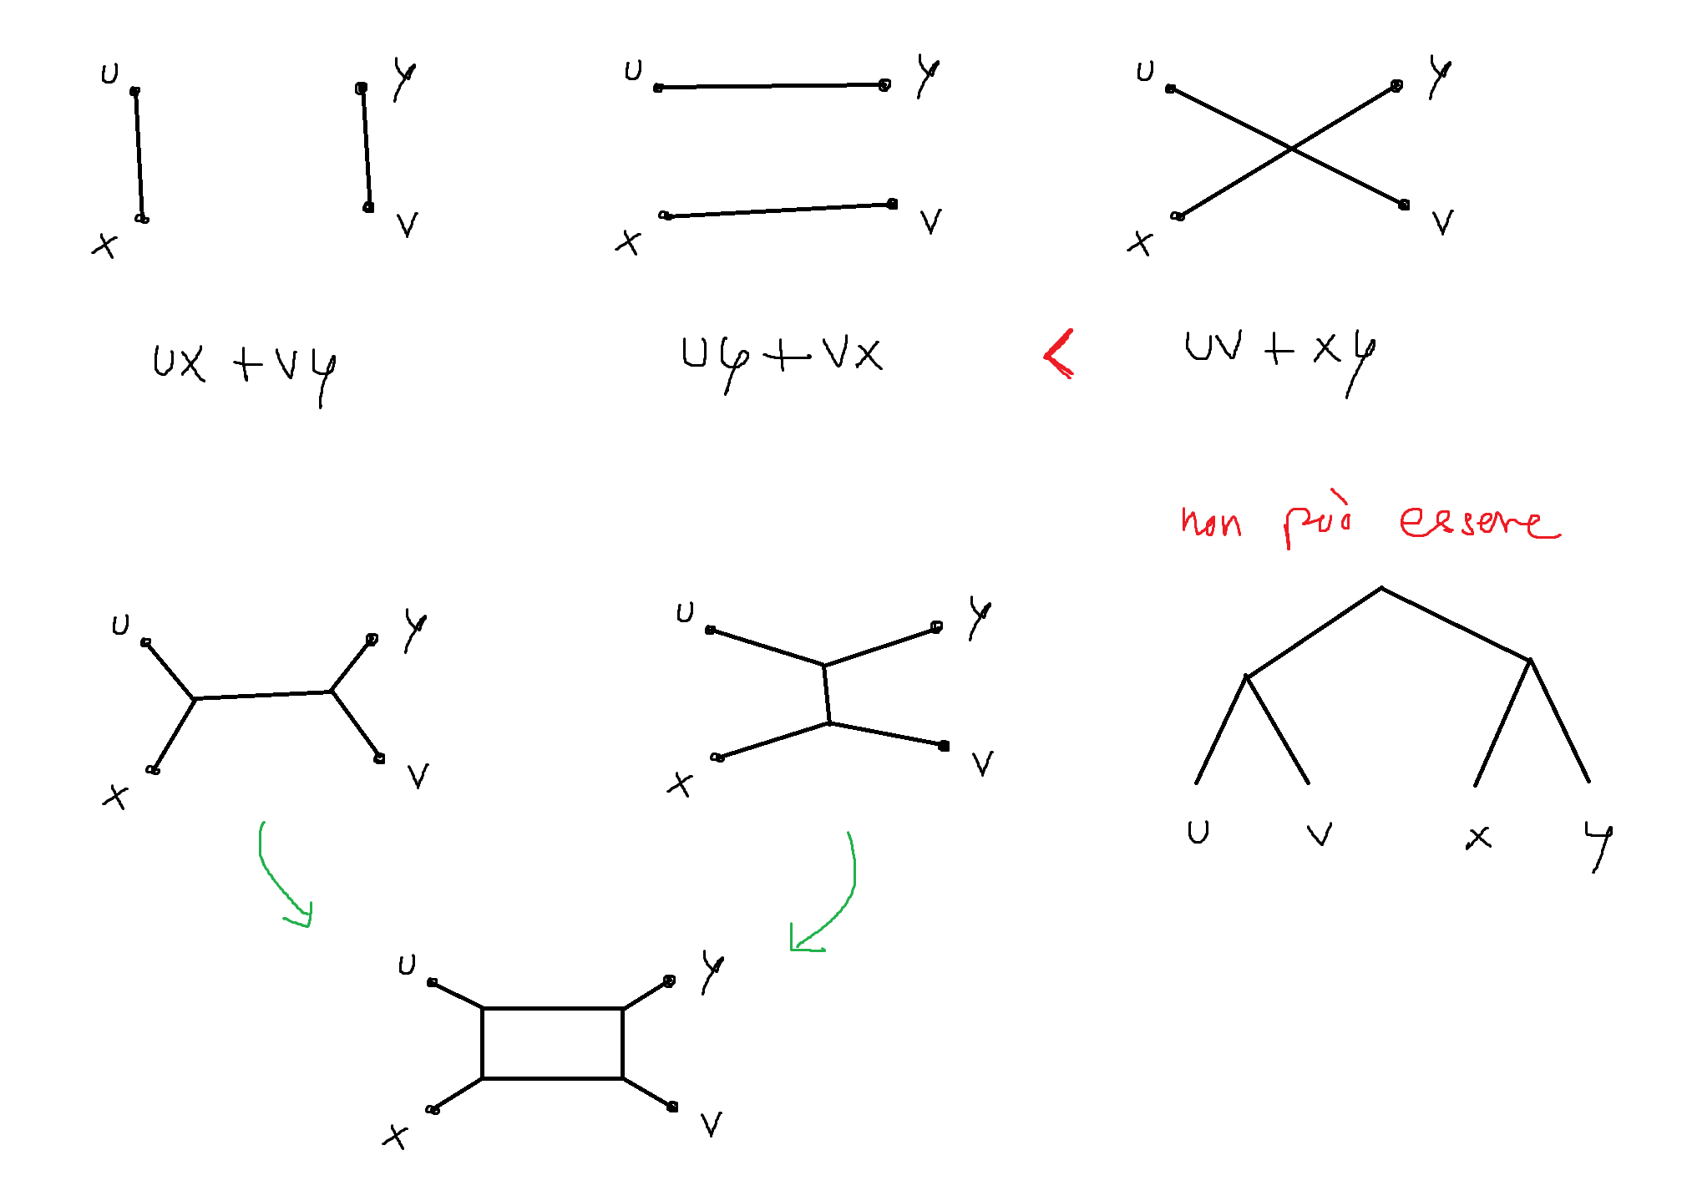

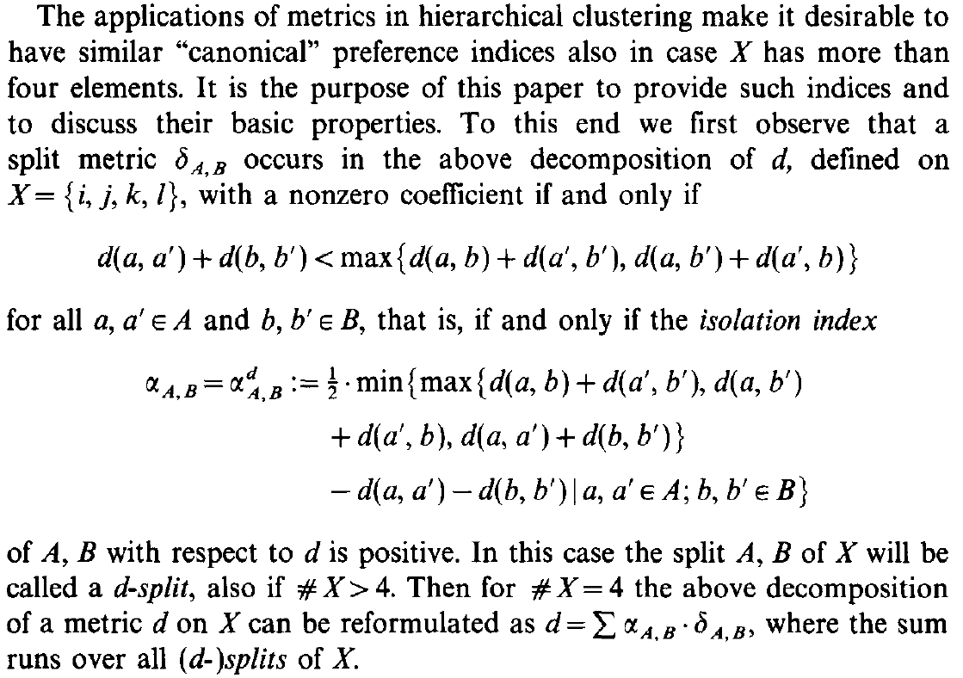

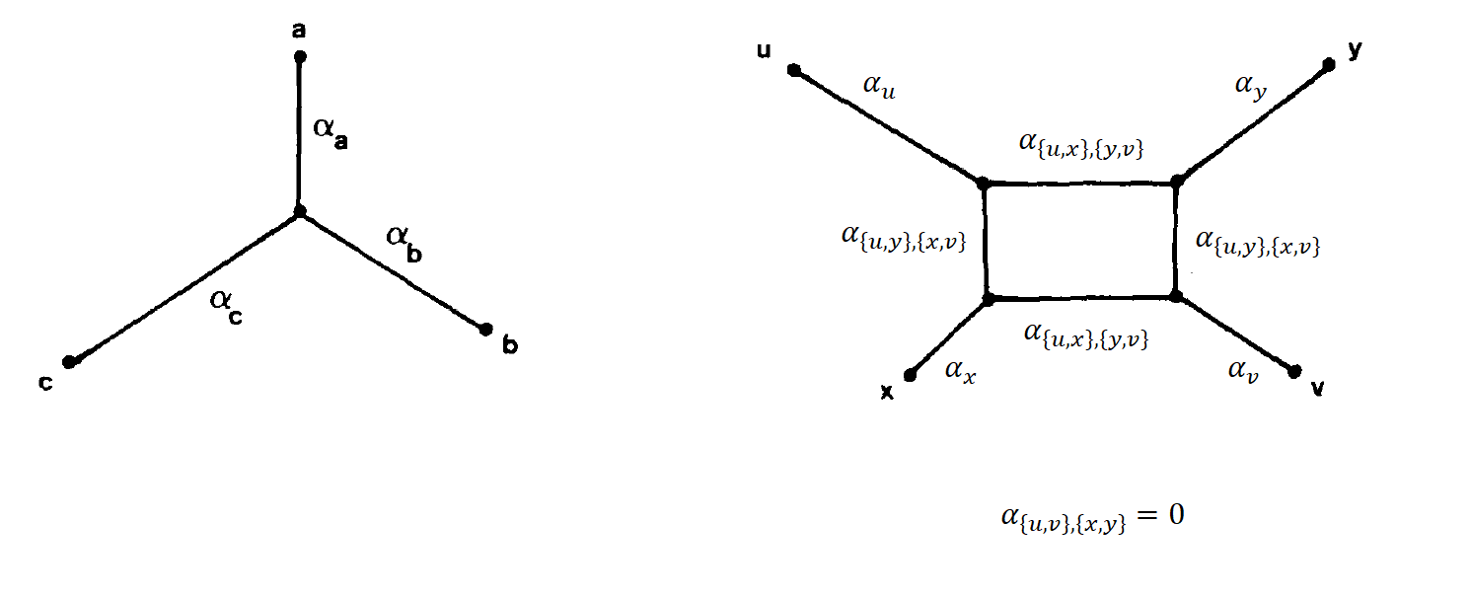

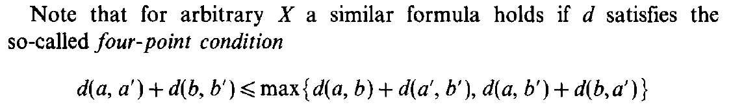 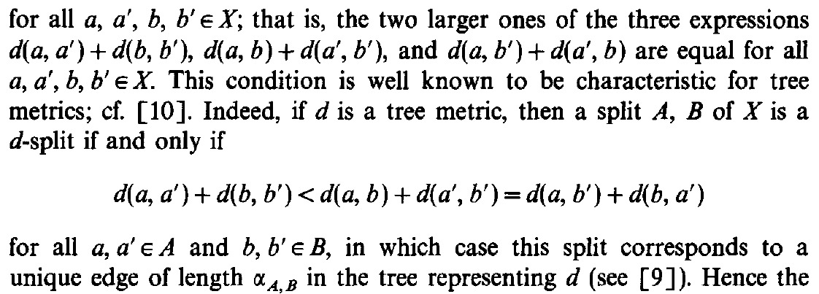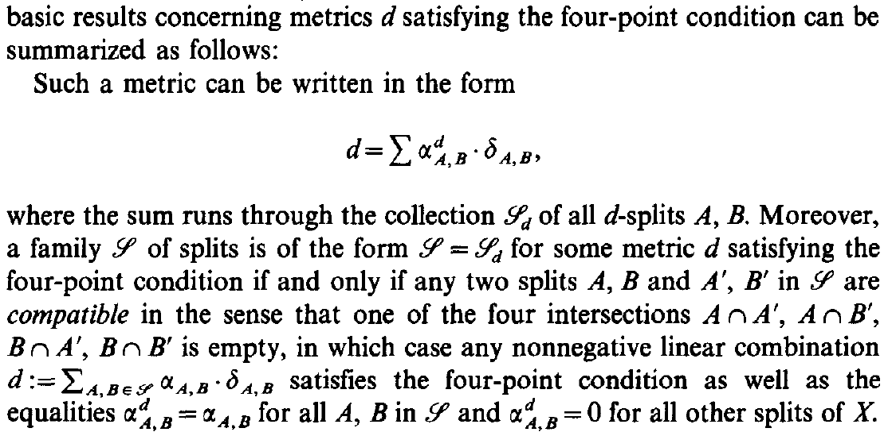

**Fact** A pseudo-metric $d$ is a tree metric if and only if it satisfies  
the four-point condition, that is for every $t,u,v,w∈X$

$$tu+vw≤\max{\{tv+uw,tw+uv\}}$$

**Fact** Let $d$ be a tree metric. Then a split $\{A,B\}$ is a $d$-split if and only if for every $a,a^{'}∈A$ and $b,b^{'}∈B$

$$aa^{'}+bb^{'}<ab+a^{'}b^{'}=ab^{'}+a'b$$

In this case the split corresponds to a unique edge  
 of length $α_{A,B}$ in the tree representing $d$.

**Prop**. If $d$ is a pseudo-metric satisfying the four-point condition,  
 then it can be written as

$$d=\sum_{S ∈ S_{d}(X)}{α_{S}^{d}⋅δ_{S}}$$

Moreover, a collection of splits $S$ is of the form $S=S_{d}(X)$  
 where $d$ is a pseudo-metric satisfying the four-point condition, if and only if the splits in $S$ are compatible.

**Dim**. The first assertion is a consequence of **Teo**. 2 and **Cor**. 7.

$(⇒)$ It is a consequence of **Cor**. 7.

$(⇐)$ Since compatible implies weakly compatible,  
it is a consequence of **Teo**. 3 + **Cor**. 7.

In other words, tree metrics are totally decomposable and  
a set of splits coincide with the $d$-splits of some tree metric if and only if  
 they are compatible.

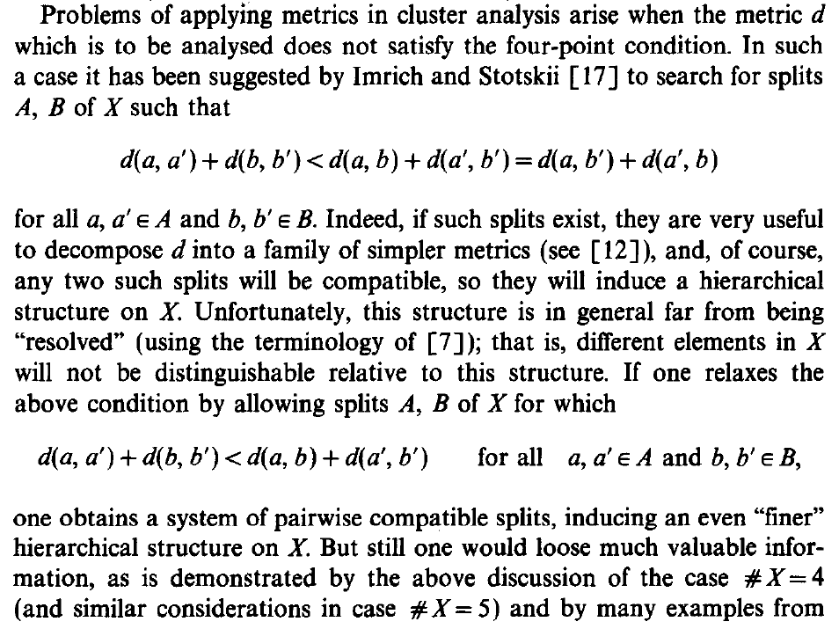 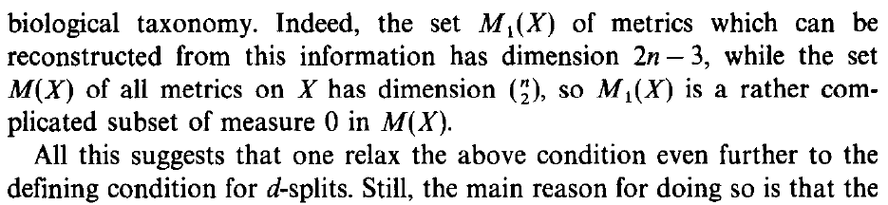

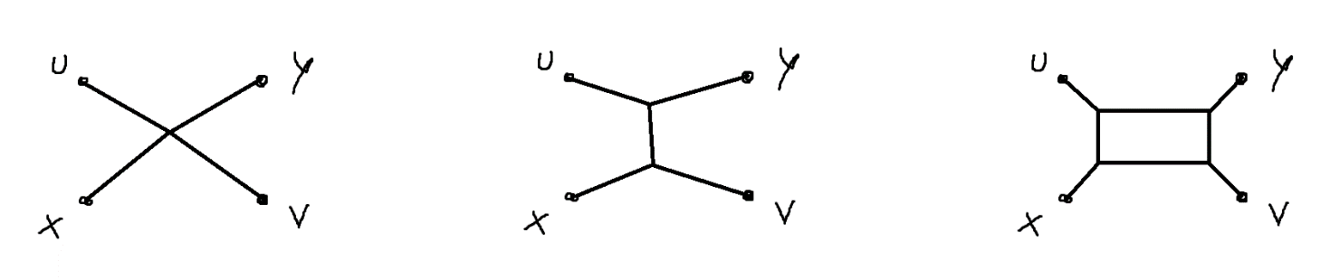

$$aa^{'}+bb^{'}<ab+a^{'}b^{'}=ab^{'}+a'b$$

$$aa^{'}+bb^{'}<ab+a^{'}b^{'}, ab^{'}+a'b \\ aa^{'}+bb^{'}<\min{\{ab+a^{'}b^{'},ab^{'}+a'b\}}$$

$$aa^{'}+bb^{'}<\max{\{ab+a^{'}b^{'},ab^{'}+a'b\}}$$

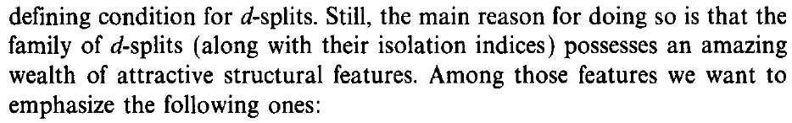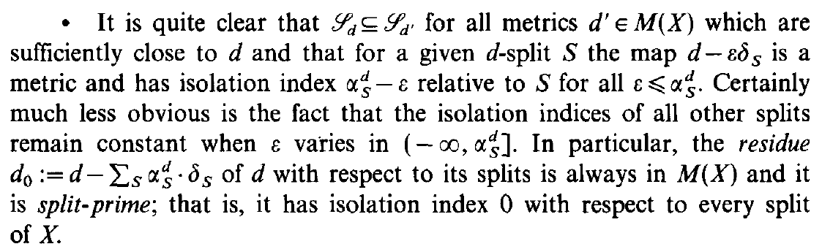

**Prop**. Let $d$ be a pseudo-metric, $S$ a $d$-split and $ε≤α_{S}^{d}$.

Then $d^{'}≔d-εδ_{S}$ is a pseudo-metric, $α_{S}^{d^{'}}=α_{S}^{d}-ε$ 
 and $α_{T}^{d^{'}}=α_{T}^{d}, ∀ T≠S$.

In particular, the residue $d_{0}≔d-\sum_{S ∈ S(X)}{α_{S}^{d}⋅δ_{S}}$  
 is a pseudo-metric and it is split-prime,  
 that is $α_{S}^{d_{0}}=0, ∀ S∈S(X)$.

**Dim**. It is a consequence of **Teo**. 2.

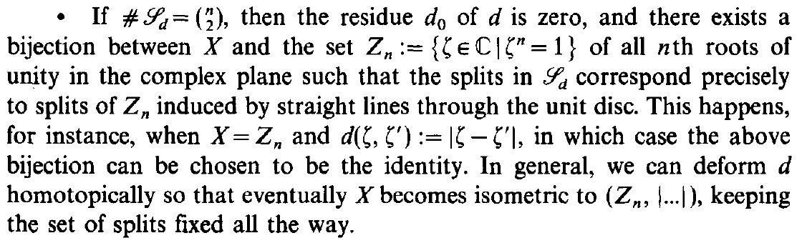

La prima riga è il **Cor**. 5; il resto è conseguenza di (ii) -> (i) del **Teo**. 5 con una riformulazione di circular split. L’ultima frase non viene dimostrata.

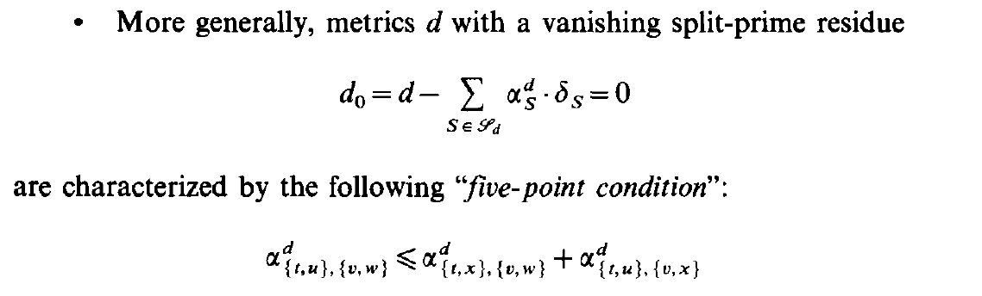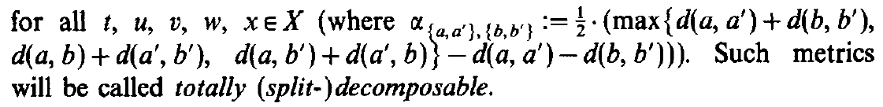

Questo è (i) => (iv) del **Teo**. 6.

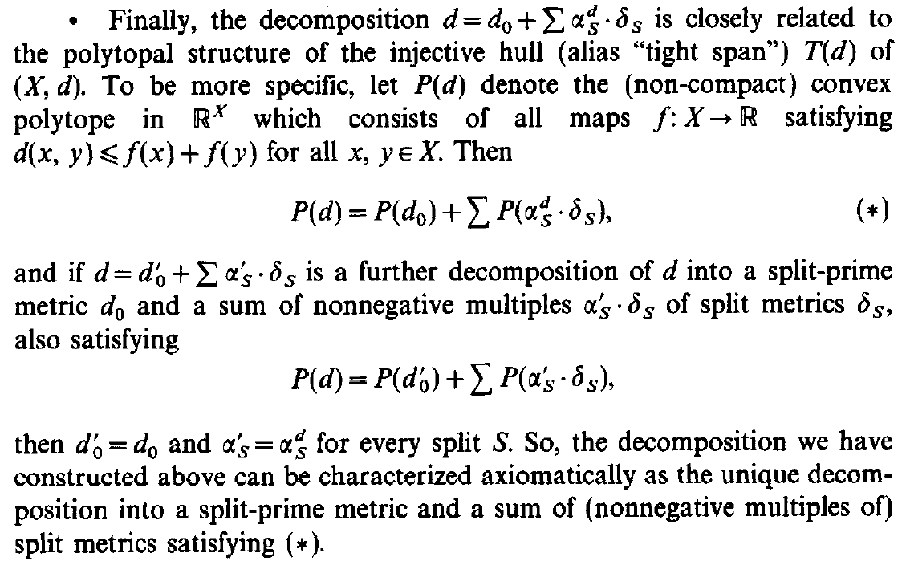

Questo è il **Teo**. 8.

Chapter 2: Decomposition via $d$-Splits

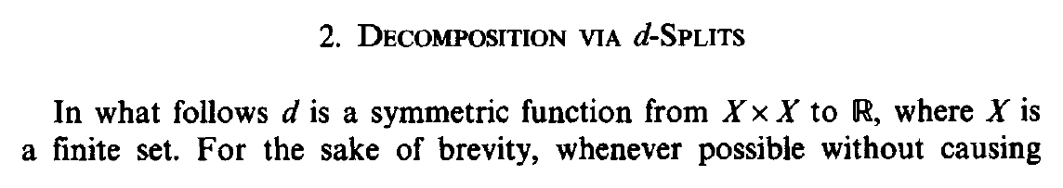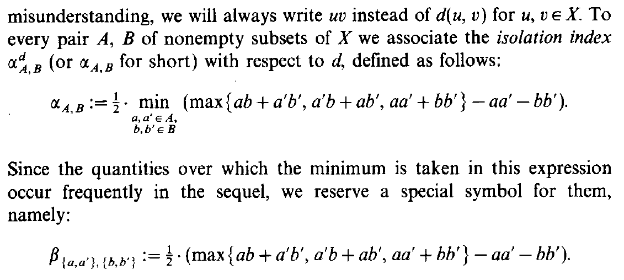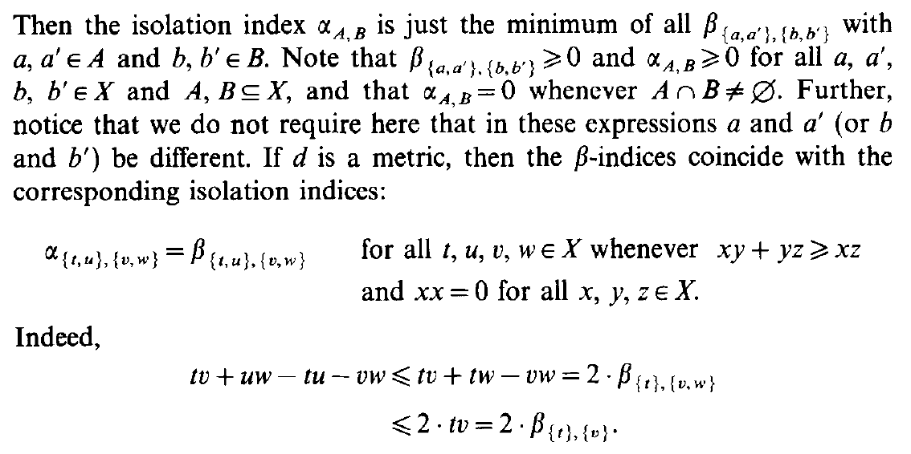

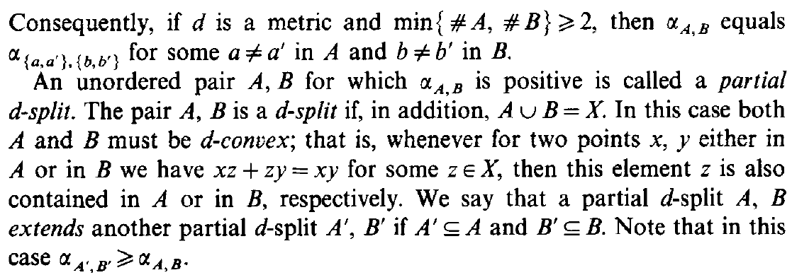

Let $d :X×X→R$ be a symmetric function.

**Not**. $uv≔d\left(u,v\right), ∀ u,v∈X$

In the following we will implicitly refer to $d$.

**Def**. (isolation index)

Let $A, B$ be non-empty subset of $X$. Then for every $a,a^{'}∈A$ and $b,b^{'}∈B$

$$β_{\{a,a^{'}\}, \{b,b^{'}\}}≔\frac{1}{2}\left( \max\left\{ab+a^{'}b^{'},a^{'}b+ab^{'},aa^{'}+bb^{'}\right\}-aa^{'}-bb^{'} \right)$$

$$α_{A,B}≔\min_{\begin{aligned}a,a^{'} ∈ A \\ b,b^{'} ∈ B\end{aligned}}{β_{\{a,a^{'}\}, \{b,b^{'}\}}}$$

We call $α_{A,B}=α_{A,B}^{d}$ the **isolation index** with respect to $d$.

**Oss**. We have $β_{\{a,a^{'}\}, \{b,b^{'}\}}≥0, ∀ a,a^{'}∈A, b,b^{'}∈B$  
since we are subtracting a term that is inside the maximum:

$$\max\left\{ab+a^{'}b^{'},a^{'}b+ab^{'},aa^{'}+bb^{'}\right\}≥aa^{'}+bb^{'}$$

It follows that also $α_{A,B}≥0, ∀ A,B⊆X$.

**Oss**. If $A$ and $B$ intersect, then $α_{A,B}=0$.

In fact, let $x∈A∩B$. Then

$$β_{\left\{x\right\}, \left\{x\right\}}=\frac{1}{2}\left( \max\left\{xx+xx,xx+xx,xx+xx\right\}-xx-xx \right) \\ =\frac{1}{2}\left(xx+xx-xx-xx\right)=0$$

and so $α_{A,B}=0$.

**Prop**. If $d$ is a pseudo-metric, then $∀ t,u,v,w∈X$

$$α_{\{t,u\}, \{v,w\}}=β_{\{t,u\}, \{v,w\}}$$

**Dim**. By (reverse) triangle inequality and the fact that $d$ vanishes on the diagonal, we observe that

$$β_{\left\{t\right\},\left\{v,w\right\}}=\frac{1}{2}\left( \max\left\{tv+tw,tv+tw,tt+vw\right\}-tt-vw \right) \\ =\frac{1}{2}\left(tv+tw-vw\right) \\ ≤\frac{1}{2}\left(tv+tv\right) \\ =\frac{1}{2}\left( \max\left\{tv+tv,tv+tv,tt+vv\right\}-tt-vv \right) \\ =β_{\left\{t\right\},\left\{v\right\}}$$

where we used $tv+tw≥vw$ in the first line  
 and $tw-vw≤tv$ in the second one.

With analogous calculations we get

$$\begin{matrix}β_{\left\{t\right\},\left\{v,w\right\}}≤β_{\left\{t\right\},\left\{v\right\}}, & β_{\left\{t\right\},\left\{v,w\right\}}≤β_{\left\{t\right\},\left\{w\right\}} \\ β_{\left\{u\right\},\left\{v,w\right\}}≤β_{\left\{u\right\},\left\{v\right\}}, & β_{\left\{u\right\},\left\{v,w\right\}}≤β_{\left\{u\right\},\left\{w\right\}} \\ β_{\left\{t,u\right\},\left\{v\right\}}≤β_{\left\{t\right\},\left\{v\right\}}, & β_{\left\{t,u\right\},\left\{v\right\}}≤β_{\left\{u\right\},\left\{v\right\}} \\ β_{\left\{t,u\right\},\left\{w\right\}}≤β_{\left\{t\right\},\left\{w\right\}}, & β_{\left\{t,u\right\},\left\{w\right\}}≤β_{\left\{u\right\},\left\{w\right\}}\end{matrix}$$

Again by (reverse) triangle inequality

$$tv+uw-tu-vw≤tv+tw-vw=2β_{\left\{t\right\},\left\{v,w\right\}} \\ ≤uv+uw-vw=2β_{\left\{u\right\},\left\{v,w\right\}} \\ ≤tv+uv-tu=2β_{\left\{t,u\right\},\left\{v\right\}} \\ ≤tw+uw-tu=2β_{\left\{t,u\right\},\left\{w\right\}} \\ uv+tw-tu-vw≤tv+tw-vw=2β_{\left\{t\right\},\left\{v,w\right\}} \\ ≤uv+uw-vw=2β_{\left\{u\right\},\left\{v,w\right\}} \\ ≤tv+uv-tu=2β_{\left\{t,u\right\},\left\{v\right\}} \\ ≤tw+uw-tu=2β_{\left\{t,u\right\},\left\{w\right\}}$$

Since

$$β_{\{t,u\}, \{v,w\}}=\frac{1}{2}\left( \max\left\{tv+uw,uv+tw,tu+vw\right\}-tu-vw \right)$$

we have proven that $β_{\{t,u\}, \{v,w\}}$ is smaller than all other possible $β$ indices for the quartet $\left\{\left\{t,u\right\}, \left\{v,w\right\}\right\}$.

This implies by definition of the isolation index

$$α_{\{t,u\}, \{v,w\}}=β_{\{t,u\}, \{v,w\}}$$

**Cor**. If $d$ is a pseudo-metric and $\min{\{\left|A\right|,|B|\}}≥2$  
 (that is both $A$ and $B$ have at least 2 elements), then

$$α_{A,B}=α_{\{a,a^{'}\}, \{b,b^{'}\}}$$

for some $a≠a^{'}∈A$ and $b≠b^{'}∈B$.

**Dim**. Let $\left\{\left\{a,a^{'}\right\}, \left\{b,b^{'}\right\}\right\}$ be the quartet that minimizes the $β$ index.

Then, for the previous inequalities about $β$ indices  
 and the hypothesis on the number of elements of $A$ and $B$,   
we conclude that $a≠a^{'}$ and $b≠b^{'}$.

Using the previous **Prop**.

$$α_{A,B}=β_{\{a,a^{'}\}, \{b,b^{'}\}}=α_{\{a,a^{'}\}, \{b,b^{'}\}}$$

**Def**. (splits and $d$-splits)

A **partial split** (of $X$) is a pair $\{A,B\}$ with $A,B⊆X$.  
A **(total) split** (of $X$) is partial split $\{A,B\}$ such that $A∪B=X$.

A partial/total $d$**-split** is a partial/total split $\{A,B\}$ such that $α_{A,B}^{d}>0$.  
Notice that in this case $A$ and $B$ must be disjoint.

We call a split **trivial** if one of the parts contains only one element.  
A partial split of the form $\left\{\left\{a,a^{'}\right\}, \left\{b,b^{'}\right\}\right\}$ is called **quartet**.

We denote the set of all splits of $X$ with $S(X)$  
 and the set of all $d$-splits of $X$ with $S_{d}(X)$.

Given $Y⊂X$ and a split $\{A,B\}$ of $Y$, we have $α_{A,B}^{d}=α_{A,B}^{d{\left.​\right|}_{Y×Y}}$.  
For this reason, we may refer to the $d{\left.​\right|}_{Y×Y}$-splits as $d$-split of $Y$  
 and indicate them with $S_{d}(Y)$.

**Def**. ($d$-convex set)

A set $S⊆X$ is $d$**-convex** if

$$∀ x,y∈S, ∀ z∈X, xz+zy=xy ⟹ z∈S$$

**Prop**. If $\{A,B\}$ is a $d$-split, then $A$ and $B$ are $d$-convex.

**Dim**. Let $x,y∈A$ and $z∈X$ such that $xz+zy=xy$.

Since $X=A∪B$, we have $z∈A$ or $z∈B$.  
If by absurd $z∈B$, then

$$β_{\left\{x,y\right\},\left\{z\right\}}=\frac{1}{2}\left( \max\left\{xz+yz,xz+yz,xy+zz\right\}-xy-zz \right) \\ =\frac{1}{2}\left(xz+yz-xy\right)=\frac{1}{2}\left(xy-xy\right)=0$$

that implies . ⭍

Then it must be $z∈A$ and so $A$ is $d$-convex.

**Def**. (extension of $d$-splits)

We say that a partial $d$-split $\{A,B\}$**extends** another partial $d$-split $\{A',B'\}$  
 if $A⊇A'$ and $B⊇B'$ (or $A⊇B'$ and $B⊇A'$).   
We denote it $\{A,B\}≽\{A',B'\}$.

Notice that $α_{A,B}≤α_{A^{'},B^{'}}$ (it’s a minimum on a larger set).

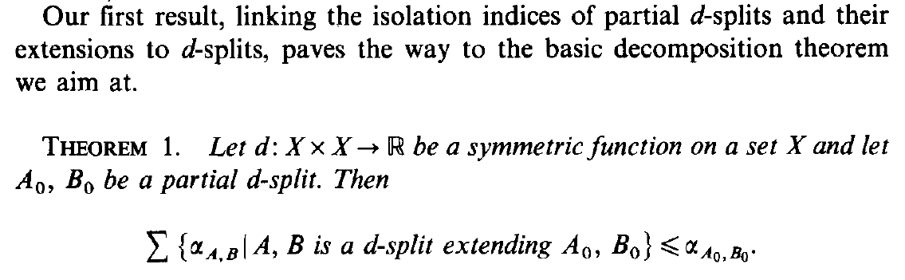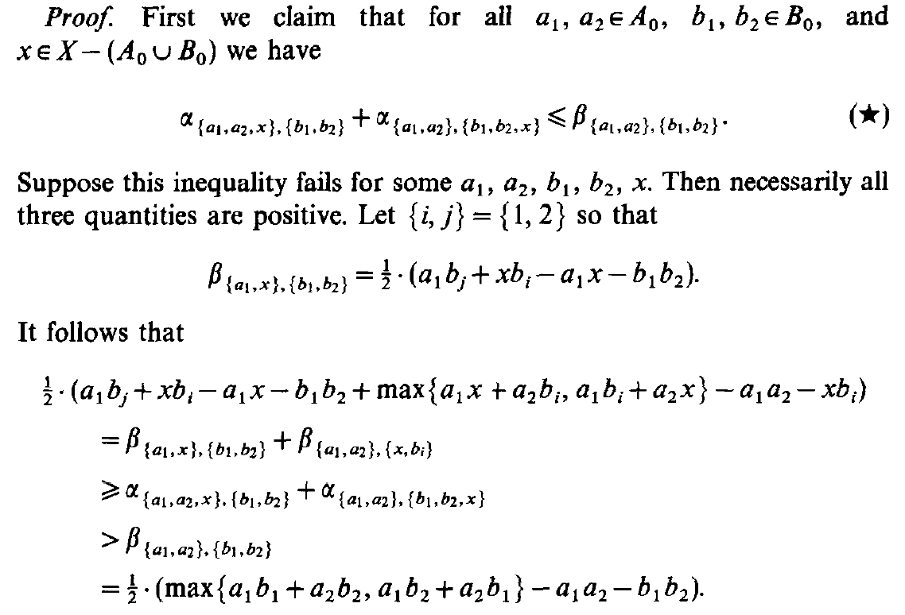

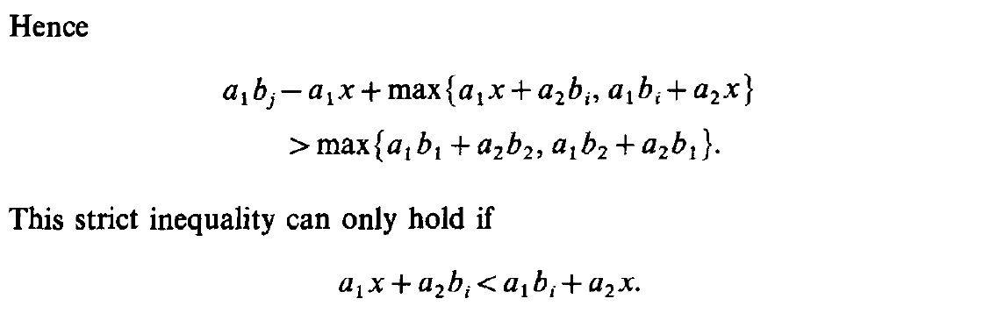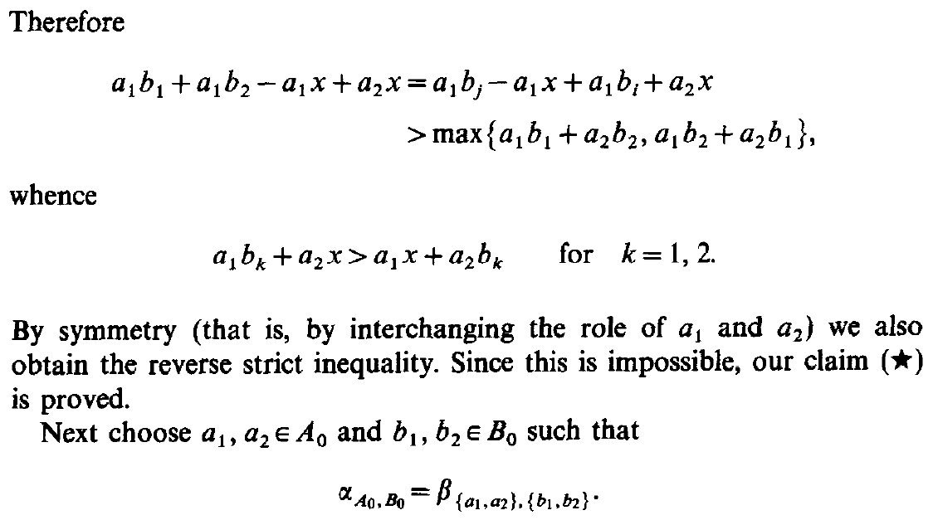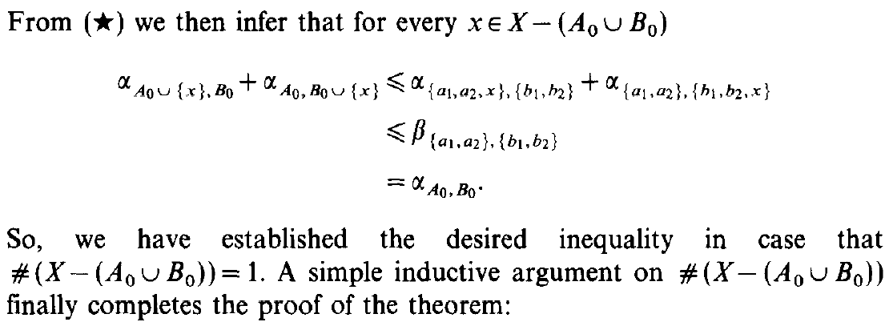

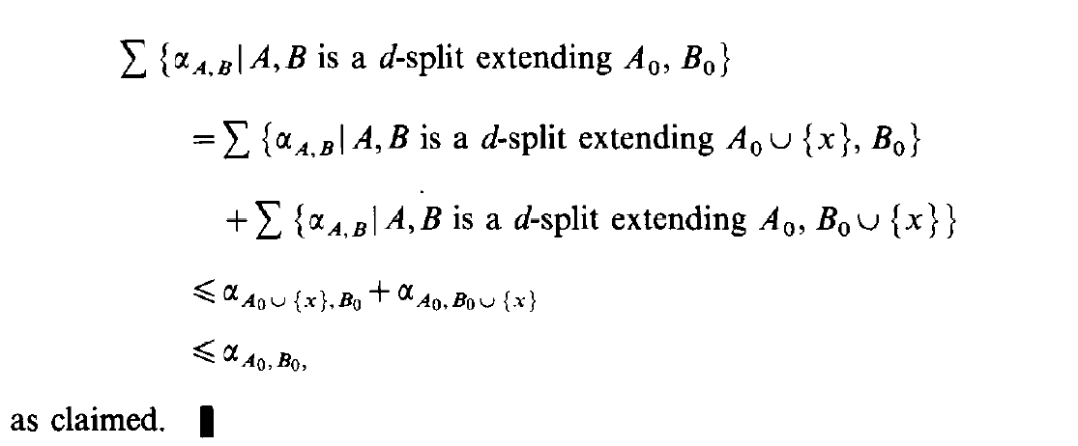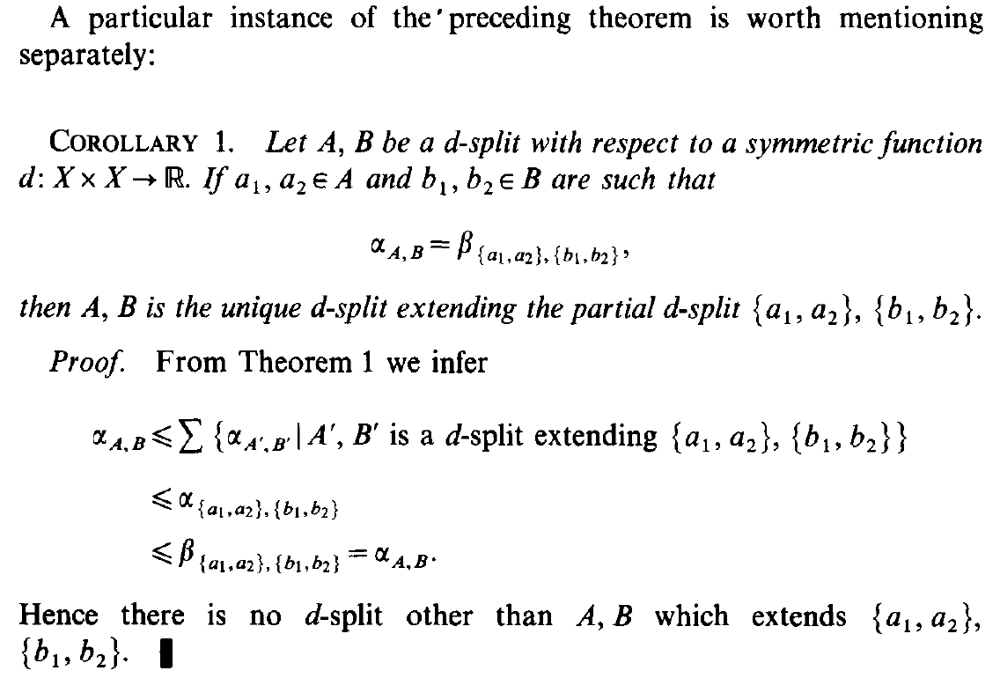

**Lemma** Let $\{A,B\}$ be a partial $d$-split.   
Then for every $a_{1},a_{2}∈A, b_{1},b_{2}∈B, x∈X \backslash (A∪B)$

$$α_{\left\{a_{1},a_{2},x\right\},\{b_{1},b_{2}\}}+α_{\left\{a_{1},a_{2}\right\},\{b_{1},b_{2},x\}}≤β_{\left\{a_{1},a_{2}\right\},\{b_{1},b_{2}\}}$$

**Dim**. Suppose by absurd that

$$α_{\left\{a_{1},a_{2},x\right\},\{b_{1},b_{2}\}}+α_{\left\{a_{1},a_{2}\right\},\{b_{1},b_{2},x\}}>β_{\left\{a_{1},a_{2}\right\},\{b_{1},b_{2}\}}$$

Observe that $β_{\left\{a_{1},a_{2}\right\},\{b_{1},b_{2}\}}>0$ since $\{A,B\}$ is a $d$-split, so also

$$α_{\left\{a_{1},a_{2},x\right\},\{b_{1},b_{2}\}}>0 , α_{\left\{a_{1},a_{2}\right\},\{b_{1},b_{2},x\}}>0$$

From this we have

$$β_{\left\{a_{1},x\right\},\left\{b_{1},b_{2}\right\}}≥α_{\left\{a_{1},a_{2},x\right\},\left\{b_{1},b_{2}\right\}}>0$$

$$β_{\left\{a_{1},a_{2}\right\},\left\{x,b_{i}\right\}}≥α_{\left\{a_{1},a_{2}\right\},\left\{b_{1},b_{2},x\right\}}>0, i=1,2$$

Let $\left\{i,j\right\}=\{1, 2\}$ so that

$$β_{\left\{a_{1},x\right\},\{b_{1},b_{2}\}}=\frac{1}{2}(a_{1}b_{j}+xb_{i}-a_{1}x-b_{1}b_{2})$$

in fact, since $β_{\left\{a_{1},x\right\},\{b_{1},b_{2}\}}>0$, the maximum

$$\max{\{a_{1}b_{1}+xb_{2},a_{1}b_{2}+xb_{1},a_{1}x+b_{1}b_{2}\}}$$

cannot be $a_{1}x+b_{1}b_{2}$.

For the same reason we have

$$β_{\left\{a_{1},a_{2}\right\},\left\{x,b_{i}\right\}}=\frac{1}{2}( \max\left\{a_{1}x+a_{2}b_{i},a_{1}b_{i}+a_{2}x\right\}-a_{1}a_{2}-xb_{i} )$$

$$β_{\left\{a_{1},a_{2}\right\},\{b_{1},b_{2}\}}=\frac{1}{2}( \max\left\{a_{1}b_{1}+a_{2}b_{2},a_{1}b_{2}+a_{2}b_{1}\right\}-a_{1}a_{2}-b_{1}b_{2} )$$

From the previous inequalities we have

$$β_{\left\{a_{1},x\right\},\left\{b_{1},b_{2}\right\}}+β_{\left\{a_{1},a_{2}\right\},\left\{x,b_{i}\right\}}≥ \\ ≥α_{\left\{a_{1},a_{2},x\right\},\left\{b_{1},b_{2}\right\}}+α_{\left\{a_{1},a_{2}\right\},\left\{b_{1},b_{2},x\right\}}>β_{\left\{a_{1},a_{2}\right\},\{b_{1},b_{2}\}}$$

and by substituting the expressions for the $β$ indices

$$\frac{1}{2}\left(a_{1}b_{j}+xb_{i}-a_{1}x-b_{1}b_{2}+\max\left\{a_{1}x+a_{2}b_{i},a_{1}b_{i}+a_{2}x\right\}-a_{1}a_{2}-xb_{i}\right)> \\ >\frac{1}{2}( \max\left\{a_{1}b_{1}+a_{2}b_{2},a_{1}b_{2}+a_{2}b_{1}\right\}-a_{1}a_{2}-b_{1}b_{2} )$$

simplifying we obtain

$$a_{1}b_{j}-a_{1}x+\max\left\{a_{1}x+a_{2}b_{i},a_{1}b_{i}+a_{2}x\right\}>\max\left\{a_{1}b_{1}+a_{2}b_{2},a_{1}b_{2}+a_{2}b_{1}\right\}$$

If by absurd $\max\left\{a_{1}x+a_{2}b_{i},a_{1}b_{i}+a_{2}x\right\}=a_{1}x+a_{2}b_{i}$,  
the previous inequality would become

$$a_{1}b_{j}-a_{1}x+a_{1}x+a_{2}b_{i}>\max\left\{a_{1}b_{1}+a_{2}b_{2},a_{1}b_{2}+a_{2}b_{1}\right\}$$

but since $a_{1}b_{j}+a_{2}b_{i}$ is a term of the maximum on the right, this is a contradiction. ⭍

So we must have $a_{1}x+a_{2}b_{i}<a_{1}b_{i}+a_{2}x$ and thus

$$a_{1}b_{j}-a_{1}x+a_{1}b_{i}+a_{2}x=a_{1}b_{1}+a_{1}b_{2}-a_{1}x+a_{2}x \\ >\max\left\{a_{1}b_{1}+a_{2}b_{2},a_{1}b_{2}+a_{2}b_{1}\right\}$$

For this to be true we need

$$a_{1}b_{k}+a_{2}x>a_{1}x+a_{2}b_{k}, k=1, 2$$

By symmetry, interchanging $a_{1}$ and $a_{2}$,  
 we obtain the other strict inequality. ⭍

**Teo**. 1 Let $\{A_{0},B_{0}\}$ be a partial $d$-split. Then

$$\sum{\left\{ α_{A,B} | \left\{A,B\right\}∈S\left(X\right) , \left\{A,B\right\}≽\left\{A_{0},B_{0}\right\}\right\}}≤α_{A_{0},B_{0}}$$

**Dim**. Let $a_{1},a_{2}∈A_{0}$ and $b_{1},b_{2}∈B_{0}$ such that

$$α_{A_{0},B_{0}}=β_{\left\{a_{1},a_{2}\right\},\{b_{1},b_{2}\}}$$

From the previous **Lemma** we have $∀ x∈X \backslash (A_{0}∪B_{0})$

$$α_{A_{0}∪\left\{x\right\},B_{0}}+α_{A_{0},B_{0}∪\left\{x\right\}}≤α_{\left\{a_{1},a_{2},x\right\},\left\{b_{1},b_{2}\right\}}+α_{\left\{a_{1},a_{2}\right\},\left\{b_{1},b_{2},x\right\}} \\ ≤β_{\left\{a_{1},a_{2}\right\},\left\{b_{1},b_{2}\right\}} \\ =α_{A_{0},B_{0}}$$

This proves the theorem in the case $\left| X \backslash \left(A_{0}∪B_{0}\right) \right|=1$.

We prove the general case by induction on $\left| X \backslash \left(A_{0}∪B_{0}\right) \right|$.  
We have already seen the base case.

Let $\left| X \backslash \left(A_{0}∪B_{0}\right) \right|=n>1$ and $x∈X \backslash (A_{0}∪B_{0})$.

Observe that the $d$-splits extending $\left\{A_{0},B_{0}\right\}$ are exactly   
the union of those extending $\left\{A_{0}∪\left\{x\right\},B_{0}\right\}$ and those extending $\left\{A_{0},B_{0}∪\left\{x\right\}\right\}$.   
In fact, since $d$-splits are partitions, if $\{A,B\}$ extends $\left\{A_{0},B_{0}\right\}$ (say WLOG $A⊇A_{0}$ and $B⊇B_{0}$), it must be $x∈A$ or $x∈B$;  
that is $A⊇A_{0}∪\left\{x\right\}$ or $B⊇B_{0}∪\left\{x\right\}$.

Moreover,

$$\left| X \backslash \left(\left\{A_{0}∪\left\{x\right\}\right\}∪B_{0}\right) \right|=n-1$$

$$\left| X \backslash \left(A_{0}∪\left\{B_{0}∪\left\{x\right\}\right\}\right) \right|=n-1$$

So we can apply the inductive step:

$$\sum{\left\{ α_{A,B} | \left\{A,B\right\}∈S\left(X\right) , \left\{A,B\right\}≽\left\{A_{0},B_{0}\right\}\right\}}=$$

$$=\sum{\left\{ α_{A,B} | \left\{A,B\right\}∈S\left(X\right) , \left\{A,B\right\}≽\left\{A_{0}∪\left\{x\right\},B_{0}\right\}\right\}}+ \\ \sum{\left\{ α_{A,B} | \left\{A,B\right\}∈S\left(X\right) , \left\{A,B\right\}≽\left\{A_{0},B_{0}∪\left\{x\right\}\right\}\right\}}≤$$

$$≤α_{A_{0}∪\left\{x\right\},B_{0}}+α_{A_{0},B_{0}∪\left\{x\right\}}≤α_{A_{0},B_{0}}$$

**Oss**. We can substitute splits with $d$-splits in the sum  
 (splits that are not $d$-splits do not contribute).

**Cor**. 1 Let $\{A,B\}$ a $d$-split and let $a_{1},a_{2}∈A$ and $b_{1},b_{2}∈B$ such that

$$α_{A,B}=β_{\left\{a_{1},a_{2}\right\},\{b_{1},b_{2}\}}$$

Then $\{A,B\}$ is the unique $d$-split that extends $\left\{\left\{a_{1},a_{2}\right\},\left\{b_{1},b_{2}\right\}\right\}$.

**Dim**. Observe that $\left\{\left\{a_{1},a_{2}\right\},\left\{b_{1},b_{2}\right\}\right\}$ is a partial $d$-split.  
In fact, if by absurd

$$α_{\left\{a_{1},a_{2}\right\},\{b_{1},b_{2}\}}=β_{\left\{a_{1},a_{2}\right\},\{b_{1},b_{2}\}}=0$$

then $α_{A,B}=0$, but $\{A,B\}$ is a $d$-split. ⭍

By applying **Teo**. 1

$$α_{A,B}≤\sum{\left\{ α_{A^{'},B^{'}} | \begin{aligned}\left\{A^{'},B^{'}\right\}∈S_{d}\left(X\right) , \\ \left\{A^{'},B^{'}\right\}≽\left\{\left\{a_{1},a_{2}\right\},\left\{b_{1},b_{2}\right\}\right\}\end{aligned} \right\}} \\ ≤α_{\left\{a_{1},a_{2}\right\},\left\{b_{1},b_{2}\right\}} \\ ≤β_{\left\{a_{1},a_{2}\right\},\left\{b_{1},b_{2}\right\}}=α_{A,B}$$

Since the sum is equal to $α_{A,B}$ and $\{A,B\}$ is a member of the range of the sum, this means that $\{A,B\}$ is the only $d$-split that extends $\left\{\left\{a_{1},a_{2}\right\},\left\{b_{1},b_{2}\right\}\right\}$.

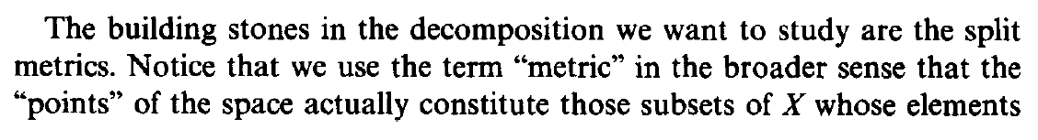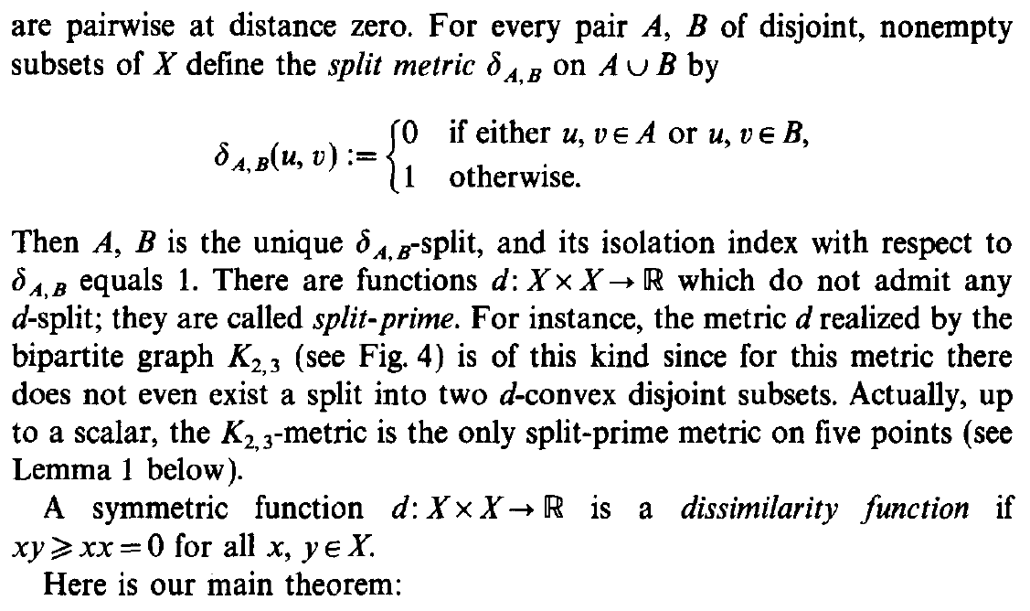

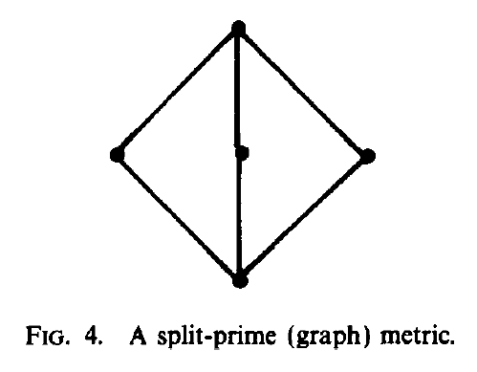

**Def**. Given $A,B$ non-empty disjoint subsets of $X$,   
the **split metric $δ_{A,B}$** on $A∪B$ is defined as

$$δ_{A,B}\left(u,v\right) :=\left\{ \begin{matrix}0 , \text{if} u,v∈A \text{or} u,v∈B \\ 1 , \text{otherwise}\end{matrix}\right.$$

Questa definizione è leggermente diversa da quella data precedentemente perché non si richiede $A∪B=X$.

**Oss**. $\{A,B\}$ is the only $δ_{A,B}$-split and its isolation index is 1.

In fact, let us consider $\{A,B\}$ and another split $\{A',B'\}$, with the following intersections: $A∩A^{'}, A∩B^{'}, B∩A^{'}, B∩B^{'}$.  
Since $A∪B=A^{'}∪B^{'}=X$ and $A,B,A^{'},B^{'}≠∅$,  
at least two of these intersection must be non-empty.   
We can divide in cases.

If all the intersections are non-empty, we can pick

$$a_{1}∈A∩A^{'}, a_{2}∈A∩B^{'}, b_{1}∈B∩A^{'}, b_{2}∈B∩B'$$

then, with respect to $δ_{A,B}$, we have

$$a_{1}b_{1}+a_{2}b_{2}=1+1=2 \\ a_{1}b_{2}+a_{2}b_{1}=1+1=2 \\ a_{1}a_{2}+b_{1}b_{2}=0+0=0$$

$$β_{\left\{a_{1},b_{1}\right\},\left\{a_{2},b_{2}\right\}}=\frac{1}{2}\left( \max\left\{\begin{aligned}a_{1}b_{1}+a_{2}b_{2}, \\ a_{1}b_{2}+a_{2}b_{1}, \\ a_{1}a_{2}+b_{1}b_{2}\end{aligned}\right\}-a_{1}b_{1}-a_{2}b_{2} \right)=0$$

so $α_{A^{'},B^{'}}=0$.

If only three of the intersections are non-empty  
 – say WLOG $A∩A^{'}, B∩A^{'}, B∩B^{'}$– then we can pick

$$a_{1}∈A∩A^{'}, b_{1}∈B∩A^{'}, b_{2}∈B∩B'$$

then, with respect to $δ_{A,B}$, we have

$$a_{1}b_{1}+b_{2}b_{2}=1+0=1 \\ a_{1}b_{2}+b_{1}b_{2}=1+0=1$$

$$β_{\left\{a_{1},b_{1}\right\},\left\{b_{2}\right\}}=\frac{1}{2}\left( \max\left\{\begin{aligned}a_{1}b_{1}+b_{2}b_{2}, \\ a_{1}b_{2}+b_{1}b_{2}\end{aligned}\right\}-a_{1}b_{1}-b_{2}b_{2} \right)=0$$

so $α_{A^{'},B^{'}}=0$.

If only two intersections are non-empty  
 – say WLOG $A∩A^{'}, B∩B^{'}$– then $\left\{A,B\right\}=\{A^{'},B'\}$.   
In fact, since $A∪B=X$ and $A∩B^{'}, B∩A^{'}=∅$,  
 then we have $A^{'}⊆A$ and $B^{'}⊆B$.  
But since $A'∪B'=X$, it must be $A^{'}=A$ and $B^{'}=B$.

Now for every $a_{1},a_{2}∈A$ and $b_{1},b_{2}∈B$ (with respect to $δ_{A,B}$)

$$a_{1}b_{1}+a_{2}b_{2}=1+1=2 \\ a_{1}b_{2}+a_{2}b_{1}=1+1=2 \\ a_{1}a_{2}+b_{1}b_{2}=0+0=0$$

$$β_{\left\{a_{1},a_{2}\right\},\left\{b_{1},b_{2}\right\}}=\frac{1}{2}\left( \max\left\{\begin{aligned}a_{1}b_{1}+a_{2}b_{2}, \\ a_{1}b_{2}+a_{2}b_{1}, \\ a_{1}a_{2}+b_{1}b_{2}\end{aligned}\right\}-a_{1}a_{2}-b_{1}b_{2} \right)=1$$

so $α_{A,B}=1$.

**Def**. (split-prime function)

A function $d :X×X→R$ is **split-prime** if it does not admit any $d$-split.

$$S_{d}\left(X\right)=∅$$

**Def**. (dissimilarity function)

A function $d :X×X→R$ is a **dissimilarity function** if

$d\left(x,y\right)=d\left(y,x\right), ∀ x,y∈X$

$d\left(x,x\right)=0, ∀ x∈X$

$d\left(x,y\right)≥0, ∀ x,y∈X$

In practice, it is a pseudo-metric without triangle inequality.

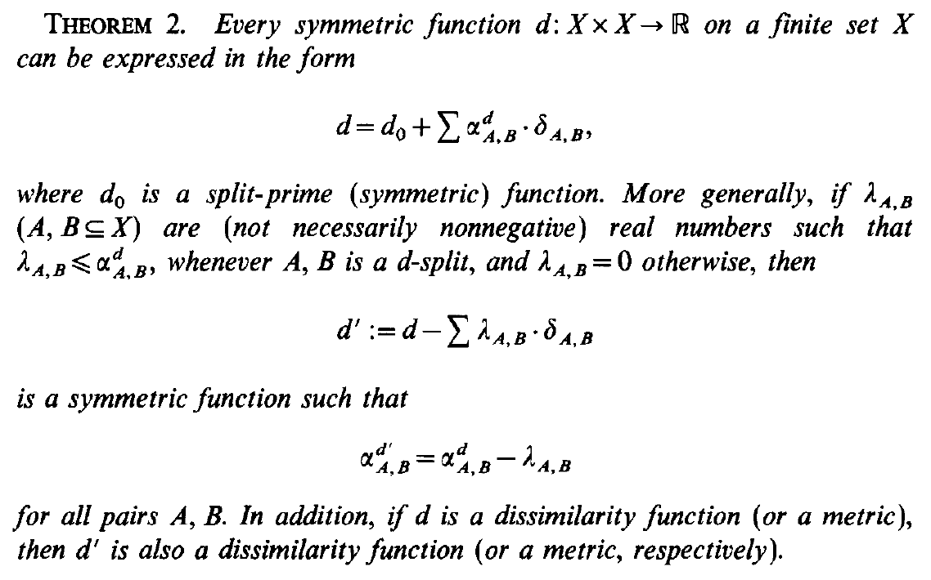

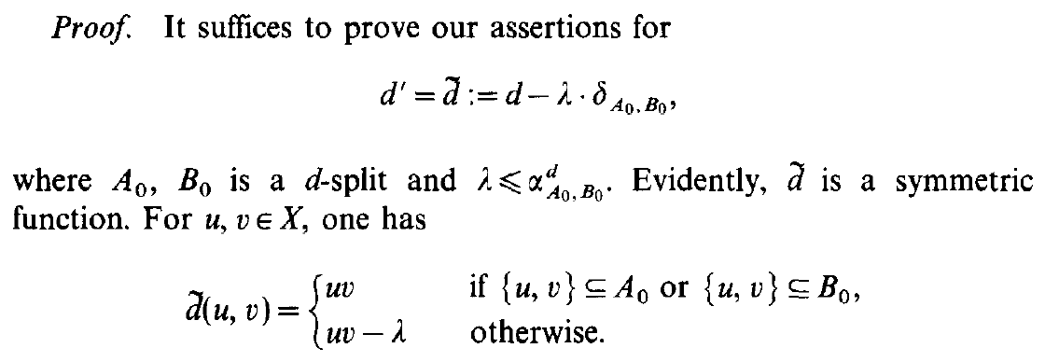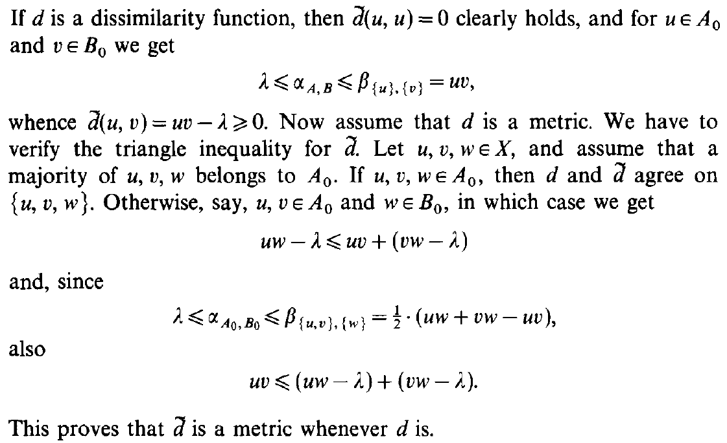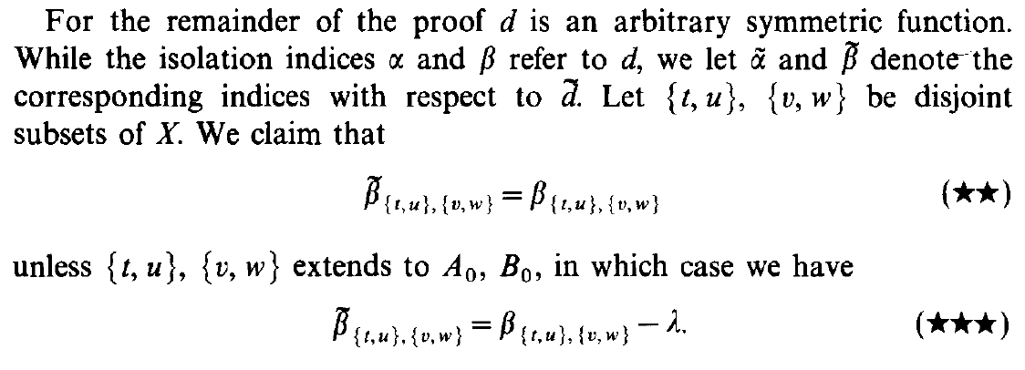

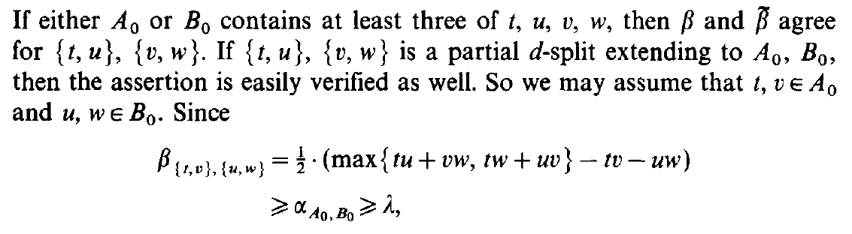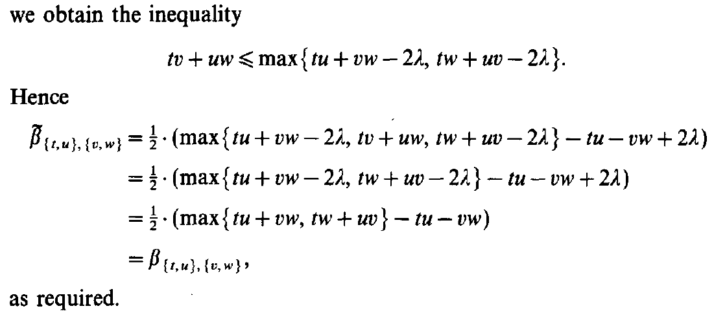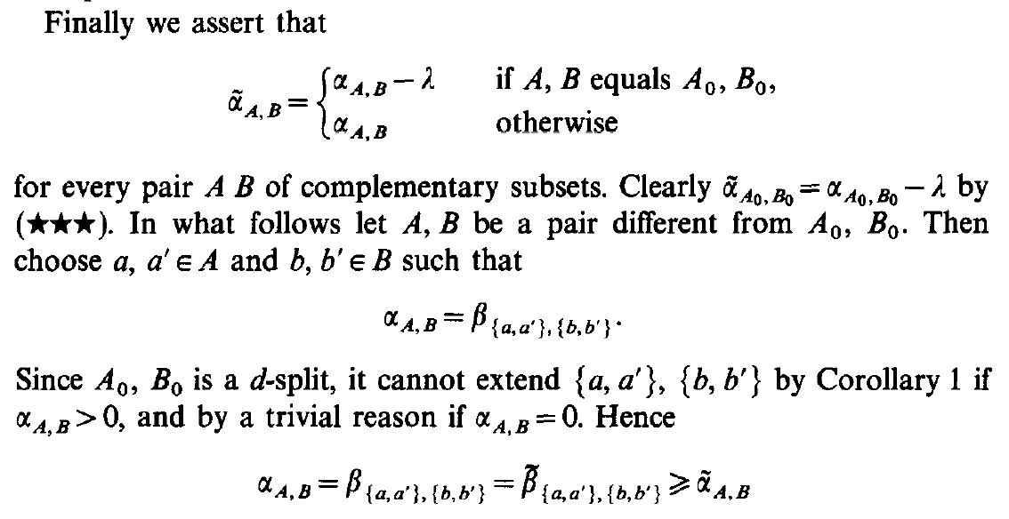

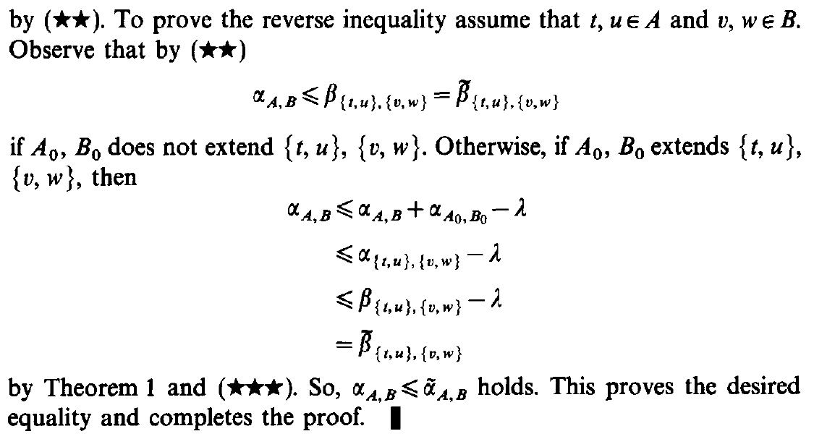

**Teo**. 2 Let $d :X×X→R$ be a symmetric function.  
Let $λ_{S}∈R$ such that $λ_{S}≤α_{S}^{d}$ if $S$ is a $d$-split  
 and $λ_{S}=0$ otherwise.  
Then $$d^{'}≔d-\sum_{S ∈ S(X)}{λ_{S}⋅δ_{S}}$$

is a symmetric function such that

$$α_{S}^{d^{'}}=α_{S}^{d}-λ_{S} , ∀ S∈S(X)$$

In addition, if $d$ is a dissimilarity function (or a pseudo-metric),  
then $d'$ is also a dissimilarity function (or a pseudo-metric).

**Dim**. It suffices to prove the assertions for

$$d^{'}=\tilde{d}≔d-λ⋅δ_{A_{0},B_{0}}$$

where $\{A_{0},B_{0}\}$ is a $d$-split and $λ≤α_{A_{0},B_{0}}^{d}$.

Then the general case follows by subtracting one split metric at a time (formally induction on the number of non-zero $λ$’s).

We use the following notation: $uv=d\left(u,v\right), ∀ u,v∈X$

$$α=α^{d}, β=β^{d}, \tilde{α}=α^{\tilde{d}}, \tilde{β}=β^{\tilde{d}}$$

Clearly $\tilde{d}$ is a symmetric function (since $d$ and $δ$ are such).

For every $u,v∈X$ we have

$$\tilde{d}\left(u,v\right)=\left\{ \begin{matrix}uv , & if \left\{u,v\right\}⊆A_{0} or \left\{u,v\right\}⊆B_{0} \\ uv-λ , & otherwise\end{matrix}\right.$$

Suppose that $d$ is a dissimilarity function.

Then $\tilde{d}\left(u,u\right)=d\left(u,u\right)=0$. For $u∈A_{0}$ and $v∈B_{0}$ we have

$$λ≤α_{A_{0},B_{0}}≤β_{\left\{u\right\},\left\{v\right\}}=uv$$

thus $\tilde{d}\left(u,v\right)=uv-λ≥0$, so $\tilde{d}$ is a dissimilarity function.

Now suppose that $d$ is a pseudo-metric.   
We have to verify the triangle inequality for $\tilde{d}$.

Let $u,v,w∈X$. If they all belong to $A_{0}$ or all to $B_{0}$,  
 then $d$ and $\tilde{d}$ agrees on $\{u,v,w\}$ and we are done.  
Otherwise, say WLOG $u,v∈A_{0}$ and $w∈B_{0}$, then we get

$$λ≤α_{A_{0},B_{0}}≤β_{\left\{u,v\right\},\left\{w\right\}} \\ =\frac{1}{2}\left( \max\left\{uw+vw,uv+ww\right\}-uv-ww \right) \\ =\frac{1}{2}\left(uw+vw-uv\right)$$

where we used the triangle inequality for $d$, and by rearranging

$$\underset{\tilde{d}\left(u,v\right)}{\underbrace{uv}}≤\underset{\tilde{d}\left(u,w\right)}{\underbrace{\left(uw-λ\right)}}+\underset{\tilde{d}\left(v,w\right)}{\underbrace{\left(vw-λ\right)}}$$

For the remainder of the proof $d$ is a symmetric function.

Let $\left\{t,u\right\},\left\{v,w\right\}$ be disjoint subsets of $X$.  
We claim that

$${\tilde{β}}_{\left\{t,u\right\},\left\{v,w\right\}}=\left\{ \begin{matrix}β_{\left\{t,u\right\},\left\{v,w\right\}}-λ , & if \left\{A_{0},B_{0}\right\}≽\left\{\left\{t,u\right\},\left\{v,w\right\}\right\} \\ β_{\left\{t,u\right\},\left\{v,w\right\}} , & otherwise\end{matrix}\right.$$

Suppose $\left\{A_{0},B_{0}\right\}≽\left\{\left\{t,u\right\},\left\{v,w\right\}\right\}$.   
Since $\left\{A_{0},B_{0}\right\}$ is a $d$-split

$$β_{\left\{t,u\right\},\left\{v,w\right\}}=\frac{1}{2}\left( \max\left\{tv+uw,tw+uv\right\}-tu-vw \right)>0$$

$$λ≤α_{A_{0},B_{0}}≤β_{\left\{t,u\right\},\left\{v,w\right\}}$$

$$2λ≤\max\left\{\begin{aligned}tv+uw, \\ tw+uv\end{aligned}\right\}-tu-vw$$

$$tu+vw≤\max\left\{\begin{aligned}\left(tv-λ\right)+\left(uw-λ\right), \\ \left(tw-λ\right)+\left(uv-λ\right)\end{aligned}\right\}$$

$${\tilde{β}}_{\left\{t,u\right\},\left\{v,w\right\}}=\frac{1}{2}\left( \max\left\{\begin{aligned}\left(tv-λ\right)+\left(uw-λ\right), \\ \left(tw-λ\right)+\left(uv-λ\right), \\ tu+vw\end{aligned}\right\}-tu-vw \right) \\ =\frac{1}{2}\left( \max\left\{\begin{aligned}tv+uw, \\ tw+uv\end{aligned}\right\}-2λ-tu-vw \right) \\ =β_{\left\{t,u\right\},\left\{v,w\right\}}-λ$$

If instead $A_{0}$ or $B_{0}$ contains at least three of $t,u,v,w$  
 – say WLOG $t,u,v∈A_{0}$ and $w∈B_{0}$– then

$${\tilde{β}}_{\left\{t,u\right\},\left\{v,w\right\}}=\frac{1}{2}\left( \max\left\{\begin{aligned}tv+\left(uw-λ\right), \\ \left(tw-λ\right)+uv, \\ tu+\left(vw-λ\right)\end{aligned}\right\}-tu-\left(vw-λ\right) \right)=\frac{1}{2}\left( \max\left\{\begin{aligned}tv+uw, \\ tw+uv, \\ tu+vw\end{aligned}\right\}-λ-tu-\left(vw-λ\right) \right)=β_{\left\{t,u\right\},\left\{v,w\right\}}$$

So we may assume WLOG that $t,v∈A_{0}$ and $u,w∈B_{0}$.  
Since $\left\{A_{0},B_{0}\right\}$ is a $d$-split

$$β_{\left\{t,v\right\},\left\{u,w\right\}}=\frac{1}{2}\left( \max\left\{tu+vw,tw+uv\right\}-tv-uw \right)≥α_{A_{0},B_{0}}≥λ$$

from which, similarly as before, we get the inequality

$$tv+uw≤\max\left\{tu+vw-2λ,tw+uv-2λ\right\}$$

$${\tilde{β}}_{\left\{t,u\right\},\left\{v,w\right\}}=\frac{1}{2}\left( \max\left\{\begin{aligned}tv+uw, \\ \left(tw-λ\right)+\left(uv-λ\right), \\ \left(tu-λ\right)+\left(vw-λ\right)\end{aligned}\right\}-\left(tu-λ\right)-\left(vw-λ\right) \right) \\ =\frac{1}{2}\left( \max\left\{\begin{aligned}tw+uv, \\ tu+vw\end{aligned}\right\}-2λ-tu-vw+2λ \right) \\ =β_{\left\{t,u\right\},\left\{v,w\right\}}$$

Finally, we claim that for every split $\left\{A,B\right\}$

$${\tilde{α}}_{A,B}=\left\{ \begin{matrix}α_{A,B}-λ , & if \left\{A,B\right\}=\left\{A_{0},B_{0}\right\} \\ α_{A,B} , & otherwise\end{matrix}\right.$$

Since ${\tilde{β}}_{\left\{t,u\right\},\left\{v,w\right\}}=β_{\left\{t,u\right\},\left\{v,w\right\}}-λ , ∀ t,u∈A_{0}, ∀ v,w∈B_{0}$, then ${\tilde{α}}_{A_{0},B_{0}}=α_{A_{0},B_{0}}-λ$.

Now let $\left\{A,B\right\}≠\left\{A_{0},B_{0}\right\}$.

If $A∩B≠∅$, then ${\tilde{α}}_{A,B}=0=α_{A,B}$.  
So we can suppose $A$ and $B$ disjoint.

Then choose $a,a^{'}∈A$ and $b,b^{'}∈B$ such that

$$α_{A,B}=β_{\left\{a,a^{'}\right\},\left\{b,b^{'}\right\}}$$

We claim that $\left\{A_{0},B_{0}\right\}$ cannot extend $\left\{\left\{a,a^{'}\right\},\left\{b,b^{'}\right\}\right\}$.   
In fact, if by absurd it is an extension, then there are two cases.

If $α_{A,B}=0$, then $β_{\left\{a,a^{'}\right\},\left\{b,b^{'}\right\}}=0$ that implies $α_{A_{0},B_{0}}=0$.  
But $\left\{A_{0},B_{0}\right\}$ is a $d$-split. ⭍

If $α_{A,B}>0$, then $\left\{A,B\right\}$ is a $d$-split extending $\left\{\left\{a,a^{'}\right\},\left\{b,b^{'}\right\}\right\}$.  
But by **Cor**. 1, such a $d$-split extension is unique,  
 so . ⭍

Since $\left\{A_{0},B_{0}\right\}⋡\left\{\left\{a,a^{'}\right\},\left\{b,b^{'}\right\}\right\}$, we get

$$α_{A,B}=β_{\left\{a,a^{'}\right\},\left\{b,b^{'}\right\}}={\tilde{β}}_{\left\{a,a^{'}\right\},\left\{b,b^{'}\right\}}≥{\tilde{α}}_{A,B}$$

Now for the same reason, for every $t,u∈A$ and $v,w∈B$

$$α_{A,B}≤β_{\left\{t,u\right\},\left\{v,w\right\}}={\tilde{β}}_{\left\{t,u\right\},\left\{v,w\right\}}$$

if $\left\{A_{0},B_{0}\right\}$ does not extend $\left\{\left\{t,u\right\},\left\{v,w\right\}\right\}$.

Otherwise, if $\left\{A_{0},B_{0}\right\}$ extends $\left\{\left\{t,u\right\},\left\{v,w\right\}\right\}$, then

$$λ≤α_{A_{0},B_{0}}$$

$$α_{A,B}≤α_{A,B}+α_{A_{0},B_{0}}-λ \\ ≤α_{\left\{t,u\right\},\left\{v,w\right\}}-λ \\ ≤β_{\left\{t,u\right\},\left\{v,w\right\}}-λ \\ ={\tilde{β}}_{\left\{t,u\right\},\left\{v,w\right\}}$$

where we used **Teo**. 1.

Since $$α_{A,B}≤{\tilde{β}}_{\left\{t,u\right\},\left\{v,w\right\}}, ∀ t,u∈A, ∀ v,w∈B$$

then $α_{A,B}≤{\tilde{α}}_{A,B}$.

**Cor**. (**split decomposition** / canonical decomposition)

For any symmetric function $d :X×X→R$ we can write

$$d=d_{0}+\sum_{S ∈ S(X)}{α_{S}^{d}⋅δ_{S}}$$

where $d_{0}$ is a split-prime (symmetric) function.  
We call $d_{0}$ the **split-prime residue** of $d$.

**Dim**. Apply **Teo**. 2 with $λ_{S}=α_{S}^{d}, ∀ S∈S(X)$.

Let $d_{0}≔d-\sum_{S ∈ S(X)}{α_{S}^{d}⋅δ_{S}}$.

Then if $S$ is a $d$-split, $α_{S}^{d_{0}}=α_{S}^{d}-α_{S}^{d}=0$;  
otherwise $α_{S}^{d_{0}}=0-0=0$.

**Oss**. We can sum over only the $d$-splits, since the others do not contribute (they have zero coefficient).

**Oss**. The residue of a split-prime function coincides with the function itself (there are no splits on which to decompose).

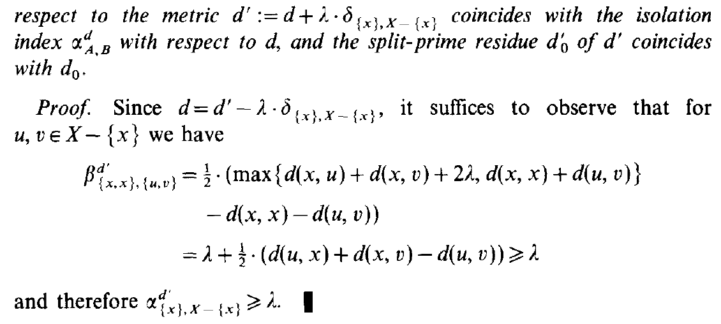

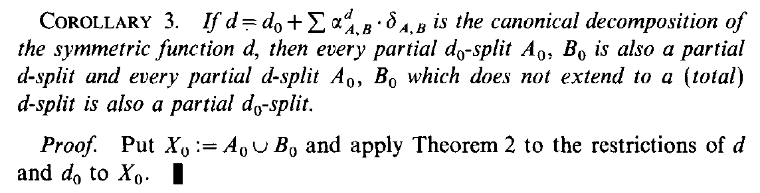

**Cor**. 2 Let $d :X×X→R$ be a pseudo-metric and $x∈X$.  
Let $λ≥0$ and consider

$$d^{'}≔d+λ⋅δ_{x}$$

Then we have $d_{0}^{'}=d_{0}$ and

$$\left\{ \begin{matrix}α_{S}^{d^{'}}=α_{S}^{d} , \\ α_{\left\{x\right\},X\backslash \left\{x\right\}}^{d^{'}}=α_{\left\{x\right\},X\backslash \left\{x\right\}}^{d}+λ\end{matrix}\right. \begin{matrix}∀ S≠\left\{\left\{x\right\},X\backslash \left\{x\right\}\right\} \\ \end{matrix}$$

**Dim**. Observe that for every $u,v∈X \backslash \{x\}$ we have

$$β_{\left\{x\right\},\left\{u,v\right\}}^{d^{'}}=\frac{1}{2}\left( \max\left\{\begin{aligned}\left(xu+λ\right)+\left(xv+λ\right), \\ xx+uv\end{aligned}\right\}-xx-uv \right) \\ =\frac{1}{2}\left(xu+xv+2λ-uv\right) \\ =λ+\frac{1}{2}\left(xu+xv-uv\right)≥λ$$ where we used the triangle inequality for $d$.

Therefore $α_{\left\{x\right\},X\backslash \left\{x\right\}}^{d^{'}}≥λ$ and, since $d=d^{'}-λ⋅δ_{x}$,  
 we get the thesis by applying **Teo**. 2.

Moreover, since $α_{\left\{x\right\},X\backslash \left\{x\right\}}^{d^{'}}=α_{\left\{x\right\},X\backslash \left\{x\right\}}^{d}-λ$, and

$$d_{0}^{'}=d^{'}-\sum{α_{S}^{d^{'}}⋅δ_{S}}-α_{\left\{x\right\},X\backslash \left\{x\right\}}^{d^{'}}⋅δ_{x}= \\ =\left(d+λ⋅δ_{x}\right)-\sum{α_{S}^{d}⋅δ_{S}}-\left(α_{\left\{x\right\},X\backslash \left\{x\right\}}^{d}-λ\right)⋅δ_{x}=d_{0}$$

where the sums range over the splits different from $\left\{\left\{x\right\},X\backslash \left\{x\right\}\right\}$.

**Prop.** **THIS IS FALSE!!!** The split-prime residue of the restriction coincides with the restriction of the split-prime residue

$${\left(d{\left.​\right|}_{Y×Y}\right)}_{0}=d_{0}{\left.​\right|}_{Y×Y}, ∀ Y⊆X$$

Moreover, for every partial split $\{A,B\}$ of $X$ we have

$$α_{A,B}^{d_{0}}=α_{A,B}^{d}-\sum{α_{A^{'},B^{'}}^{d}}$$

where the sum ranges over all the $d$-splits that extend $\{A,B\}$.

**Dim**. Let $Y⊆X$. Restricting the canonical decomposition to $Y$ we get

$$d{\left.​\right|}_{Y×Y}=d_{0}{\left.​\right|}_{Y×Y}+\sum_{S ∈ S(X)}{α_{S}^{d}⋅δ_{S}{\left.​\right|}_{Y×Y}}$$

Instead, the canonical decomposition of the restriction is

$$d{\left.​\right|}_{Y×Y}={\left(d{\left.​\right|}_{Y×Y}\right)}_{0}+\sum_{S ∈ S(Y)}{α_{S}^{d}⋅δ_{S}{\left.​\right|}_{Y×Y}}$$

But the splits of $Y$ are the restriction of the splits of $X$ to $Y$ minus the splits such that one of the parts contains $Y$.  
For such splits, the split metrics restricted to $Y$ become the zero function, so we can ignore their splits in the sum.   
Thus the summations in the two decompositions coincide, therefore also the residues.

Servirebbe $α_{T}^{d{\left.​\right|}_{Y×Y}}=\sum{α_{S}^{d}}$ per tutti gli $S$ che estendono $T$.  
Ma questo implicherebbe $d$ totally decomposable.

Controesempio: prendi una metrica split-prime e restringerla a un insieme di al più 4 elementi. La sua restrizione è non nulla, ma il residuo della restrizione è nullo.

Consider the case $$d_{0}=d-α_{A_{0},B_{0}}^{d}⋅δ_{A_{0},B_{0}}$$

where $\left\{A_{0},B_{0}\right\}$ is a $d$-split.

We can recycle the proof of **Teo**. 2 with some minor variation.  
First we get that for every $\left\{t,u\right\},\left\{v,w\right\}⊆X$ disjoint

$$β_{\left\{t,u\right\},\left\{v,w\right\}}^{d_{0}}=\left\{ \begin{matrix}β_{\left\{t,u\right\},\left\{v,w\right\}}^{d}-α_{A_{0},B_{0}}^{d} , & if \left\{A_{0},B_{0}\right\}≽\left\{\left\{t,u\right\},\left\{v,w\right\}\right\} \\ β_{\left\{t,u\right\},\left\{v,w\right\}}^{d} , & otherwise\end{matrix}\right.$$

Suppose that $\left\{A_{0},B_{0}\right\}$ extends $\{A,B\}$. Since

$$β_{\left\{t,u\right\},\left\{v,w\right\}}^{d_{0}}=β_{\left\{t,u\right\},\left\{v,w\right\}}^{d}-α_{A_{0},B_{0}}^{d}, ∀ t,u∈A, ∀ v,w∈B$$

we get $α_{A,B}^{d_{0}}=α_{A,B}^{d}-α_{A_{0},B_{0}}^{d}$.

Now suppose that $\left\{A_{0},B_{0}\right\}$ does not extend $\{A,B\}$.  
Then we prove that $\left\{A_{0},B_{0}\right\}$ cannot extend the quartet that realizes $α_{A,B}^{d}$.

In order to apply **Cor**. 1, we need to restrict $\left\{A_{0},B_{0}\right\}$ to $A∪B$

$$\left\{A_{0}∩A,B_{0}∩B\right\} or \left\{A_{0}∩B,B_{0}∩A\right\}$$

Notice that at least one of these is a total split of $A∪B$,  
 so it must coincide with $\{A,B\}$.

In order to apply **Teo**. 1, we backtrack $\left\{A_{0},B_{0}\right\}$ in the tree extension to an ancestor at the same level of $\{A,B\}$ (observe that this must be different from $\{A,B\}$ because $\left\{A_{0},B_{0}\right\}$ is not an extension). Then the sum of their indices is less than the sum of the indices of all the partial splits on the same level, that is less than the index of $\{A,B\}$.

Therefore, for every partial split $\{A,B\}$

$$α_{A,B}^{d_{0}}=\left\{ \begin{matrix}α_{A,B}^{d}-α_{A_{0},B_{0}}^{d} , & if \left\{A_{0},B_{0}\right\}≽\left\{A,B\right\} \\ α_{A,B}^{d} , & otherwise\end{matrix}\right.$$

We conclude by induction as before.

**Cor**. 3 Let $d :X×X→R$ be a symmetric function.

Then every partial $d_{0}$-split is also a partial $d$-split;  
and every partial $d$-split, which does not extend  
 to a (total) $d$-split, is also a partial $d_{0}$-split.

**Dim**. It is a consequence of the previous **Prop**.

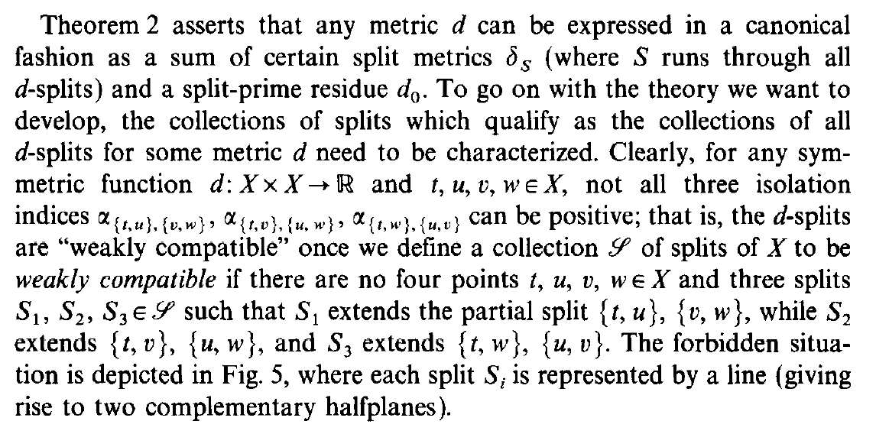

Let $d :X×X→R$ be a symmetric function.

**Oss**. Let $t,u,v,w∈X$.  
Then at least one of the following indices must be zero

$$α_{\left\{t,u\right\},\{v,w\}} , α_{\left\{t,v\right\},\{u,w\}} , α_{\left\{t,w\right\},\{u,v\}}$$

In fact, suppose

$$\max{\{tu+vw,tv+uw,tw+uv\}}=tu+vw$$

then $β_{\left\{t,u\right\},\{v,w\}}=0$ and so $α_{\left\{t,u\right\},\{v,w\}}=0$.  
The other cases are analogous.

**Def**. (weakly compatible splits)

Three splits $S_{1},S_{2},S_{3}$ of $X$ are **weakly compatible** if  
 there are no four points $t,u,v,w∈X$ such that

$$S_{1}≽\left\{\left\{t,u\right\},\left\{v,w\right\}\right\} , S_{2}≽\left\{\left\{t,v\right\},\left\{u,w\right\}\right\} , S_{3}≽\left\{\left\{t,w\right\},\left\{u,v\right\}\right\}$$

A set of splits $S$ of $X$ is **weakly compatible** if  
 its splits are (triplewise) weakly compatible.

**Oss**. Subsets of weakly compatible sets are weakly compatible.

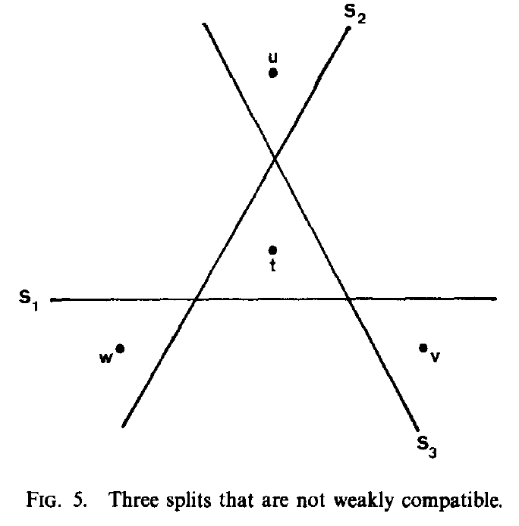

**Prop**. The set of all $d$-splits $S_{d}(X)$ is weakly compatible.

**Dim**. Let $t,u,v,w∈X$. From the previous observation we can suppose WLOG $α_{\left\{t,u\right\},\{v,w\}}=0$.  
For every split $S$ that extends $\left\{\left\{t,u\right\},\left\{v,w\right\}\right\}$ we have

$$0≤α_{S}≤α_{\left\{t,u\right\},\left\{v,w\right\}}=0 ⟹ α_{S}=0$$

that is $S$ is not a $d$-split. In other words, there are no $d$-splits that extend $\left\{\left\{t,u\right\},\left\{v,w\right\}\right\}$.

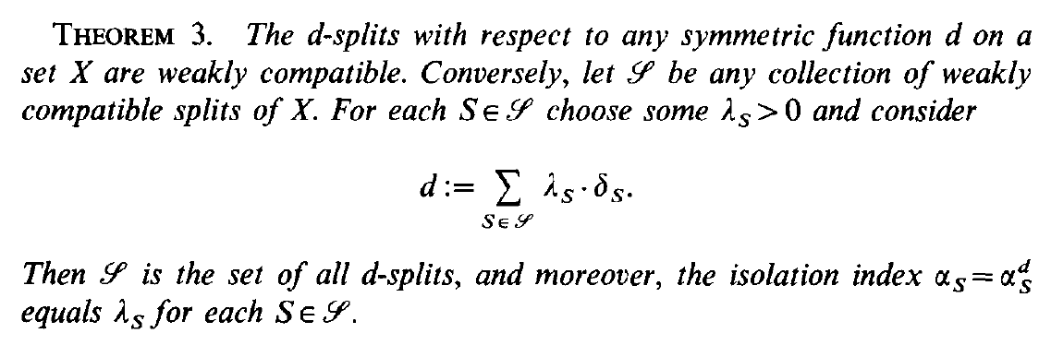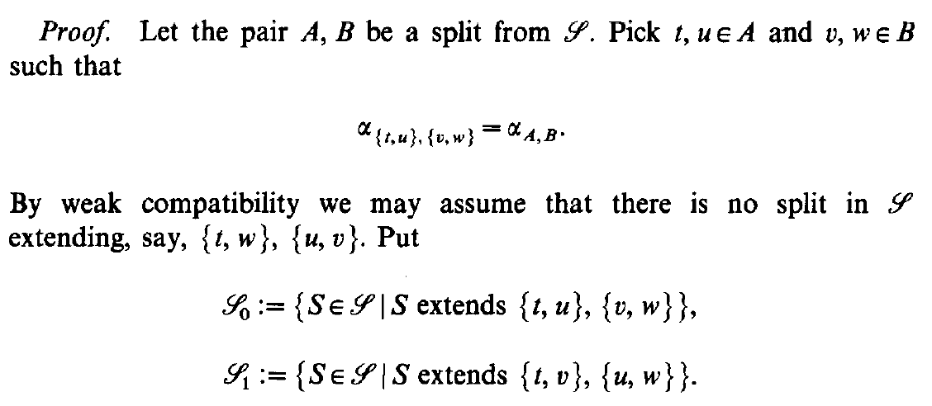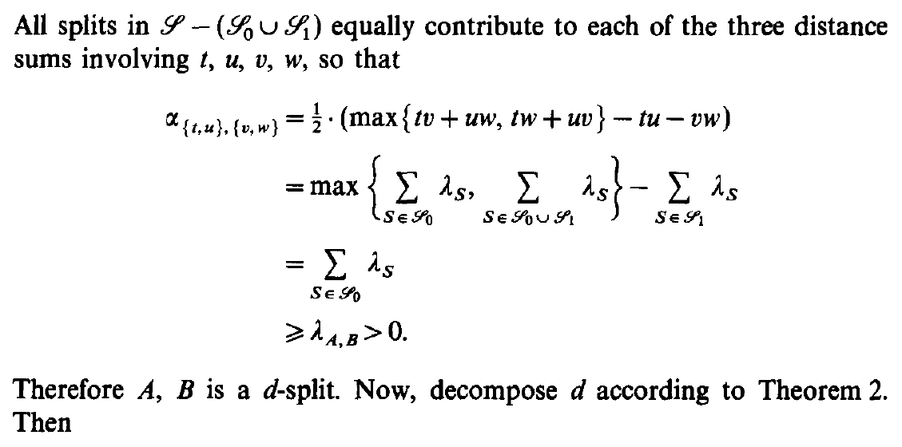

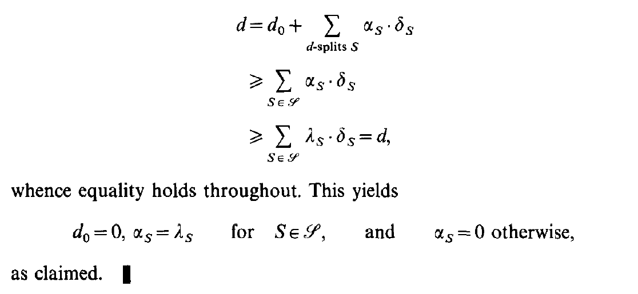

**Teo**. 3 Let $S$ be a set of weakly compatible splits of $X$.  
For each $S∈S$, let $λ_{S}>0$ and consider

$$d≔\sum_{S ∈ S}{λ_{S}⋅δ_{S}}$$

Then $S=S_{d}(X)$ and $α_{S}=λ_{S} , ∀ S∈S$.

**Dim**. Notice that $d$ is a conical combination of split metrics  
 (which are pseudo-metrics), so it is a pseudo-metric.

Let $\left\{A,B\right\}∈S$. Pick $t,u∈A$ and $v,w∈B$ such that

$$α_{\left\{t,u\right\},\{v,w\}}=α_{A,B}$$

Consider the sets $$S_{0}=\left\{ S∈S | S≽\left\{\left\{t,u\right\},\left\{v,w\right\}\right\} \right\}$$

$$S_{1}=\left\{ S∈S | S≽\left\{\left\{t,v\right\},\left\{u,w\right\}\right\} \right\}$$

$$S_{2}=\left\{ S∈S | S≽\left\{\left\{t,w\right\},\left\{u,v\right\}\right\} \right\}$$

If all three sets are non-empty, then there exist three splits  
 that violates the weak compatibility assumption.   
So at least one of them is empty, say WLOG $S_{2}$.

All splits in $S \backslash (S_{0}∪S_{1}∪S_{2})$ equally contribute to each of the three distances $tu+vw, tv+uw, tw+uv$;  
so we can ignore them in the calculation of the isolation index:

$$α_{A,B}=α_{\left\{t,u\right\},\left\{v,w\right\}}=β_{\left\{t,u\right\},\left\{v,w\right\}}= \\ =\frac{1}{2}⋅\left( \max\left\{tu+vw, tv+uw, tw+uv\right\}-tu-vw \right) \\ =\max\left\{\sum_{S ∈ S_{1}∪\underset{=∅}{\underbrace{S_{2}}}}{λ_{s}},\sum_{S ∈ S_{0}∪\underset{=∅}{\underbrace{S_{2}}}}{λ_{s}},\sum_{S ∈ S_{0}∪S_{1}}{λ_{s}}\right\}-\sum_{S ∈ S_{1}∪\underset{=∅}{\underbrace{S_{2}}}}{λ_{s}} \\ =\sum_{S ∈ S_{0}∪S_{1}}{λ_{s}}-\sum_{S ∈ S_{1}}{λ_{s}} \\ =\sum_{S ∈ S_{0}}{λ_{s}} \\ ≥λ_{A,B}>0$$

So for every $S∈S$ we have $α_{S}≥λ_{S}>0$  
 and $S$ is a $d$-split, therefore $S⊆S_{d}(X)$.

Decomposing $d$ as in **Teo**. 2

$$d=d_{0}+\sum_{S ∈ S_{d}\left(X\right)}{α_{S}⋅δ_{S}} \\ ≥\sum_{S ∈ S}{α_{S}⋅δ_{S}} \\ ≥\sum_{S ∈ S}{λ_{S}⋅δ_{S}}=d$$

where we used that $d_{0}≥0$, since it is a pseudo-metric.  
So the inequalities hold as equal. Thus

$$d_{0}=0 , \left\{ \begin{matrix}α_{S}=λ_{S} , ∀ S∈S \\ α_{S}=0 , otherwise\end{matrix}\right.$$

that is if $S∉S$, then $S$ is not a $d$-split.

We conclude that $S=S_{d}(X)$.

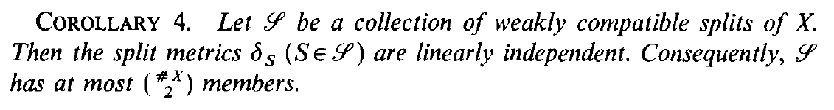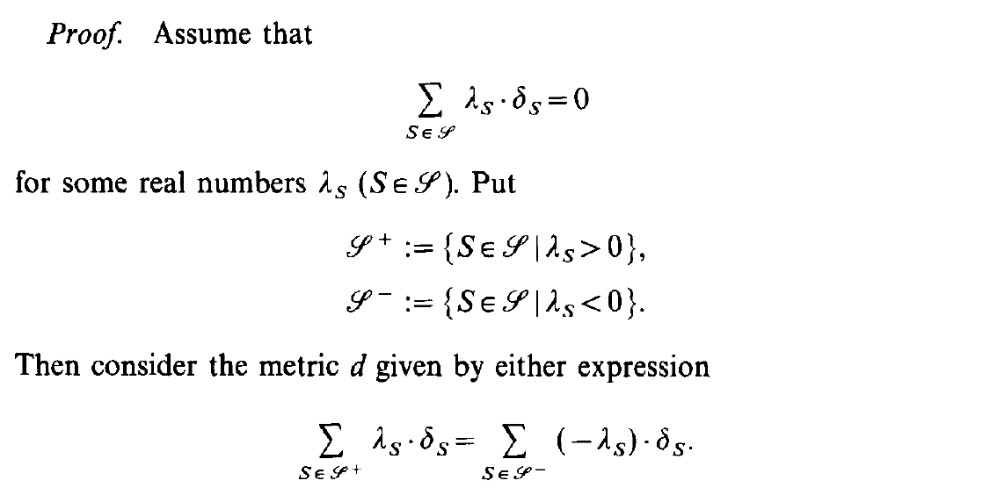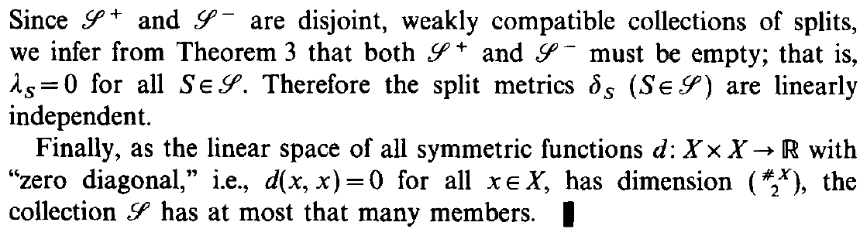

**Cor**. 4 Let $S$ be a set of weakly compatible splits of $X$.

Then the split metrics ${\left\{δ_{S}\right\}}_{ S ∈ S}$ are linearly independent.  
Also $\left|S\right|≤\left({n \atop 2}\right)$, where $n=\left|X\right|$.

**Dim**. In order to prove the linear independence, suppose

$$\sum_{S ∈ S}{λ_{S}⋅δ_{S}}=0$$

for some $λ_{S}∈R$ for each $S∈S$.

Let $$S^{+}≔\left\{ S∈S | λ_{S}>0 \right\}$$

$$S^{-}≔\left\{ S∈S | λ_{S}<0 \right\}$$

We can decompose the previous expression in

$$\sum_{S ∈ S^{+}}{λ_{S}⋅δ_{S}}+\sum_{S ∈ S^{-}}{λ_{S}⋅δ_{S}}=0$$

Consider the pseudo-metric

$$d≔\sum_{S ∈ S^{+}}{λ_{S}⋅δ_{S}}=\sum_{S ∈ S^{-}}{(-λ_{S})⋅δ_{S}}$$

Observe that both $S^{+}$ and $S^{-}$ are weakly compatible.  
Applying **Teo**. 3 to the first expression of $d$ we get

$$S^{+}=S_{d}(X)$$

and doing the same with the second expression we get

$$S^{-}=S_{d}(X)$$

So $S^{+}=S^{-}$.  
But $S^{+}$ and $S^{-}$ are disjoint due to how they are defined.  
So they are both empty: $S^{+}=S^{-}=∅$.

We conclude that $λ_{S}=0, ∀ S∈S$.  
Therefore the split metrics ${\left\{δ_{S}\right\}}_{S∈S}$ are linearly independent.

Since $δ_{S}∈M\left(X\right), ∀ S∈S$ and $\dim_{R}{〈M(X)〉}=\left({n \atop 2}\right)$ then

$$|S|=\#\{δ_{S}\}≤\left({n \atop 2}\right)$$

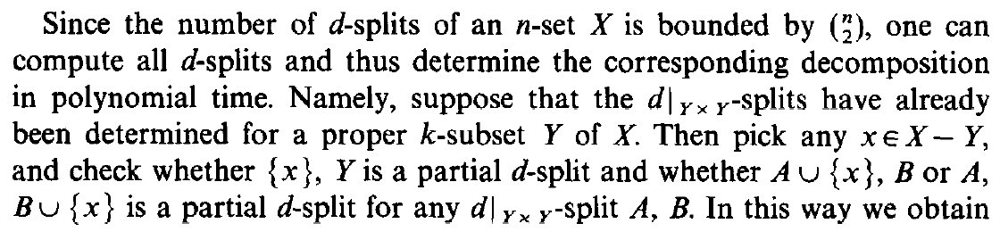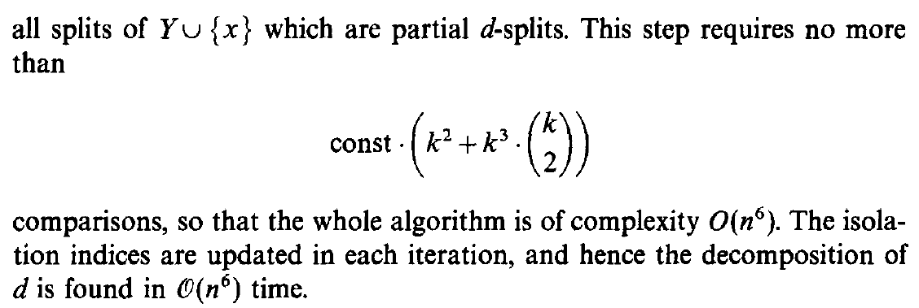

**Oss**. Since $S_{d}\left(X\right)$ is weakly compatible, from **Cor**. 4 we have that the number of $d$-splits is at most $\left({n \atop 2}\right)$.

A brute force approach to find all the $d$-splits of $X$ would be to compute the isolation indices of all the splits of $X$ and discard those that are zero.  
But, since $\left|S\left(X\right)\right|=2^{n-1}-1$, this is an exponential algorithm.

We can instead use a more “inductive” approach:   
suppose that the $d{\left.​\right|}_{Y×Y}$-splits of a proper subset $Y⊂X$ of size $k$ have already been determined. Then pick any $x∈X \backslash Y$ and check

* if $\left\{Y,\left\{x\right\}\right\}$ is a partial $d$-split
* if $\left\{A,B∪\left\{x\right\}\right\}$ and $\left\{A,B∪\left\{x\right\}\right\}$ are partial $d$-split  
   for any $\left\{A,B\right\}$ $d$-split of $Y$

In this way we obtain all the $d$-splits of $Y∪\{x\}$.

Crucially, we just have to check at most $2⋅\left({k \atop 2}\right)+1$ splits at each step, thanks to the previous observation. So we can compute the $d$-splits of $X$ (and their decomposition) in polynomial time.

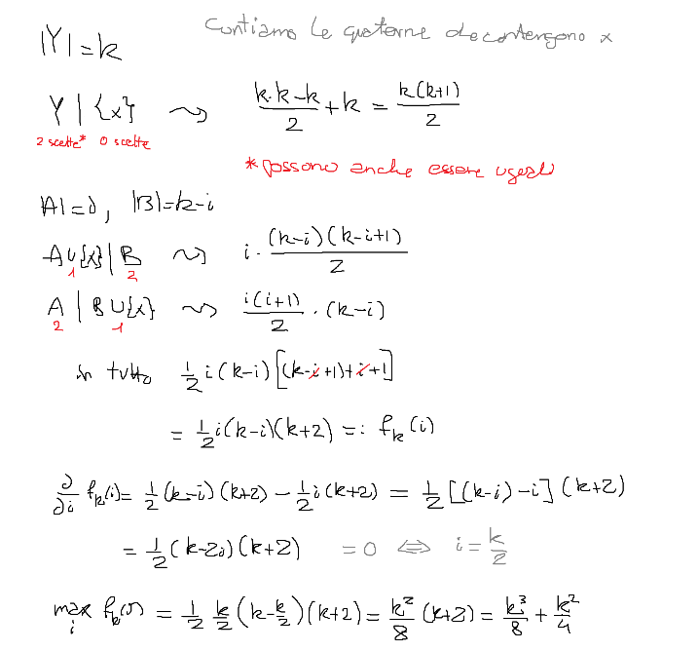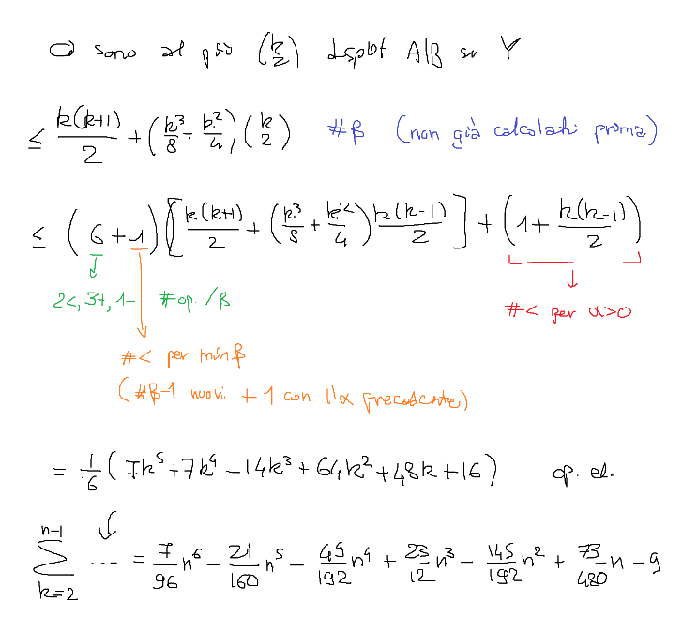

The reason why the algorithm works is that once we find splits that are not partial $d$-splits (that is they have zero isolation index), we know that also their extensions won’t be $d$-splits – since the isolation index can only get lower by extending.

A similar improvement in the actual implementation can be made: once we find that a quartet has zero $β$ index, then also the $α$ index is zero;   
so we can stop checking the other quartets.  
Also when computing the $β$ index we can exploit the symmetry of $d$ to skip about $3/4$ of quartets.

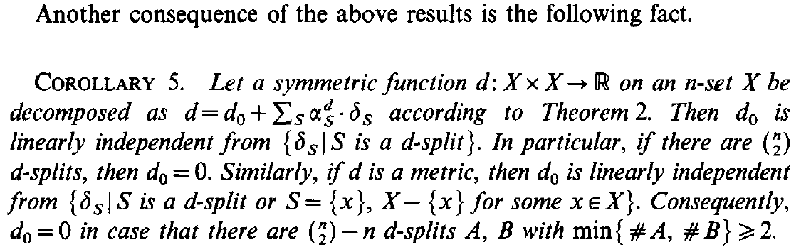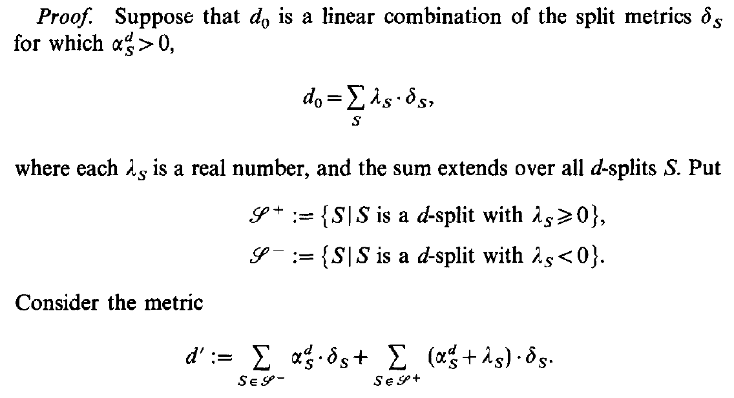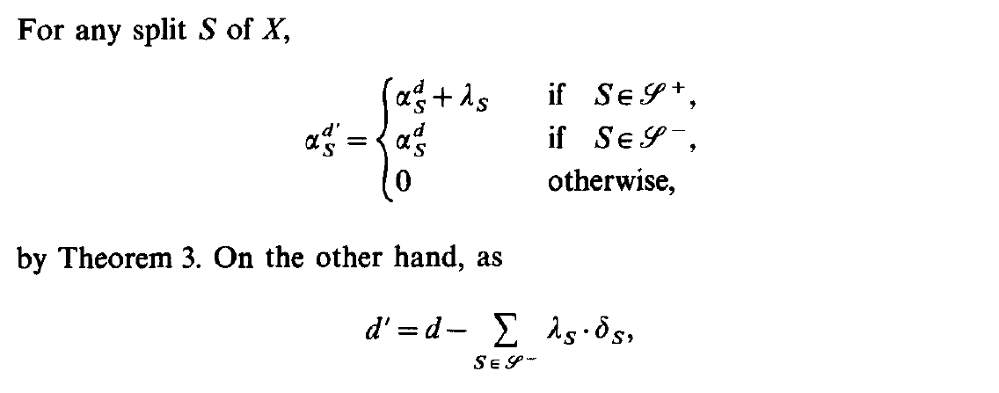

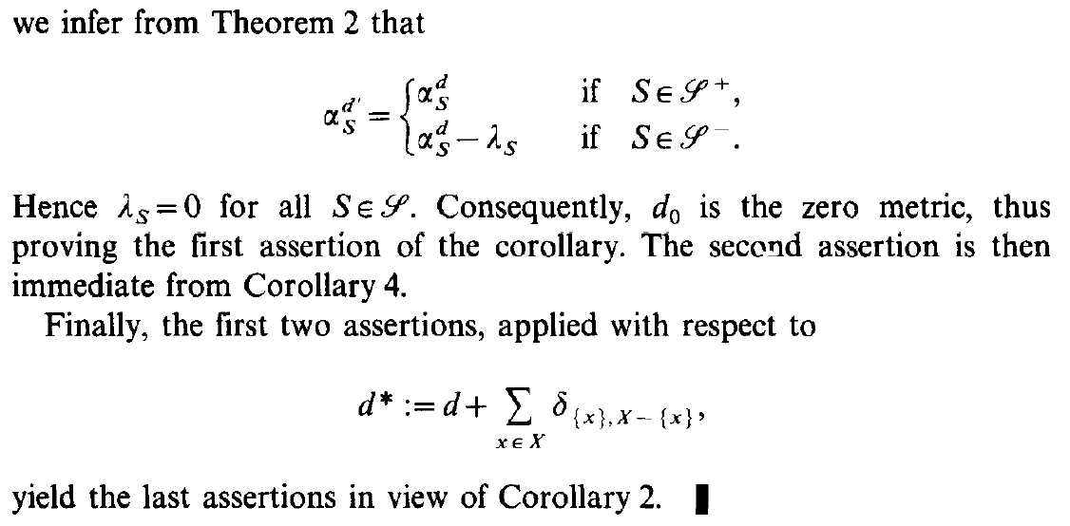

**Cor**. 5 Let $d :X×X→R$ be a symmetric function.

Then the residue $d_{0}$ is linearly independent from ${\left\{δ_{S}\right\}}_{S ∈ S_{d}(X)}$.  
In particular, if there are $\left({n \atop 2}\right)$ $d$-splits, then $d_{0}=0$.

If $d$ is a pseudo-metric,  
 then $d_{0}$ is linearly independent from ${\left\{δ_{S}\right\}}_{S ∈ S_{d}(X)}∪{\left\{δ_{x}\right\}}_{x ∈ X}$.  
If there are $\left({n \atop 2}\right)-n$ non trivial $d$-splits, then $d_{0}=0$.

**Dim**. Suppose that

$$d_{0}=\sum_{S ∈ S_{d}(X)}{λ_{S}⋅δ_{S}}$$

so that

$$d=d_{0}+\sum_{S ∈ S\left(X\right)}{α_{S}^{d}⋅δ_{S}} \\ =\sum_{S ∈ S_{d}\left(X\right)}{λ_{S}⋅δ_{S}}+\sum_{S ∈ S_{d}\left(X\right)}{α_{S}^{d}⋅δ_{S}} \\ =\sum_{S ∈ S_{d}\left(X\right)}{\left(α_{S}^{d}+λ_{S}\right)⋅δ_{S}}$$

Let $$S^{+}≔\left\{ S∈S_{d}\left(X\right) | λ_{S}≥0 \right\}$$

$$S^{-}≔\left\{ S∈S_{d}\left(X\right) | λ_{S}<0 \right\}$$

Observe that $S_{d}\left(X\right)=S^{+}⊔S^{-}$.

Consider the pseudo-metric

$$d^{'}≔\sum_{S ∈ S^{-}}{α_{S}^{d}⋅δ_{S}}+\sum_{S ∈ S^{+}}{(α_{S}^{d}+λ_{S})⋅δ_{S}}$$

Applying **Teo**. 3 we get

$$α_{S}^{d^{'}}=\left\{ \begin{matrix}α_{S}^{d}+λ_{S} \\ α_{S}^{d}\end{matrix}, \begin{matrix}S∈S^{+} \\ S∈S^{-}\end{matrix}\right.$$

We can write

$$d^{'}=d-\sum_{S ∈ S^{-}}{λ_{S}⋅δ_{S}}$$

and by applying **Teo**. 2 we get

$$α_{S}^{d^{'}}=\left\{ \begin{matrix}α_{S}^{d} \\ α_{S}^{d}-λ_{S}\end{matrix}, \begin{matrix}S∈S^{+} \\ S∈S^{-}\end{matrix}\right.$$

Thus $λ_{S}=0$ for every split $S$, proving the linear independence. The second assertion follows from **Cor**. 4.

Consider $$d^{*}≔d+\sum_{x ∈ X}{δ_{x}}$$

By **Cor**. 2, $d_{0}^{*}=d_{0}$. Also notice that

$$S_{d^{*}}\left(X\right)=S_{d}\left(X\right)∪\bigcup_{x ∈ X}{\left\{\left\{x\right\},X\backslash \left\{x\right\}\right\}}$$

We get the thesis by applying the first assertion on $d^{*}$.

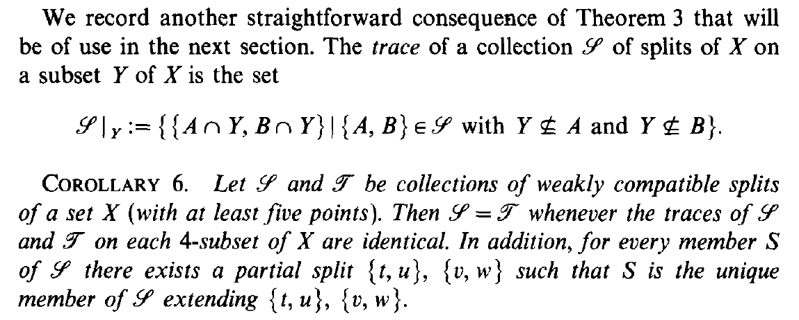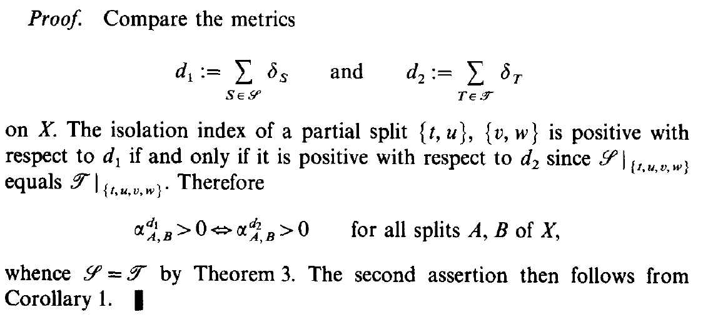

**Def**. Let $S$ be a collection of splits of $X$ and $Y⊆X$ a subset.  
Then the **trace** of $S$ on $Y$ is the set

$$S{\left.​\right|}_{Y}≔\left\{ \left\{A∩Y,B∩Y\right\} | \left\{A,B\right\}∈S, Y⊈A ∧ Y⊈B \right\}$$

In practice, it is the restriction of the splits to $Y$ such that they are still splits: in particular the members cannot be empty and, since the set of all splits is a partition of $X$, it is equivalent to ask that $Y$ is not contained in a single member.

**Cor**. 6 Let $S$ and $T$ be collections of weakly compatible splits of $X$.

Then $S=T$ if and only if   
 their traces are identical on every 4-subset of $X$.

**Dim**. The $(⇒)$ implication is obvious.

Consider the pseudo-metrics  
 (since they are conical combinations of split metrics)

$$d_{1}≔\sum_{S ∈ S}{δ_{S}} , d_{2}≔\sum_{T ∈ T}{δ_{T}}$$

Observe that, given $Y=\{t,u,v,w\}$ a 4-subset of $X$,

$$d_{1}{\left.​\right|}_{Y}=d_{2}{\left.​\right|}_{Y}$$

because they depend only by (the restrictions of) the splits on $Y$, and $S,T$ have the same trace on 4-subsets.

If we consider a split on $Y$, for example $\left\{\left\{t,u\right\},\left\{v,w\right\}\right\}$,   
and the fact that $d_{1}, d_{2}$ are pseudo-metrics, we have

$$α_{\left\{t,u\right\},\left\{v,w\right\}}^{d_{1}}=β_{\left\{t,u\right\},\left\{v,w\right\}}^{d_{1}}=β_{\left\{t,u\right\},\left\{v,w\right\}}^{d_{2}}=α_{\left\{t,u\right\},\left\{v,w\right\}}^{d_{2}}$$

In particular, the isolation index on quartets is positive with respect to $d_{1}$ if and only if it is positive with respect to $d_{2}$.

This is true also for generic splits because  
 the isolation index on a generic split is the minimum of  
 the isolation indices on appropriate quartets.  
In particular, the $d_{1}$-splits coincide with the $d_{2}$-splits.

By **Teo**. 3 we have

$$S=S_{d_{1}}\left(X\right)=T_{d_{2}}(X)=T$$

**Prop**. Let $S$ be a collection of weakly compatible splits of $X$.

Then for every $S∈S$ there exists a partial split $\left\{\left\{t,u\right\},\left\{v,w\right\}\right\}$ such that $S$ is its unique split extension in $S$.

**Dim**. Let $\left\{\left\{t,u\right\},\left\{v,w\right\}\right\}$ such that

$$α_{S}=β_{\left\{t,u\right\},\{v,w\}}$$

with respect to the distance $d≔\sum_{S ∈ S}{δ_{S}}$.

Since by **Teo**. 3 it holds $S=S_{d}\left(X\right)$, then $S$ is a $d$-split.  
Applying **Cor**. 1 we conclude that $S$ is the unique $d$-split (that is equivalent to saying element of $S$) extending $\left\{\left\{t,u\right\},\left\{v,w\right\}\right\}$.

Solo enunciati.

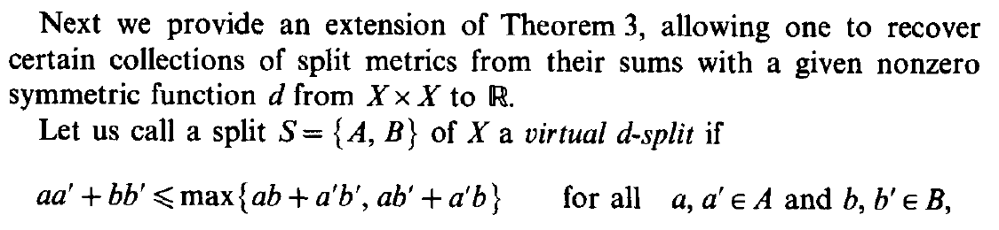 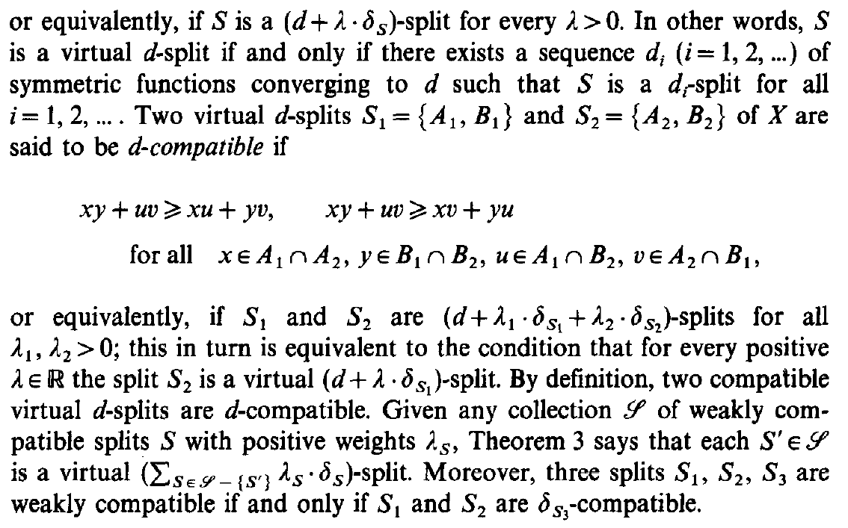 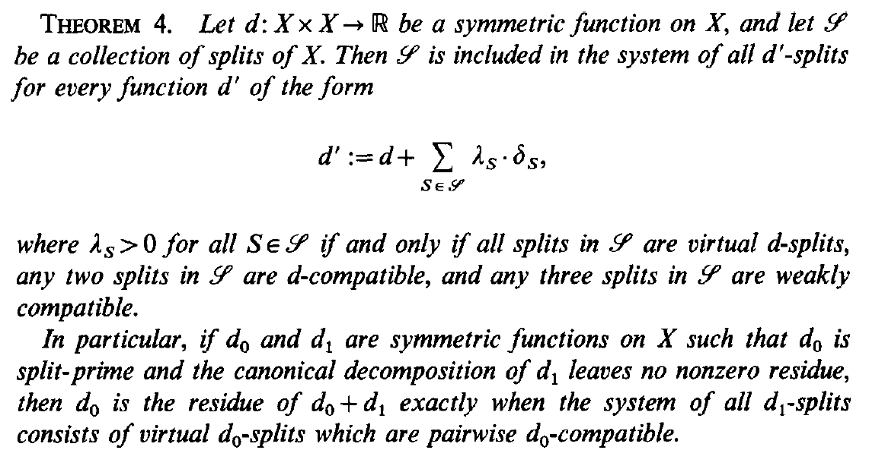

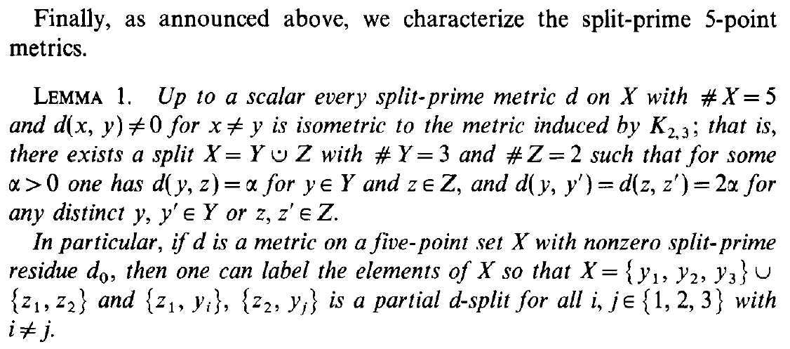

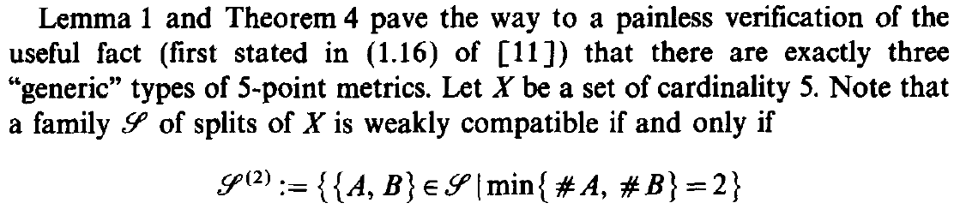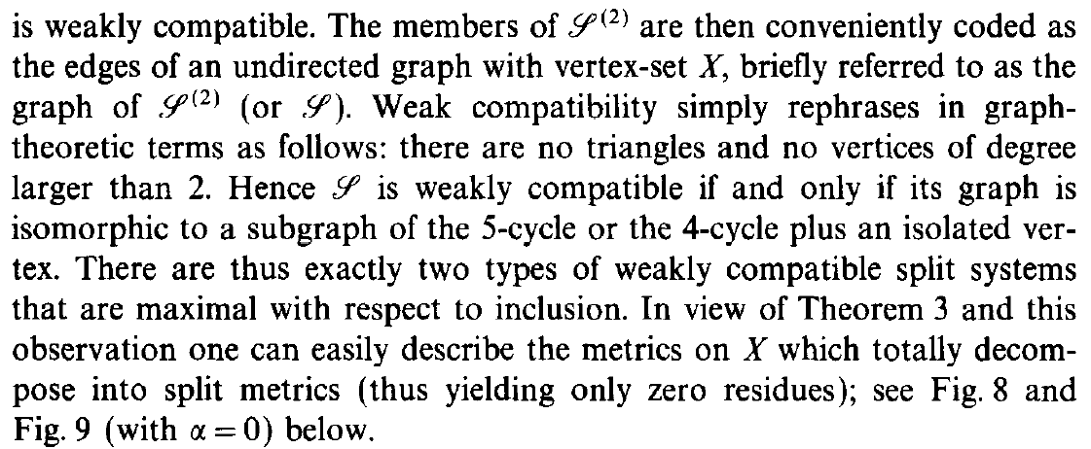

[...]

 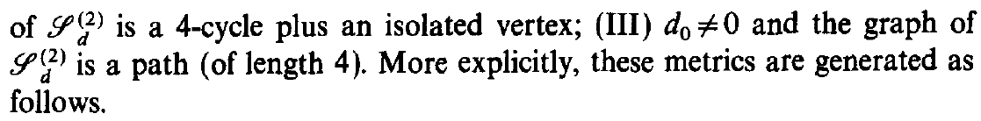

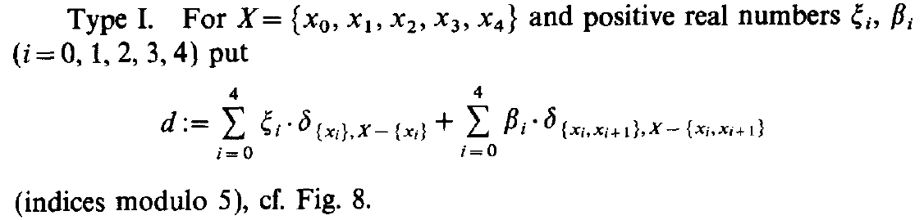

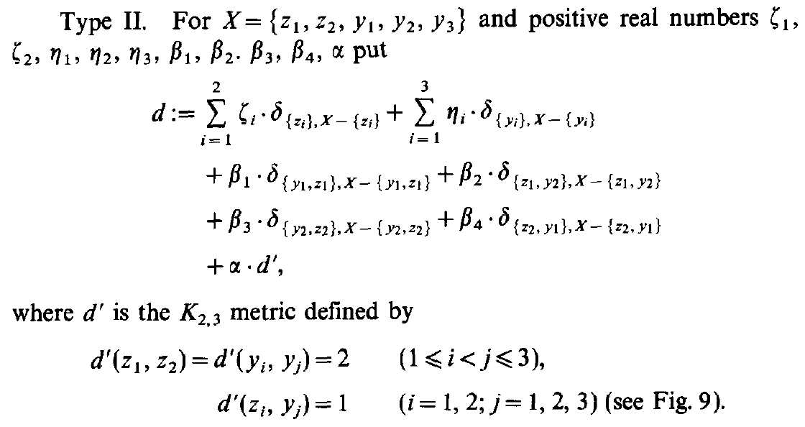

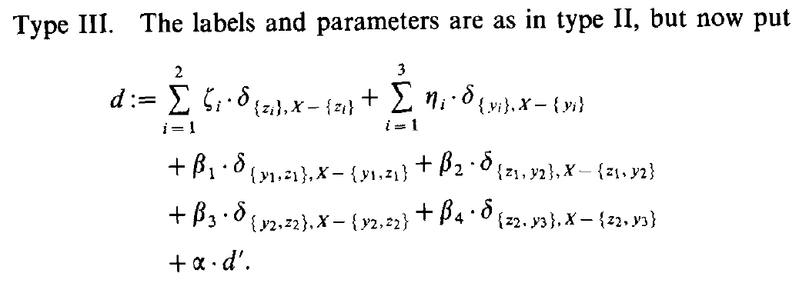

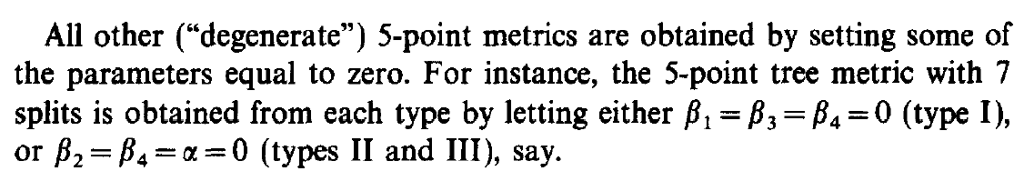

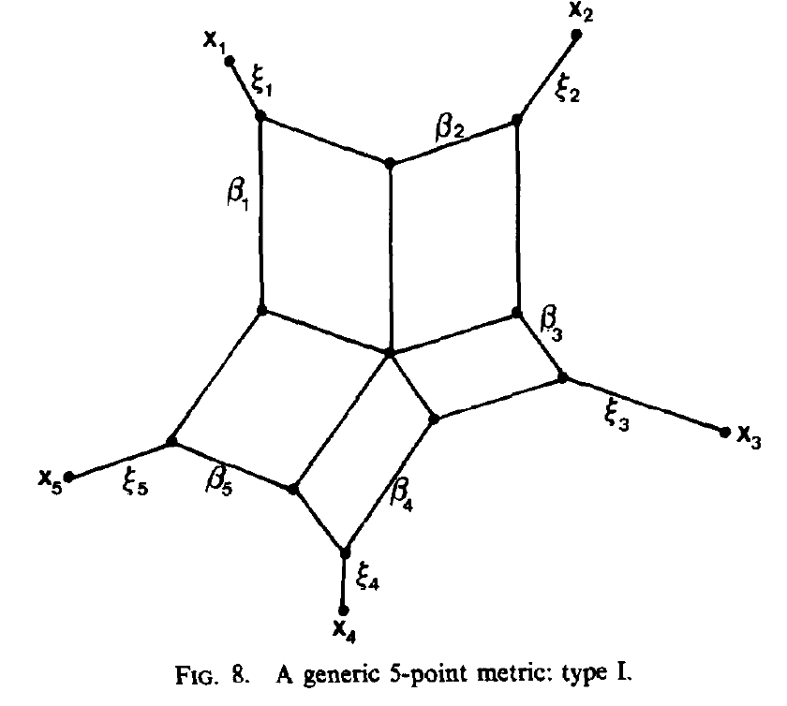

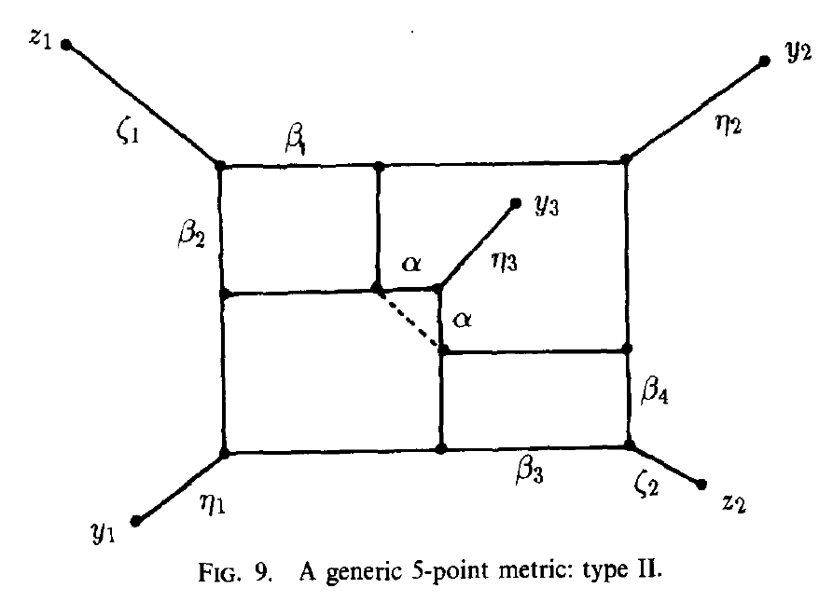

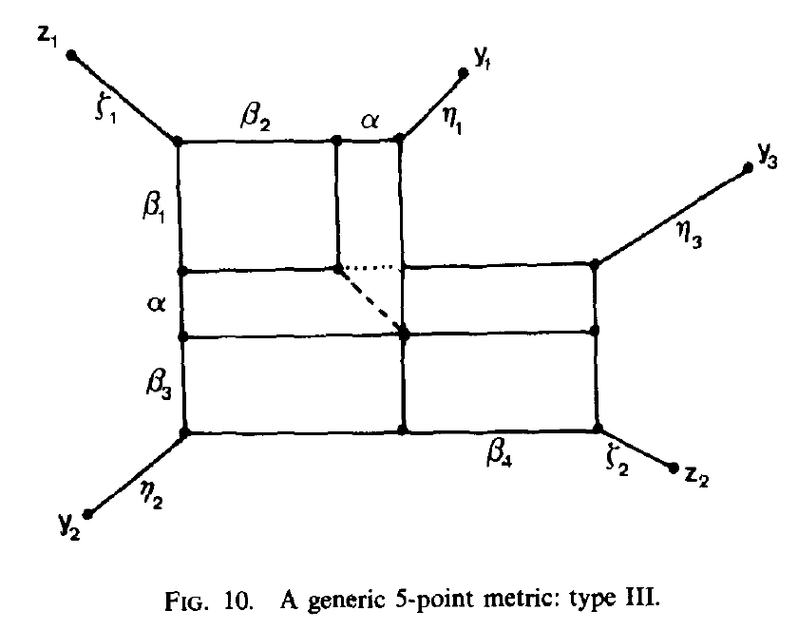

Chapter 3: Maximum Collections of Weakly Compatible Splits

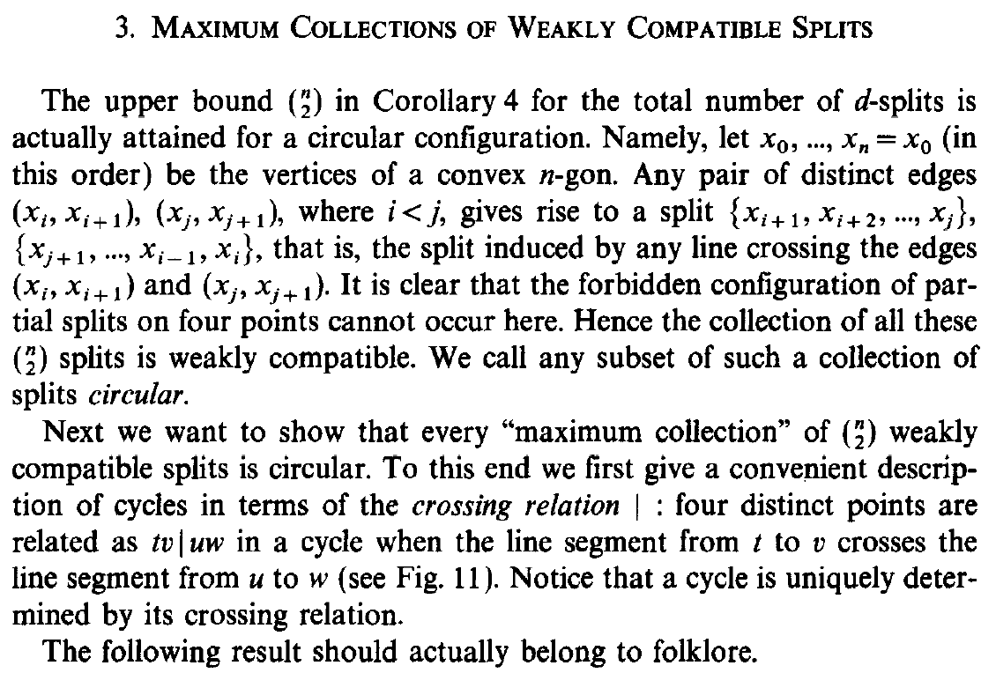

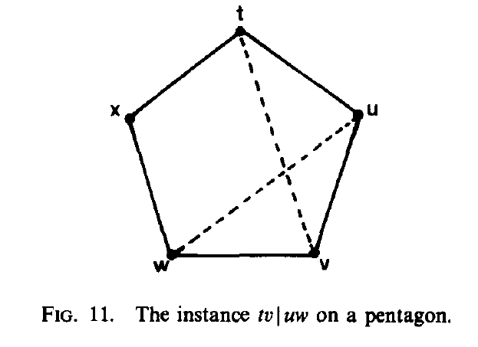

I circular splits sono weakly compatible perché 4 punti disposti in cerchio non sono linearmente separabili.

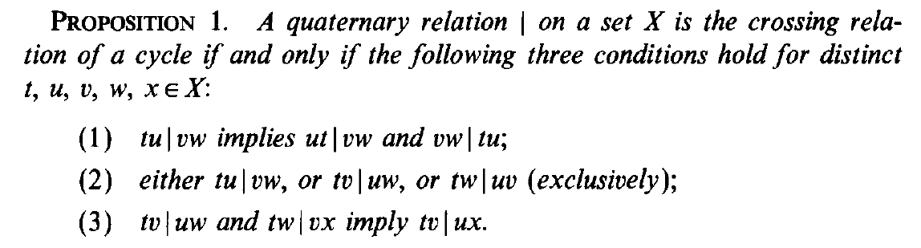

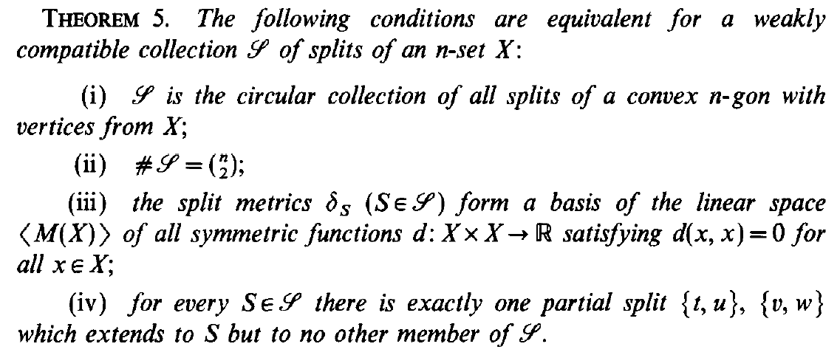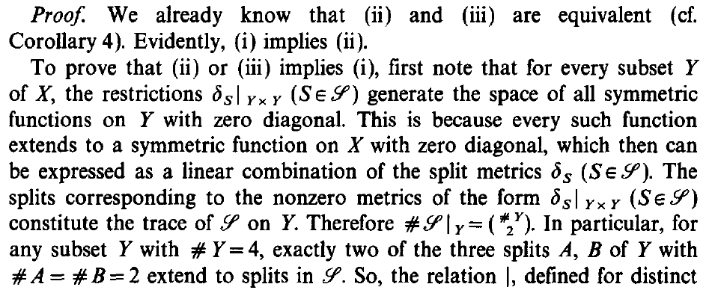

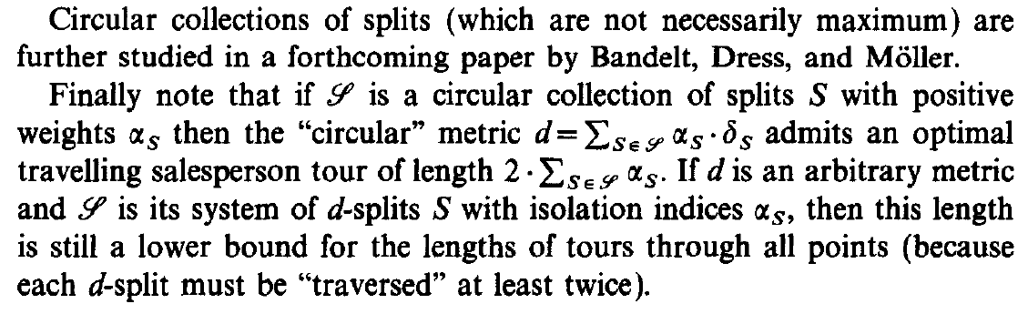

Chapter 4: Total Decomposability

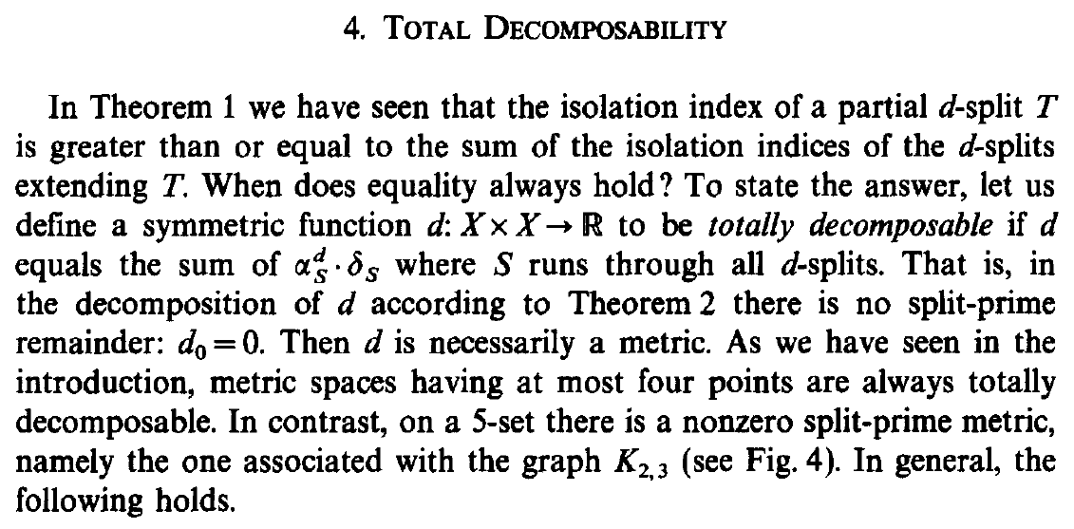

**Def**. A symmetric function $d :X×X→R$ is **totally decomposable** if its split-prime residue is zero $d_{0}=0$;   
or equivalently, if it can be written as

$$d=\sum_{S ∈ S_{d}(X)}{α_{S}^{d}⋅δ_{S}}$$

**Oss**. A totally decomposable function is a pseudo-metric.

In fact, it is a conical combination of split metrics  
 (that are pseudo-metrics).

**Fact** If $\left|X\right|≤4$, then every pseudo-metric is totally decomposable.

If $\left|X\right|=5$, then there is a non-zero split-prime pseudo-metric, namely the one associated with the graph .

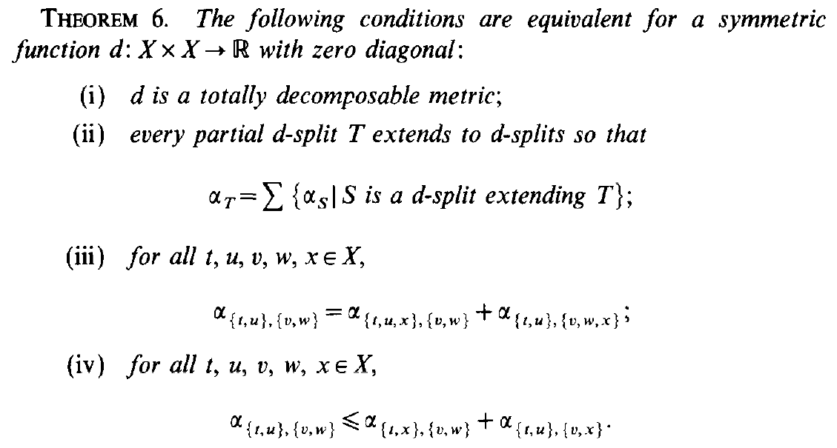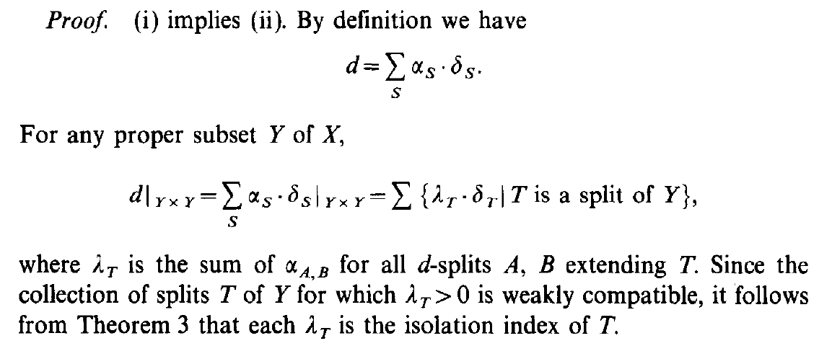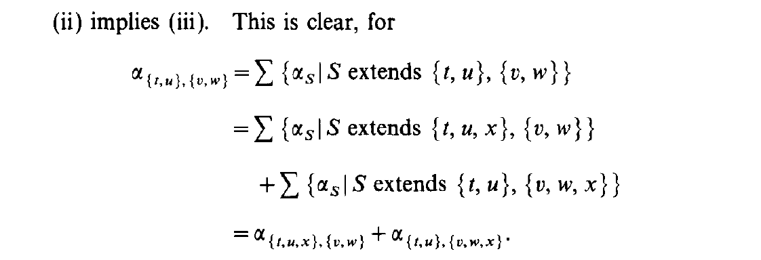

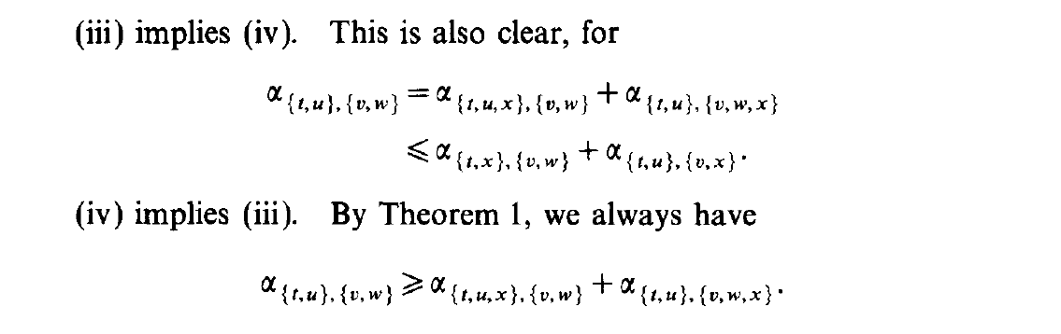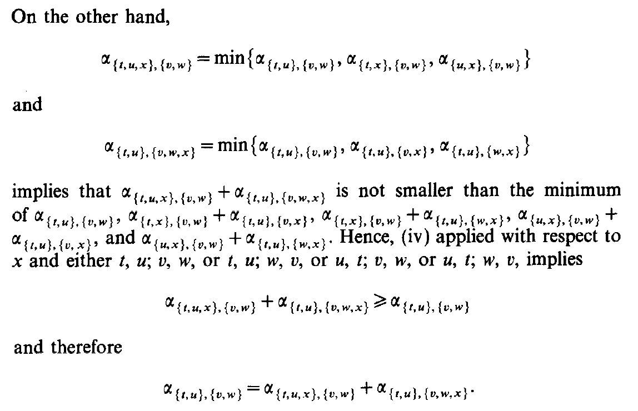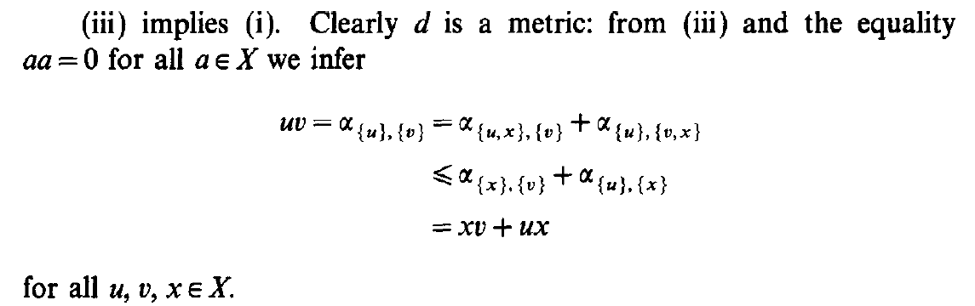

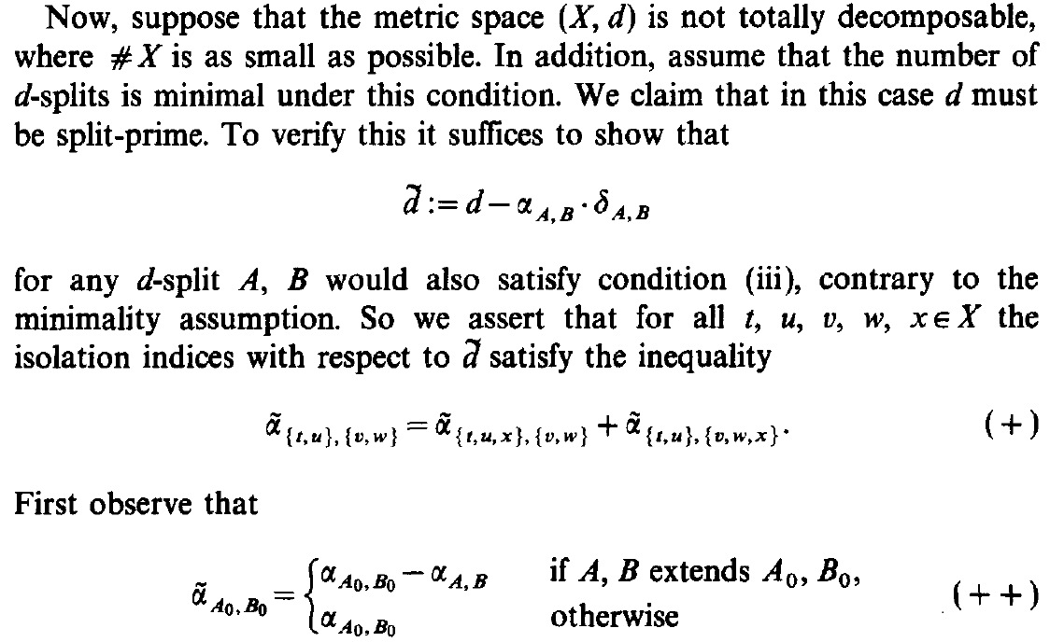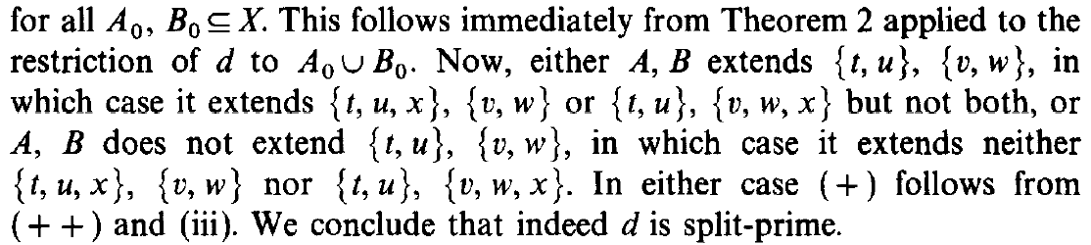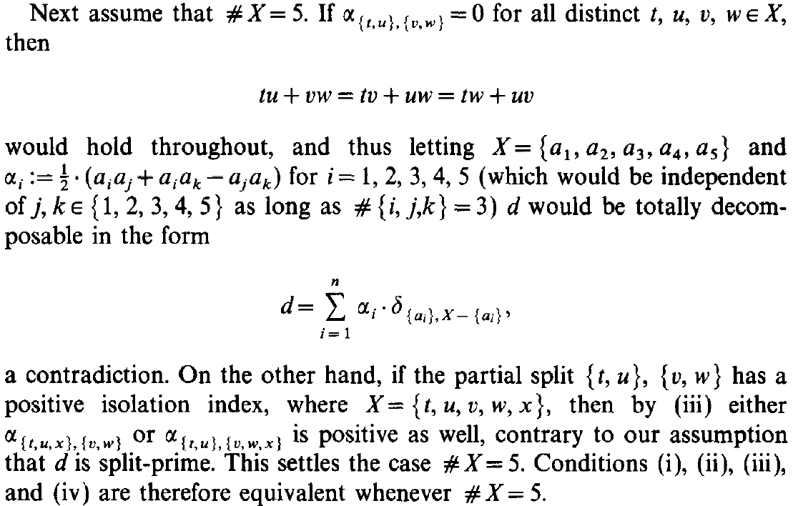

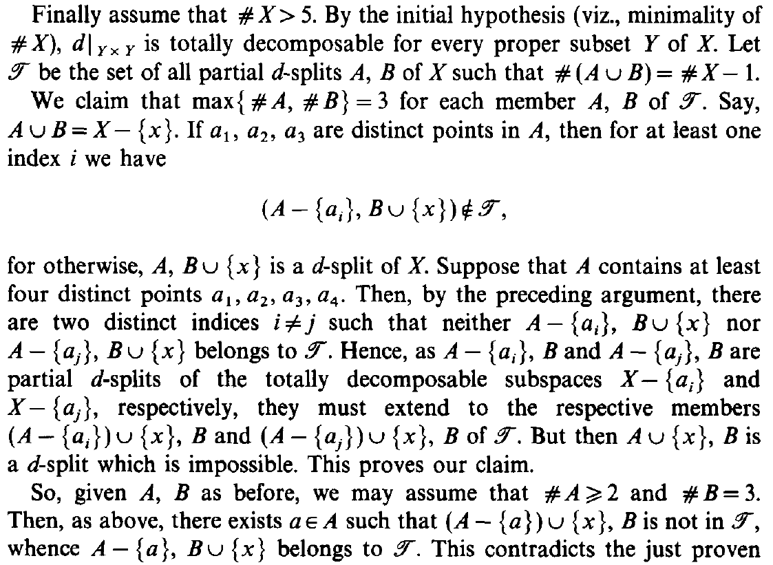

**Teo**. 6 Let $d :X×X→R$ be a symmetric function with zero diagonal. Then the following conditions are equivalent:

1. $d$ is totally decomposable
2. for every partial split $T$
$$α_{T}=\sum{\left\{ α_{S} | S∈S_{d}\left(X\right), S≽T \right\}}$$

3. for all $t,u,v,w,x∈X$
$$α_{\left\{t,u\right\},\{v,w\}}=α_{\left\{t,u,x\right\},\{v,w\}}+α_{\left\{t,u\right\},\{v,w,x\}}$$

4. for all $t,u,v,w,x∈X$

$$α_{\left\{t,u\right\},\{v,w\}}≤α_{\left\{t,x\right\},\{v,w\}}+α_{\left\{t,u\right\},\{v,x\}}$$

**Dim**. $(i⇒ii)$ By definition of total decomposability, we have

$$d=\sum_{S ∈ S_{d}(X)}{α_{S}⋅δ_{S}}$$

For any proper subset $Y⊂X$

$$d{\left.​\right|}_{Y×Y}=\sum_{S ∈ S_{d}(X)}{α_{S}⋅δ_{S}{\left.​\right|}_{Y×Y}}=\sum{\left\{ λ_{T}⋅δ_{T} | T∈S(Y) \right\}}$$

where $λ_{T}=\sum{\left\{ α_{S} | S∈S_{d}\left(X\right), S≽T \right\}}$.

From **Teo**. 1, we have $λ_{T}≤α_{T}$ for every $T$ split of $Y$. Thus

$$\left\{ T∈S\left(Y\right) | λ_{T}>0 \right\}⊆S_{d}\left(Y\right)$$

so it is weakly compatible. Applying **Teo**. 3 to this set we get

$$α_{T}=λ_{T}$$

$\left(ii⇒iii\right)$ Let $t,u,v,w,x∈X$. Then

$$α_{\left\{t,u\right\},\left\{v,w\right\}}=\sum{\left\{ α_{S} | S∈S_{d}\left(X\right), S≽\left\{\left\{t,u\right\},\left\{v,w\right\}\right\} \right\}} \\ =\sum{\left\{ α_{S} | S∈S_{d}\left(X\right), S≽\left\{\left\{t,u,x\right\},\left\{v,w\right\}\right\} \right\}}+\sum{\left\{ α_{S} | S∈S_{d}\left(X\right), S≽\left\{\left\{t,u\right\},\left\{v,w,x\right\}\right\} \right\}} \\ =α_{\left\{t,u,x\right\},\{v,w\}}+α_{\left\{t,u\right\},\{v,w,x\}}$$

$\left(iii⇒iv\right)$ Let $t,u,v,w,x∈X$. Then

$$α_{\left\{t,u\right\},\left\{v,w\right\}}=α_{\left\{t,u,x\right\},\left\{v,w\right\}}+α_{\left\{t,u\right\},\left\{v,w,x\right\}} \\ ≤α_{\left\{t,x\right\},\{v,w\}}+α_{\left\{t,u\right\},\{v,x\}}$$

$\left(iv⇒iii\right)$ Let $t,u,v,w,x∈X$. By **Teo**. 1 we have

$$α_{\left\{t,u,x\right\},\left\{v,w\right\}}+α_{\left\{t,u\right\},\left\{v,w,x\right\}}≤α_{\left\{t,u\right\},\left\{v,w\right\}}$$

On the other hand

$$α_{\left\{t,u,x\right\},\left\{v,w\right\}}=\min{\{α_{\left\{t,u\right\},\left\{v,w\right\}},α_{\left\{t,x\right\},\left\{v,w\right\}},α_{\left\{u,x\right\},\left\{v,w\right\}}\}}$$

$$α_{\left\{t,u\right\},\left\{v,w,x\right\}}=\min{\{α_{\left\{t,u\right\},\left\{v,w\right\}},α_{\left\{t,u\right\},\left\{v,x\right\}},α_{\left\{t,u\right\},\left\{w,x\right\}}\}}$$

Applying condition $\left(iv\right)$ with respect to $x$ and either $$t,u;v,w , t,u;w,u , u,t;v,w , u,t;w,v$$

we get $$α_{\left\{t,u\right\},\left\{v,w\right\}}≤α_{\left\{t,x\right\},\left\{v,w\right\}}+α_{\left\{t,u\right\},\left\{v,x\right\}} \\ α_{\left\{t,u\right\},\left\{w,v\right\}}≤α_{\left\{t,x\right\},\left\{w,v\right\}}+α_{\left\{t,u\right\},\left\{w,x\right\}} \\ α_{\left\{u,t\right\},\left\{v,w\right\}}≤α_{\left\{u,x\right\},\left\{v,w\right\}}+α_{\left\{u,t\right\},\left\{v,x\right\}} \\ α_{\left\{u,t\right\},\left\{w,v\right\}}≤α_{\left\{u,x\right\},\left\{w,v\right\}}+α_{\left\{u,t\right\},\left\{w,x\right\}}$$

Therefore $$α_{\left\{t,u,x\right\},\left\{v,w\right\}}+α_{\left\{t,u\right\},\left\{v,w,x\right\}}=\min\left\{\begin{aligned}α_{\left\{t,u\right\},\left\{v,w\right\}}+α_{\left\{t,u\right\},\left\{v,w\right\}}, \\ α_{\left\{t,u\right\},\left\{v,w\right\}}+α_{\left\{t,u\right\},\left\{v,x\right\}}, \\ α_{\left\{t,u\right\},\left\{v,w\right\}}+α_{\left\{t,u\right\},\left\{w,x\right\}}, \\ α_{\left\{t,x\right\},\left\{v,w\right\}}+α_{\left\{t,u\right\},\left\{v,w\right\}}, \\ α_{\left\{t,x\right\},\left\{v,w\right\}}+α_{\left\{t,u\right\},\left\{v,x\right\}}, \\ α_{\left\{t,x\right\},\left\{v,w\right\}}+α_{\left\{t,u\right\},\left\{w,x\right\}}, \\ α_{\left\{u,x\right\},\left\{v,w\right\}}+α_{\left\{t,u\right\},\left\{v,w\right\}}, \\ α_{\left\{u,x\right\},\left\{v,w\right\}}+α_{\left\{t,u\right\},\left\{v,x\right\}}, \\ α_{\left\{u,x\right\},\left\{v,w\right\}}+α_{\left\{t,u\right\},\left\{w,x\right\}}\end{aligned}\right\} \\ ≥\min\left\{\begin{aligned}α_{\left\{t,u\right\},\left\{v,w\right\}} \\ α_{\left\{t,x\right\},\left\{v,w\right\}}+α_{\left\{t,u\right\},\left\{v,x\right\}}, \\ α_{\left\{t,x\right\},\left\{v,w\right\}}+α_{\left\{t,u\right\},\left\{w,x\right\}}, \\ α_{\left\{u,x\right\},\left\{v,w\right\}}+α_{\left\{t,u\right\},\left\{v,x\right\}}, \\ α_{\left\{u,x\right\},\left\{v,w\right\}}+α_{\left\{t,u\right\},\left\{w,x\right\}}\end{aligned}\right\} \\ ≥α_{\left\{t,u\right\},\left\{v,w\right\}}$$

$\left(iii⇒i\right)$ [DA FARE]

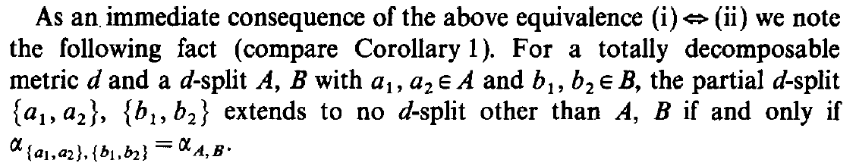

**Cor**. Let $d$ a totally decomposable pseudo-metric, $\{A,B\}$ 
 a $d$-split and $a_{1},a_{2}∈A, b_{1},b_{2}∈B$.

Then $\{A,B\}$ is the only $d$-split extension of $\left\{\left\{a_{1},a_{2}\right\},\left\{b_{1},b_{2}\right\}\right\}$  
if and only if $α_{\left\{a_{1},a_{2}\right\},\left\{b_{1},b_{2}\right\}}=α_{A,B}$.

**Dim**. $(⇒)$ By **Teo**. 6

$$α_{\left\{a_{1},a_{2}\right\},\left\{b_{1},b_{2}\right\}}=\sum{\left\{ α_{S} | S∈S_{d}\left(X\right), S≽\left\{\left\{a_{1},a_{2}\right\},\left\{b_{1},b_{2}\right\}\right\} \right\}} \\ =α_{A,B}$$

$\left(⇐\right)$ By **Teo**. 6

$$α_{A,B}=α_{\left\{a_{1},a_{2}\right\},\left\{b_{1},b_{2}\right\}} \\ =\sum{\left\{ α_{S} | S∈S_{d}\left(X\right), S≽\left\{\left\{a_{1},a_{2}\right\},\left\{b_{1},b_{2}\right\}\right\} \right\}}$$

and since $α_{A,B}$ is a term of the sum, it must be the only one.

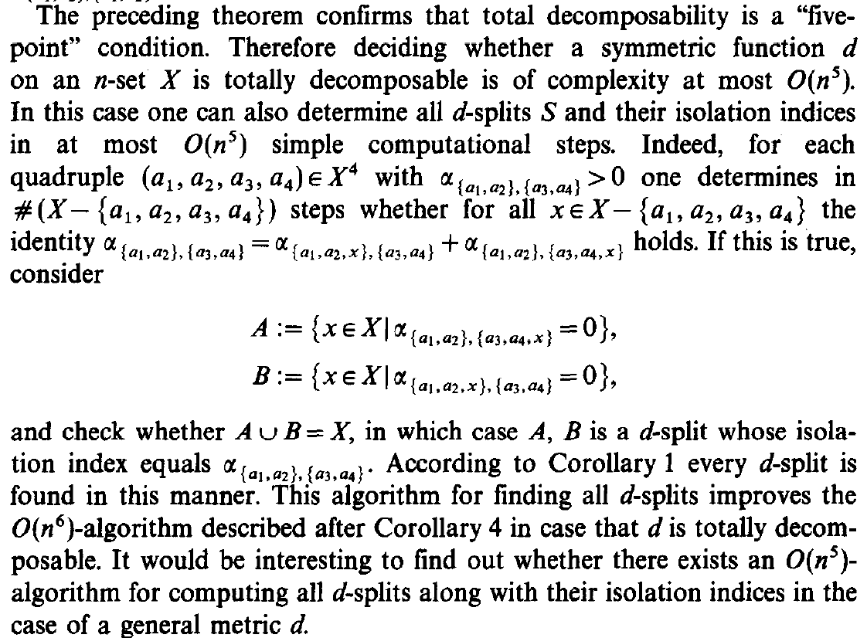

Consider $a_{1},a_{2},a_{3},a_{4}∈X$ such that $α_{\left\{a_{1},a_{2}\right\},\{a_{3},a_{4}\}}>0$ and the sets

$$A≔\left\{ x∈X | α_{\left\{a_{1},a_{2}\right\},\{a_{3},a_{4},x\}}=0 \right\}$$

$$B≔\left\{ x∈X | α_{\left\{a_{1},a_{2},x\right\},\{a_{3},a_{4}\}}=0 \right\}$$

Suppose that the following identity holds for all $x∈X, x≠a_{1},a_{2},a_{3},a_{4}$

$$α_{\left\{a_{1},a_{2}\right\},\{a_{3},a_{4}\}}=α_{\left\{a_{1},a_{2},x\right\},\{a_{3},a_{4}\}}+α_{\left\{a_{1},a_{2}\right\},\{a_{3},a_{4},x\}}$$

Then we have $a_{1},a_{2}∈A$ and $a_{3},a_{4}∈B$.

Since $α_{\left\{a_{1},a_{2}\right\},\{a_{3},a_{4},x\}}=0$ and, by extending the (partial) splits, the isolation index cannot increase, then all extensions of $\left\{\left\{a_{1},a_{2}\right\},\left\{a_{3},a_{4}\right\}\right\}$ with at least one element of $A$ in the second part have isolation index equal to 0.  
Idem for extensions of $\left\{\left\{a_{1},a_{2}\right\},\left\{a_{3},a_{4}\right\}\right\}$ with at least one element of $B$ in the first part.

So between the extensions of $\left\{\left\{a_{1},a_{2}\right\},\left\{a_{3},a_{4}\right\}\right\}$, the only possibly non zero isolation index is that of the split $\{A,B\}$ (that is all elements of $A$ in the first part and all elements of $B$ in the second one).

If $d$ is totally decomposable, then the sum of the isolation indexes of the extensions equals the isolation index of the base partial split, and so

$$α_{A,B}=α_{\left\{a_{1},a_{2}\right\},\{a_{3},a_{4}\}}$$

This gives an $O(n^{5})$ algorithm to check whether a symmetric function $d$ is totally decomposable and to compute $d$-splits and their isolation indexes:

* check the identity for all quartets $a_{1},a_{2},a_{3},a_{4}$  
  (only those whose partial split have positive isolation index)
* if the identity holds, then check if $A∪B=X$
* if this is true, then $\{A,B\}$ is a $d$-split and its isolation index is

$$α_{\left\{a_{1},a_{2}\right\},\{a_{3},a_{4}\}}$$

**Question**: Does it exist an $O(n^{5})$ algorithm for the general case?

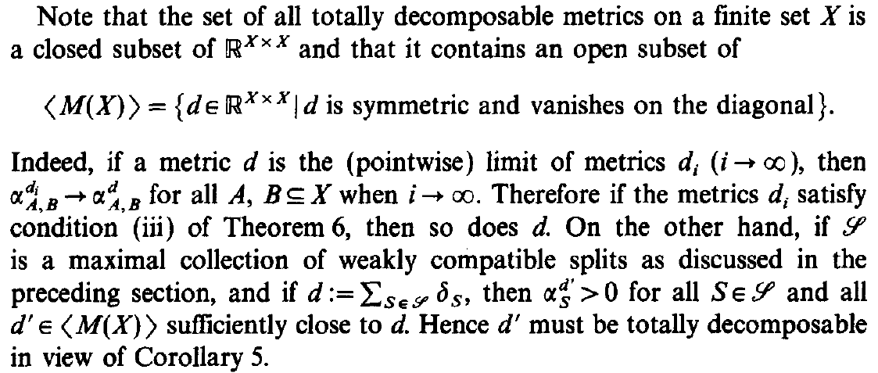

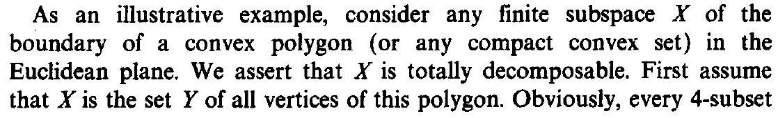

[…]

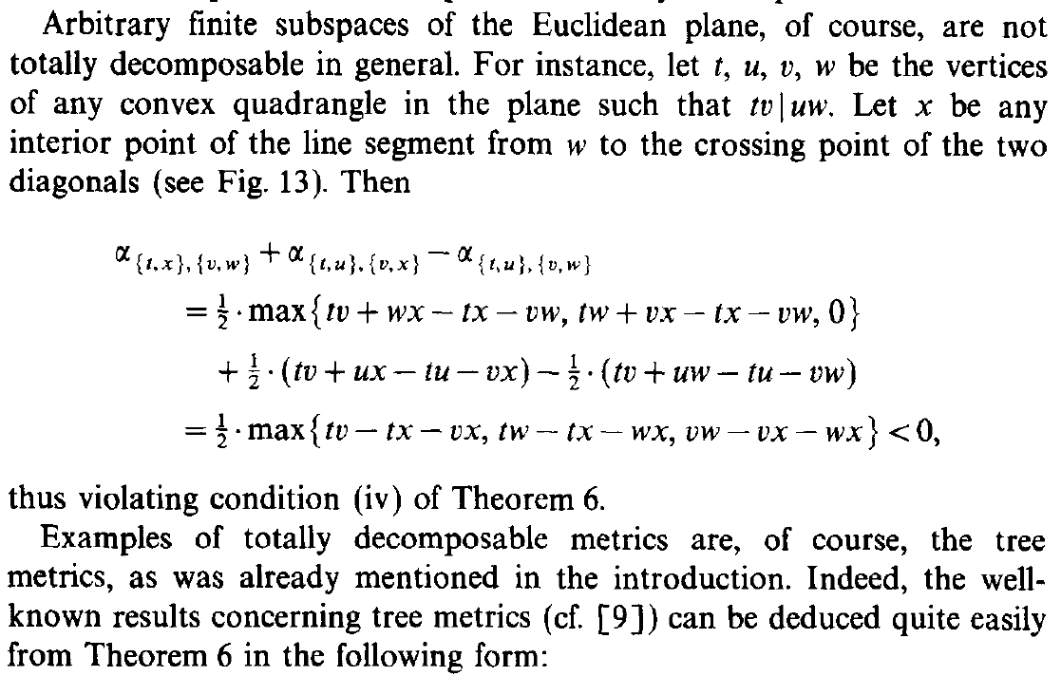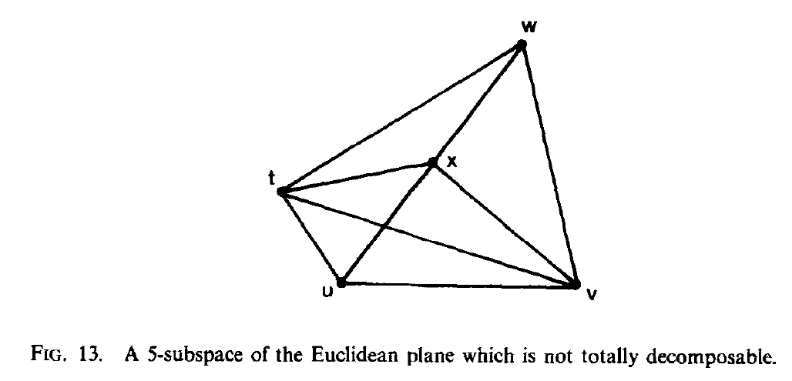

 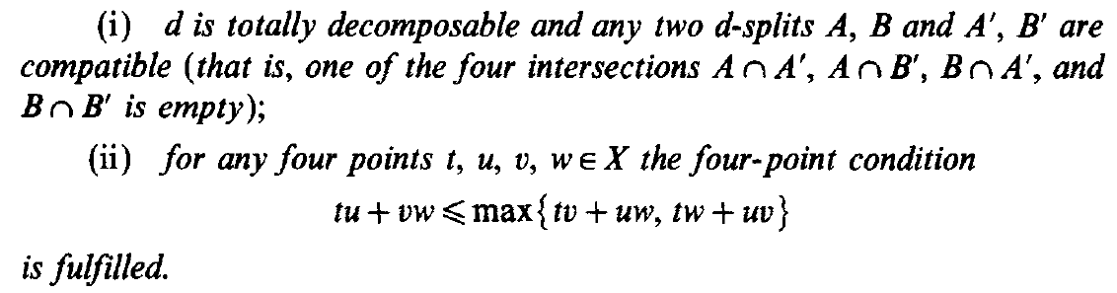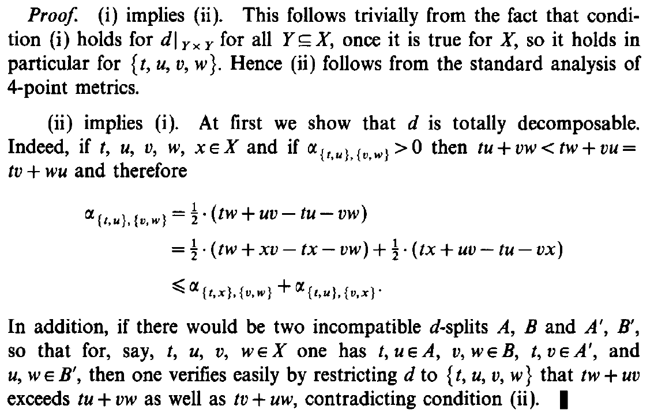

**Def**. (compatible splits)

Given two splits $\{A,B\}$ and $\{A^{'},B'\}$ we say that they are **compatible** if  
 one of the following four intersections is empty

$$A∩A^{'}, A∩B^{'} , B∩A^{'} , B∩B^{'}$$

We say that a set of splits is **compatible**  
 if its splits are (pairwise) compatible.

**Oss**. Subsets of compatible sets are compatible.

**Oss**. A compatible set is weakly compatible.

In fact, if we call $S_{0},S_{1},S_{2}$ the sets of splits extending the three respective quartets,   
then weak compatibility is equivalent to saying that  
 at most two of them are non-empty,   
while compatibility is equivalent to saying that  
 at most one of them is non-empty  
 (the splits from two different sets are not compatible).

**Def**. (four-point condition)

We say that $(X,d)$ (or just $d$) satisfies the **four-point condition**  
 if for any four points $t,u,v,w∈X$ it holds

$$tu+vw≤\max{\{tv+uw,tw+uv\}}$$

or equivalently $$tu+vw≤tv+uw=tw+uv$$

**Dim**. $(⇐)$ It is clear.

$(⇒)$ Applying the first formula

$$tv+uw≤\max\left\{tu+vw,tw+uv\right\}=tw+uv$$

$$tw+uv≤\max\left\{tv+uw,tu+vw\right\}=tv+uw$$

**Oss**. If $X$ satisfies the four-point condition  
 and $t,u,v,w∈X$ are such that $α_{\left\{t,u\right\},\{v,w\}}>0$, then

$$tu+vw<tv+uw=tw+uv$$

In fact, $tu+vw$ cannot be the maximum among the three (otherwise the isolation index would be zero).

**Prop**. If $d$ is a totally decomposable pseudo-metric, then

$$S_{d}\left(Y\right)=S_{d}\left(X\right){\left.​\right|}_{Y} , ∀ Y⊆X$$

**Dim**. Let $Y⊆X$. Clearly a $d$-split of $X$ is also a $d$-split of $Y$, because by extending the isolation index does not increase (and so by restricting it does not decrease). So $S_{d}\left(Y\right)⊇S_{d}\left(X\right){\left.​\right|}_{Y}$.

From **Teo**. 6, the isolation index of a $d$-split of $Y$ coincides with the sum of the indices of its extensions.   
In particular, there must be an extension that is also a $d$-split of $X$. Thus $S_{d}\left(Y\right)⊆S_{d}\left(X\right){\left.​\right|}_{Y}$.

**Cor**. 7 Let $d$ be a pseudo-metric on $X$.

Then $d$ is totally decomposable and any two $d$-splits are compatible if and only if $d$ satisfies the four-point condition.

**Dim**. $(⇒)$ Let $t,u,v,w∈X$. Since compatibility is preserved by restriction, from the previous **Prop**. we get that $S_{d}(Y)$ is compatible for all subsets $Y$ of $X$.   
In particular $S_{d}\left(\left\{t,u,v,w\right\}\right)$ is compatible.

By compatibility, at least two quartets cannot be $d$-splits  
 – suppose WLOG $\left\{\left\{t,v\right\},\left\{u,w\right\}\right\}$ and $\left\{\left\{t,w\right\},\left\{u,v\right\}\right\}$.

If $α_{\left\{t,u\right\},\{v,w\}}=0$, then

$$tu+vw=tv+uw=tw+uv$$

If $α_{\left\{t,u\right\},\{v,w\}}>0$, then

$$tu+vw<tv+uw=tw+uv$$

In both cases the four-point condition is satisfied.

$(⇐)$ Let $t,u,v,w∈X$. If $α_{\left\{t,u\right\},\{v,w\}}>0$, then for every $x∈X$

$$α_{\left\{t,u\right\},\left\{v,w\right\}}=\frac{1}{2}\left(tw+uv-tu-vw\right) \\ =\frac{1}{2}\left(tw+xv-tx-vw\right)+\frac{1}{2}\left(tx+uv-tu-vx\right) \\ ≤α_{\left\{t,x\right\},\left\{v,w\right\}}+α_{\left\{t,u\right\},\left\{v,x\right\}}$$

where we used the previous **Oss**. in the first line.

By **Teo**. 6 this proves that $d$ is totally decomposable.

Suppose to have two incompatible $d$-splits $\{A,B\}$ and $\{A',B'\}$.  
Then we can suppose that exist $t,u,v,w∈X$ such that

$$t,u∈A , v,w∈B , t,v∈A^{'}, u,w∈B'$$

Since $d$ is totally decomposable, its restriction to $\{t,u,v,w\}$ is a linear combination of split metrics that splits 2-2 (that is they extend one of the quartets) and 3-1.   
But the latter contribute equally to the three distances.  
Since the set of $d$-splits is weakly compatible and

$$\left\{A,B\right\}≽\left\{\left\{t,u\right\},\left\{v,w\right\}\right\} , \{A^{'},B'\}≽\left\{\left\{t,v\right\},\left\{u,w\right\}\right\}$$

then $\left\{\left\{t,w\right\},\left\{u,v\right\}\right\}$ does not have any $d$-split extension.

So the only different contributions come from split metrics that splits like $δ_{A,B}$ and $δ_{A^{'},B^{'}}$. As a consequence we have

$$tw+uv > \begin{matrix}tv+uw \\ tu+vw\end{matrix}$$

violating the four-point condition. ⭍

**Oss**. Tree metrics are totally decomposable pseudo-metrics  
 (since they satisfy the four-point condition).

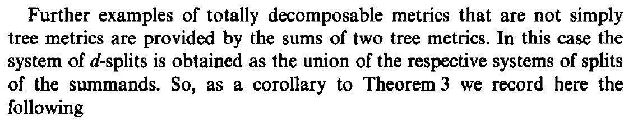 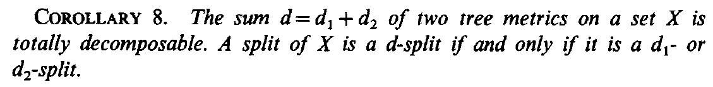

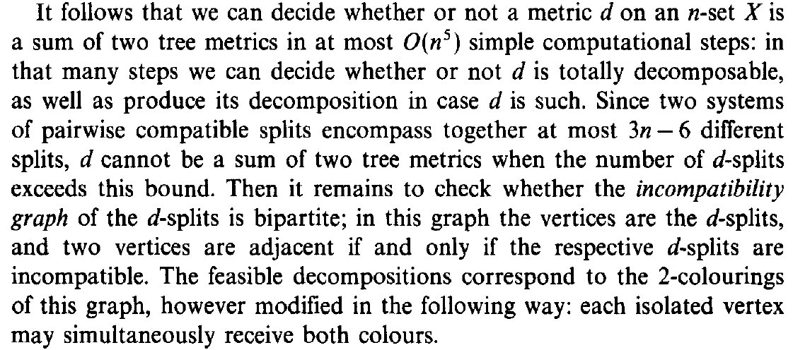 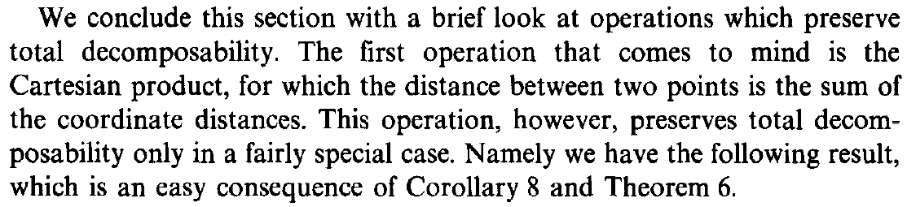

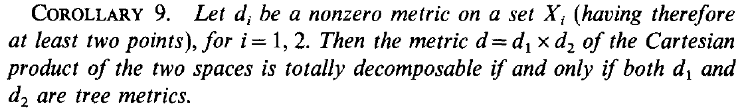

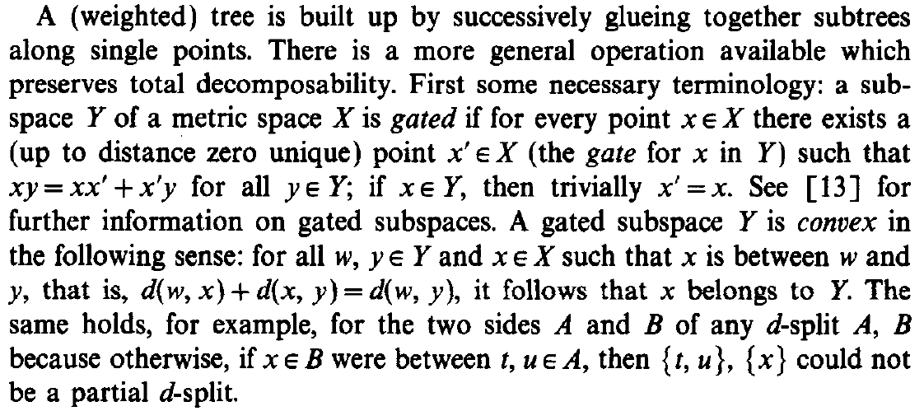

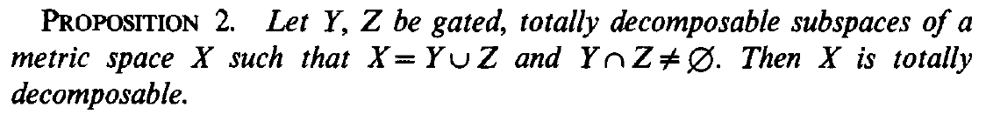

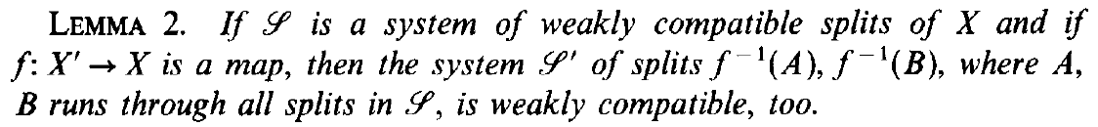

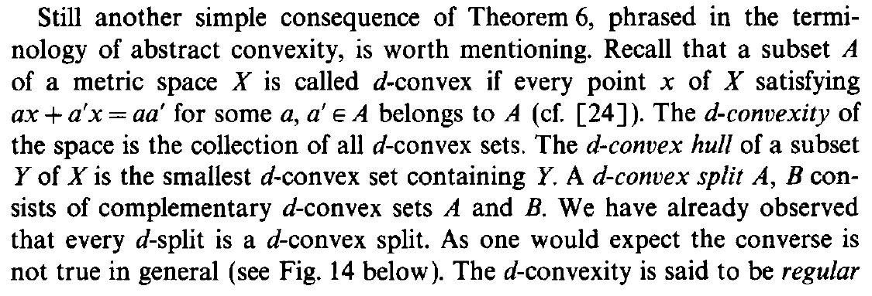 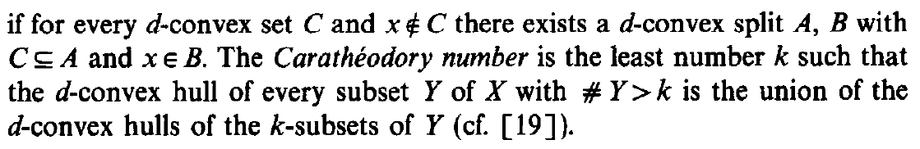

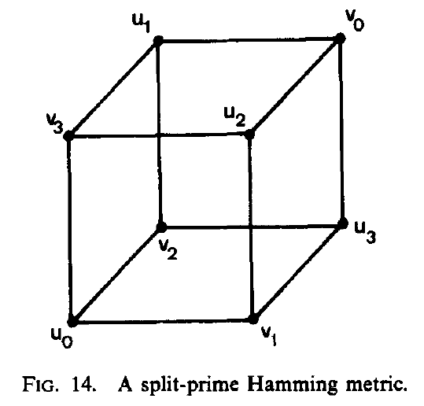



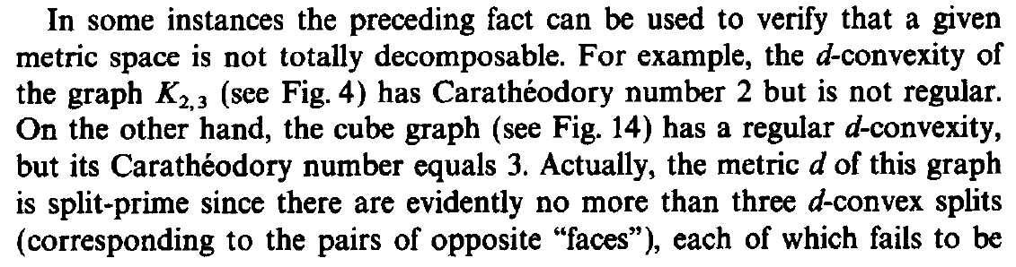 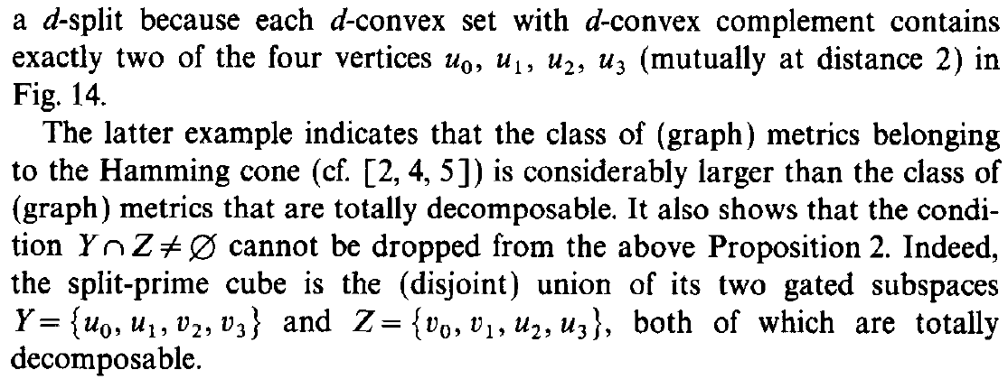

Chapter 5: Coherent Decomposition

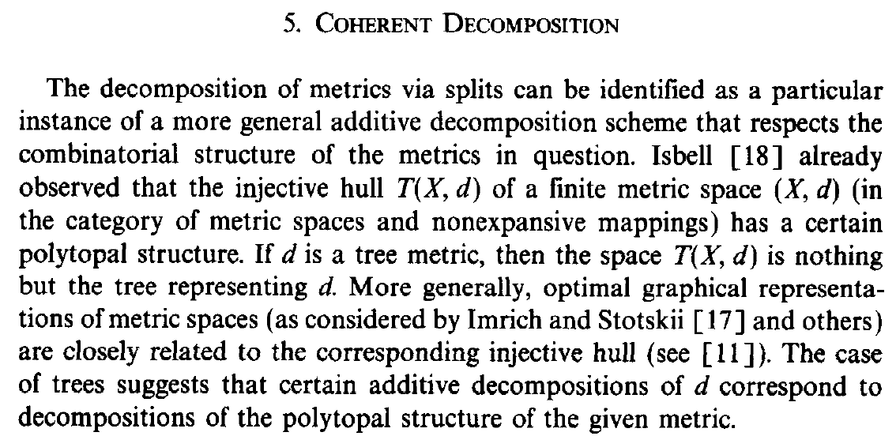 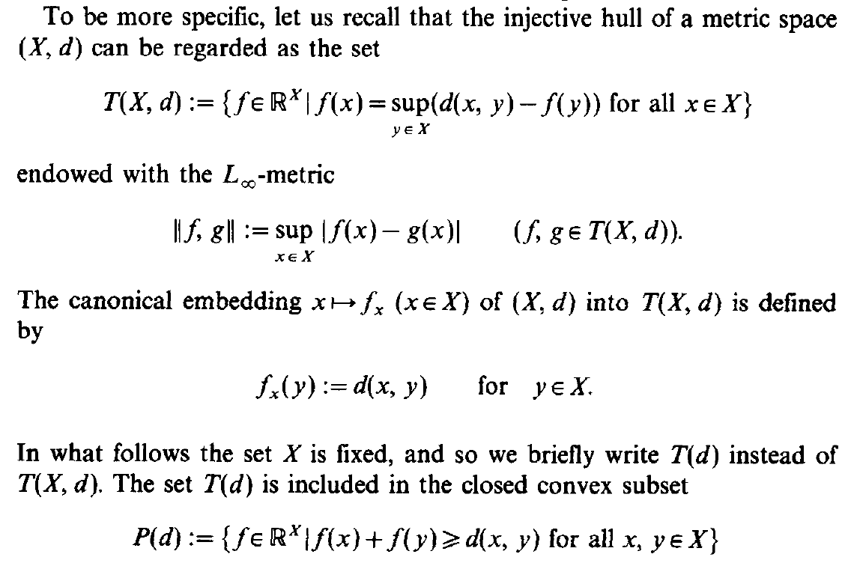

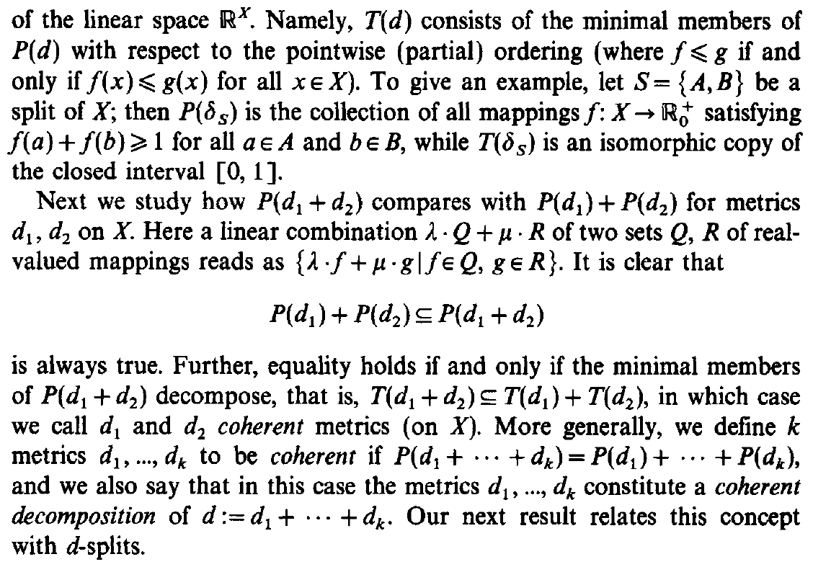

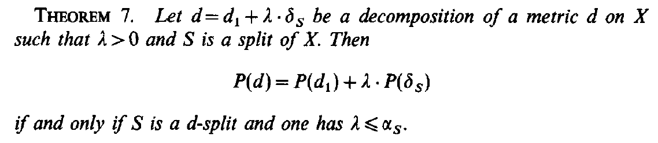

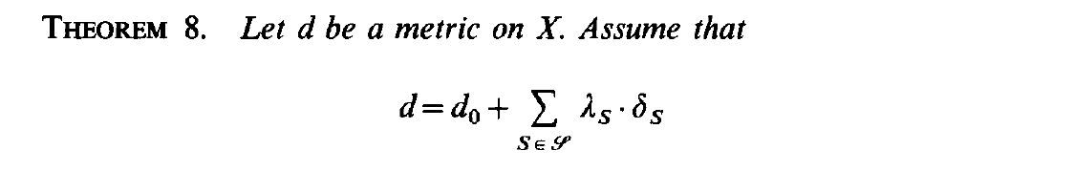 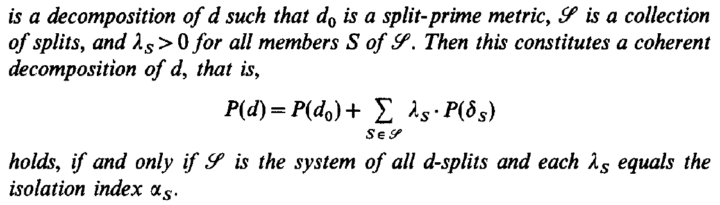

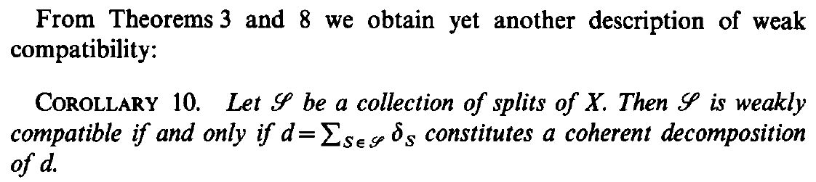

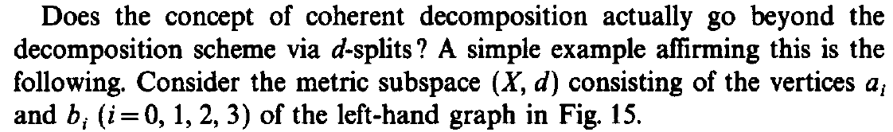 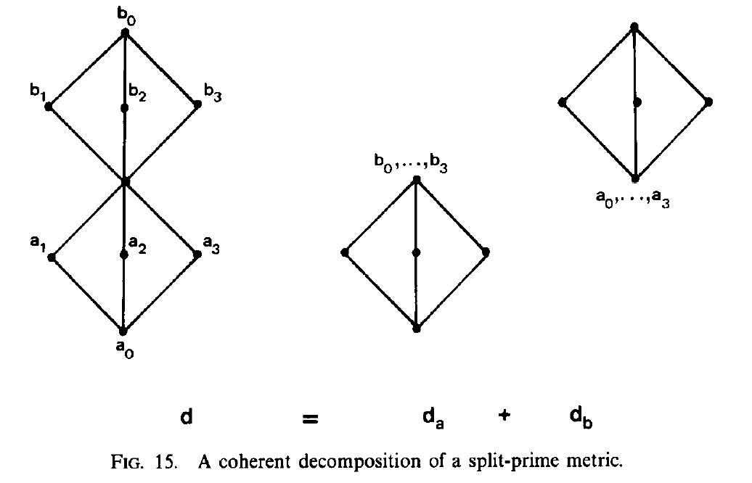 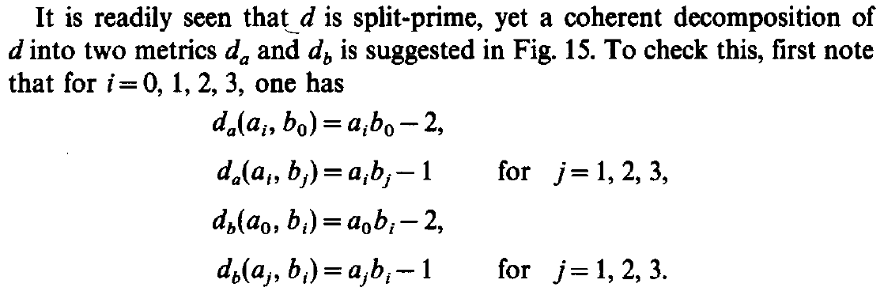

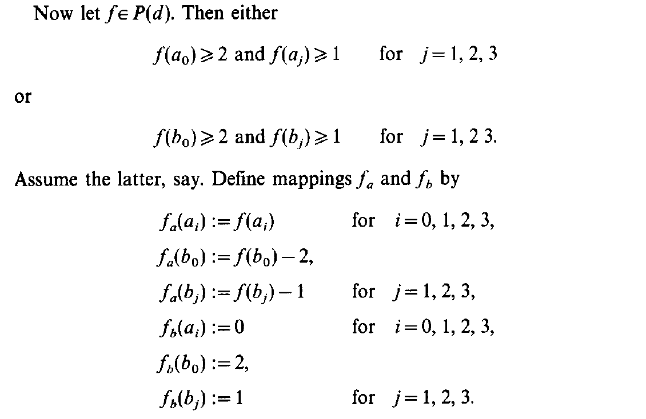 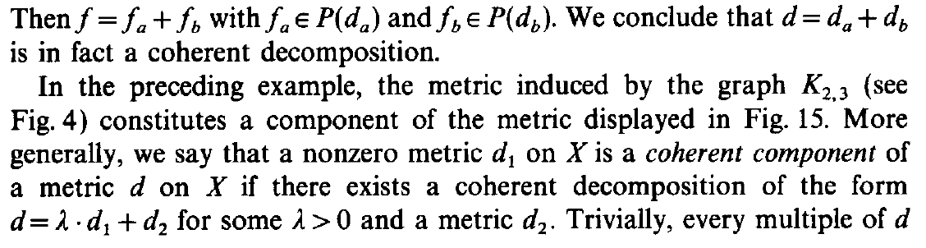 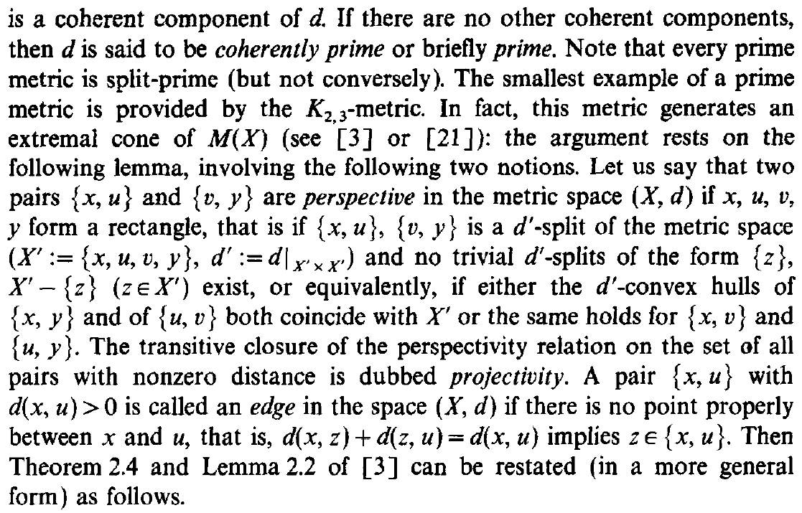 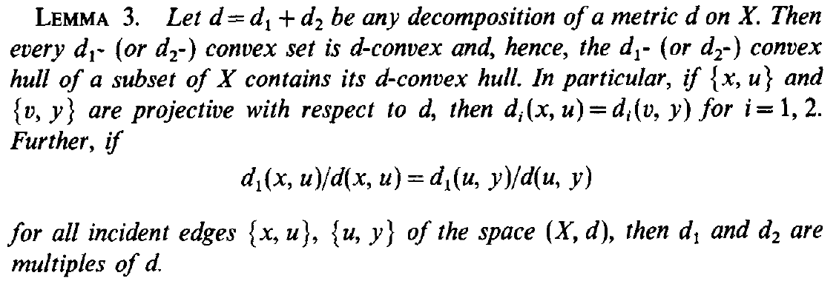 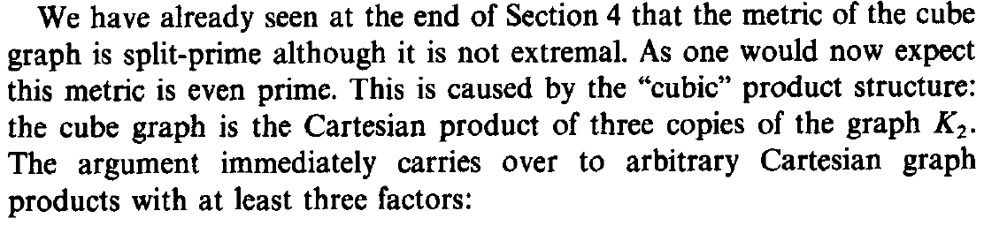 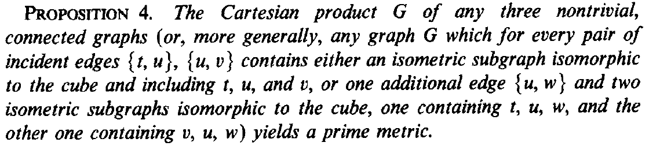

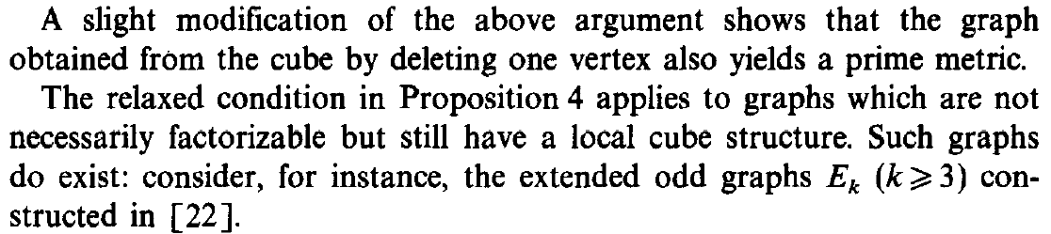 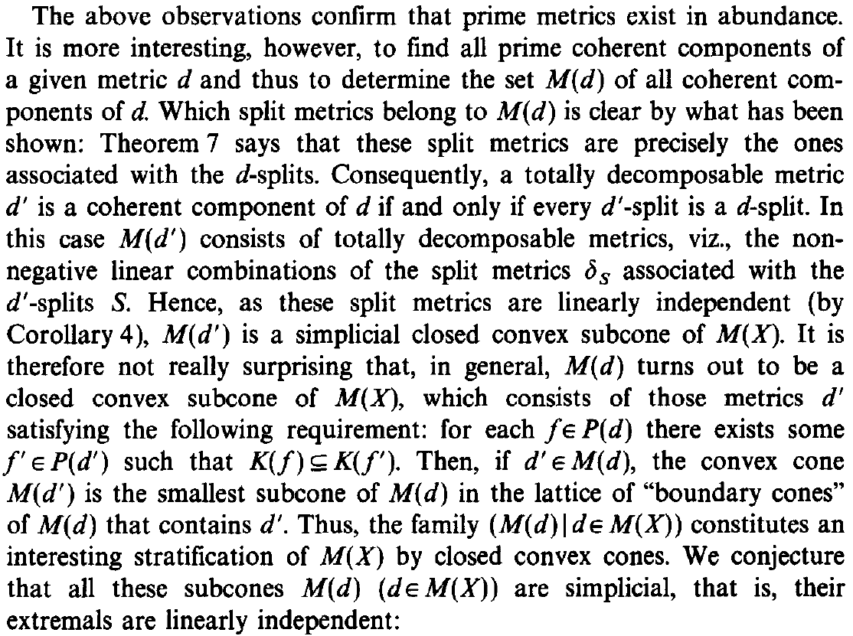 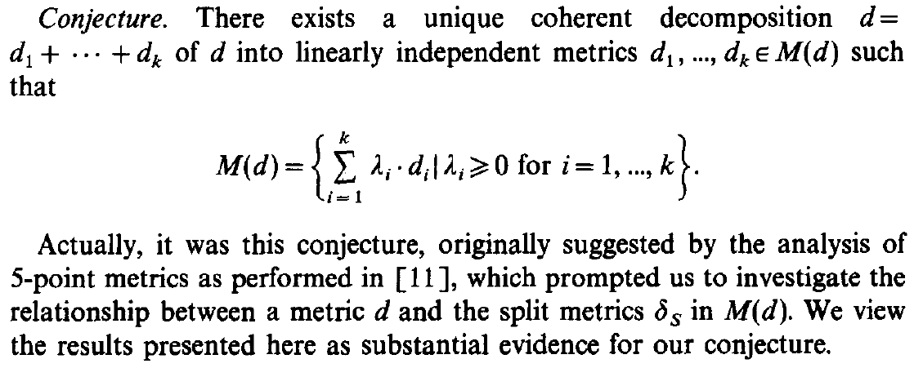

Chapter 6: Splits versus Clusters

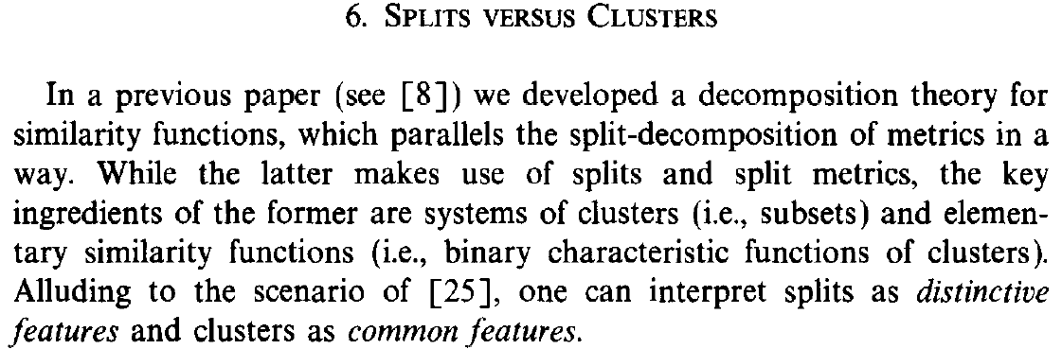 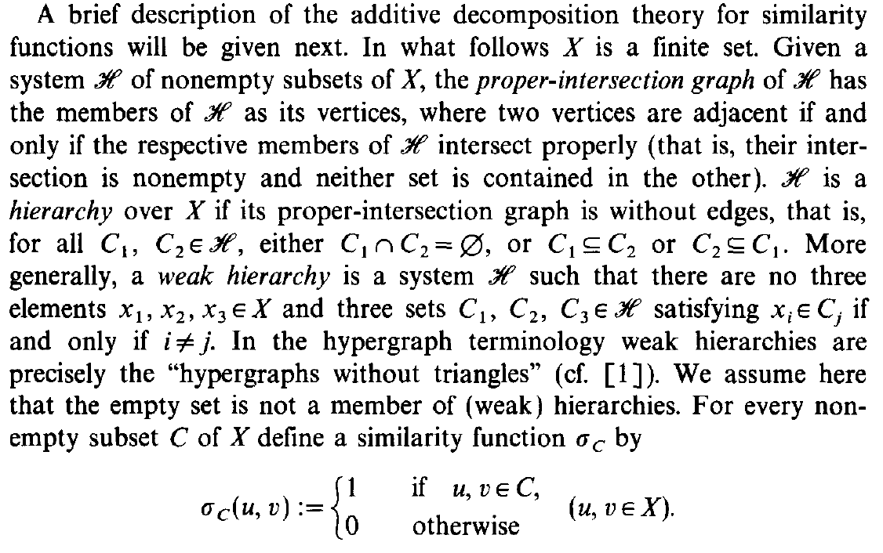

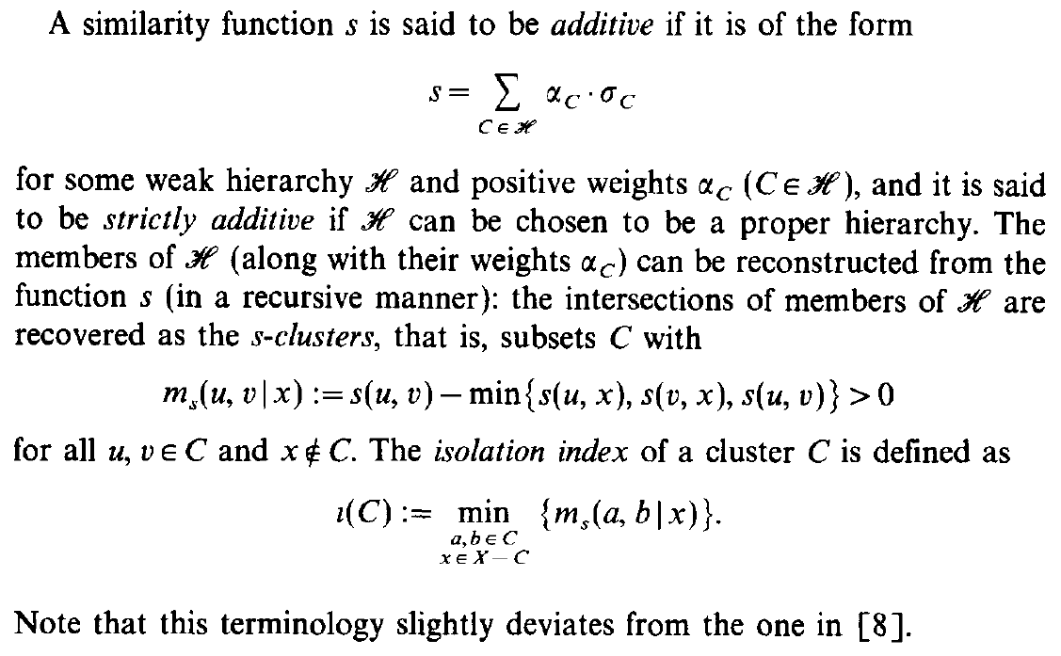 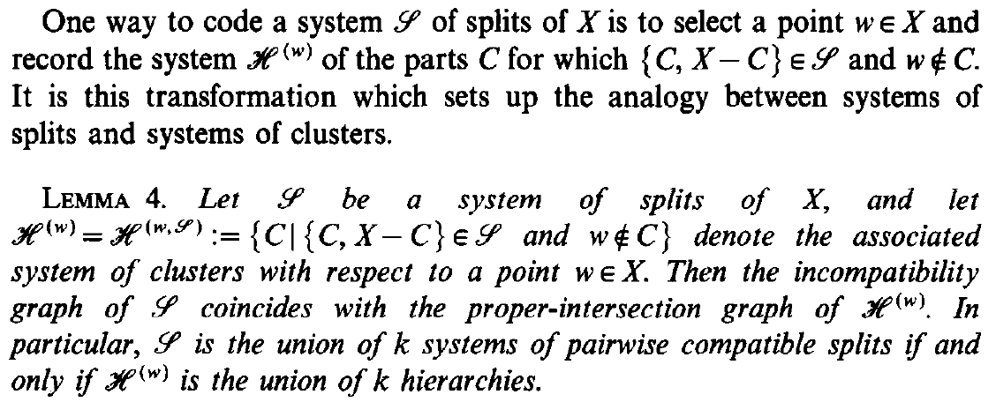

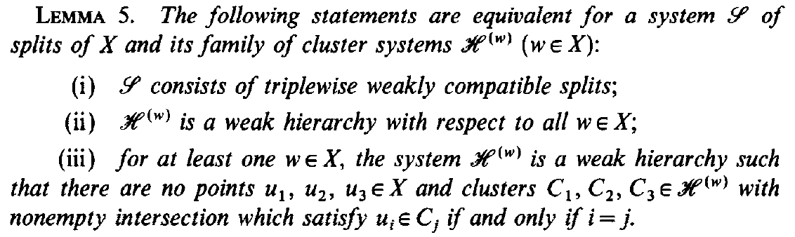

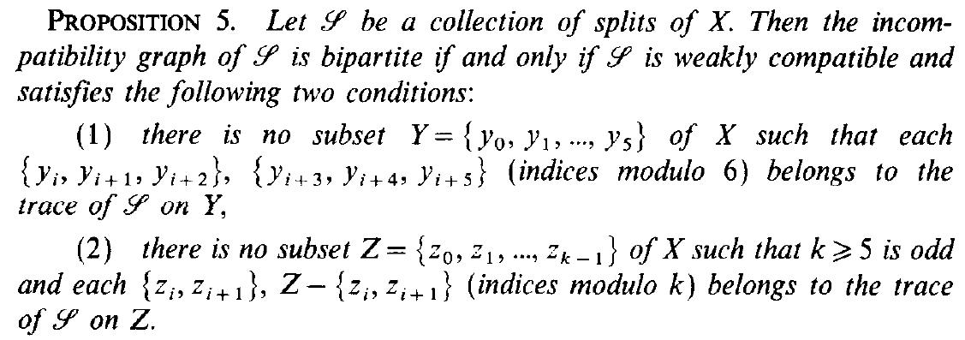

 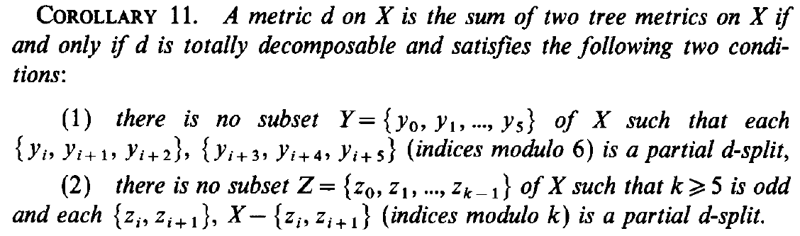

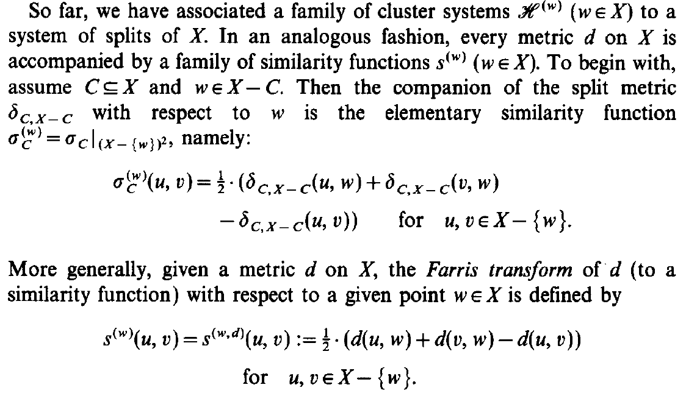

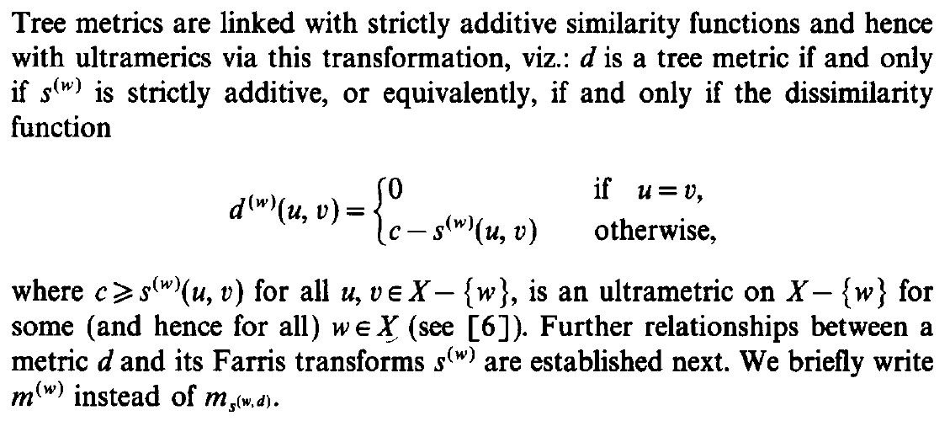

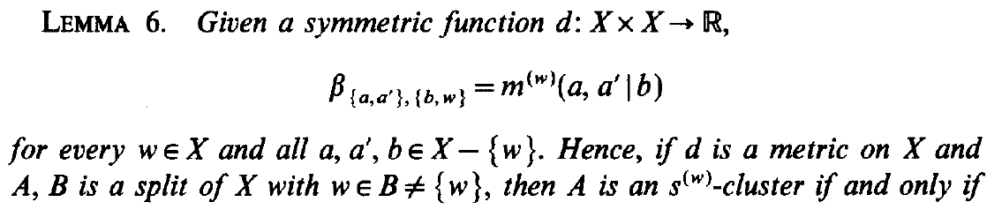 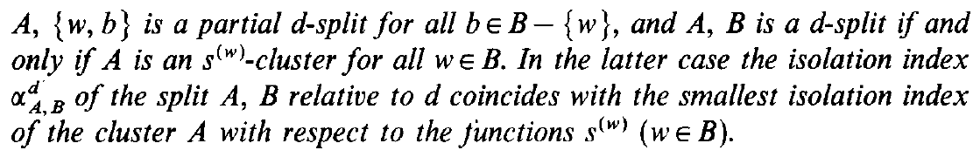

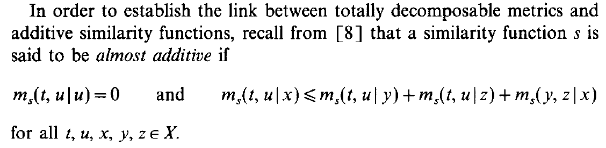

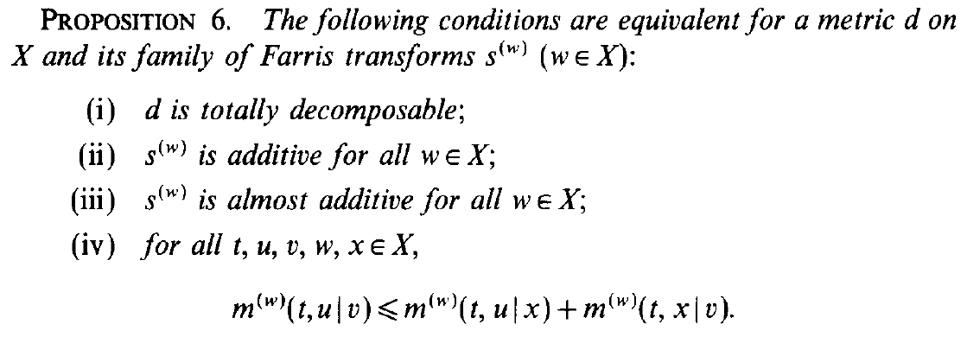

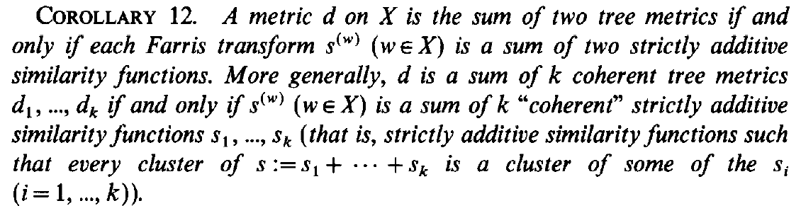

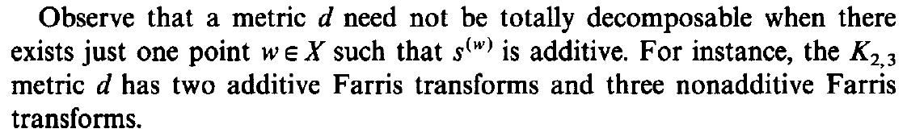 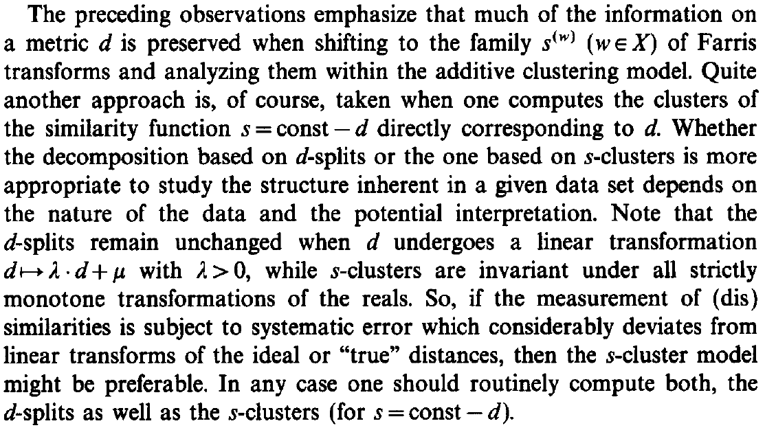

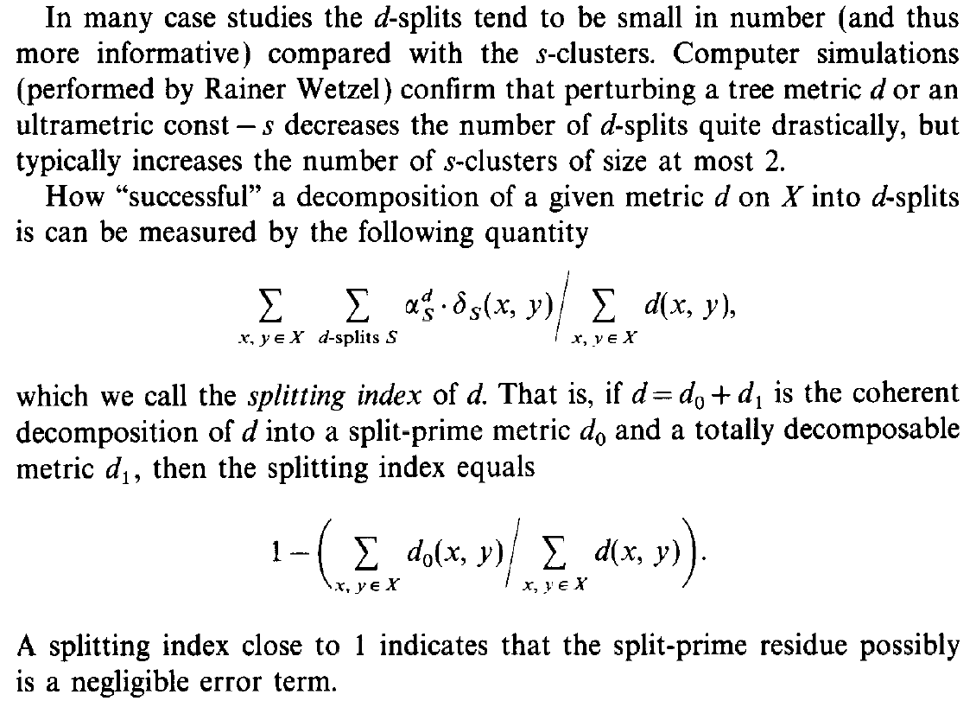 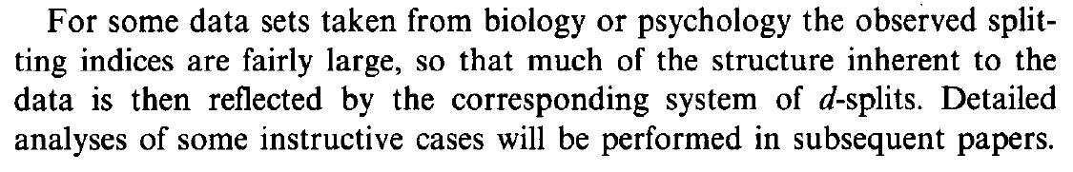

|  |  |
| --- | --- |
| **split** | **cluster** |
| incompatibility graph | proper-intersection graph |
| compatible splits | hierarchy |
| weakly compatible splits | weak hierarchy |
| metric | similarity function |
| tree metric | strictly additive similarity function |
| totally decomposable | additive / almost additive |
| linear transformations | strictly monotone transformations |

1. * Here countable means finite or countably infinite (*al più numerabile*).
2. * This is to be understood as every vector corresponds to an extreme ray  
    and no two vectors correspond to the same extreme ray.
3. * For this reason, they may be also called extremal metrics.